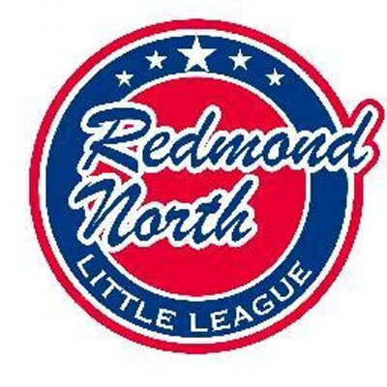

November 20, 2017 Meeting Minutes
Attendees:
Ellen Reed
Alec Weintraub
Bill Bieber
Steve Murawski
Jorge Novillo
Kathy Duncan
Elaine Gunn
Josh Sattler
Scott Miller
Mike Williams
Meghan Dosch

Initial Business
President, Alec Weintraub, requested updates from all committee members on status of works in progress. Also requested that all board members complete background check forms. Provided an update on batting facility. Noted all drawings are done, expects permit drawings to be submitted in December. Facility will not be completed this Spring, hopefully this summer. Noted that fundraising efforts need to be kicked up. Still need about 100K to complete funding. Selling memberships is one possibility, but he is not sure if it is a viable option but it provides a good revenue opportunity. Problem would be that someone would need to manage memberships, access, & scheduling. Vice-President, Bill Bieber, mentioned he has spoken to an electrician who is interested in the job. Information Officer/Webmaster, Jorge Novillo suggested https://www.rallyme.com/ as another option.
Also, he noted that Eastlake is not doing interleague games this year with us, they are doing it with Sammamish instead. He is looking at March 19-29th right before Spring Break for possible interleague games with another league. He is in discussions with RedWest, 4 games for Major times; 2 Coast games, & 2 AAA during same time frame. Board zeroed in on March 17th & 18th as dates. A board member mentioned that Sno-Valley may be interested. Alec will check.
VP, Bill Bieber, provided an update on suggested changes to local rules. Suggested the deletion of rule #19 (AAA) whereby if a kid walks 4 consecutive batters, then a coach can step in and pitch. All agreed with elimination of that rule.

Registration Update
Registrar, Josh Sattler, stated that registration is up and going and opened earlier than last year. Despite opening earlier, there is the same enrollment as last year. The signs he has placed have been disappearing. Theft is suspected. His next phase will be to email last year’s managers asking them to encourage last year’s players to re-enroll. He has flyers that will be placed in K & 1st grade backpacks with several elementary schools. He will send a second round of the peach flyer before the early bird deadline. Noted that there will be more 12 year-olds this year due to an age rule waiver. Alec reviewed list of managers from last year and believes there are a sufficient number of managers for each level-cautioned that we may be short one Coast manager.

Safety Plan
Safety Officer, Scott Miller, discussed the background check forms and reasons for rising costs. He stated he could not find safety plan document. Jorge will help him locate it. Alec stated it need to be submitted to D9 by January 1, 2018.

Equipment Update
Equipment Manager, Mike Williams, provided an update. All IB teams brought equipment back except one team. Got all new catching equipment back. Many team bags are looking bad. He will look through BSN catalogue and connect with Risan to determine costs for replacement. D9 will collect all old bats and send them overseas, it will be part of the Knock off the Rust event. Stressed that there needs to be an easier storage option and asked about storing everything at RNLL container unit. He will review what is currently stored at shed at RHS and RNLL to determine what is still viable. The board discussed buying bats for the teams. It was decided to buy bats for IB only and cheap bats. Alec will find out what other leagues are doing with bats being provided.

Uniform Update
Meghan Dosch, Fundraising & Sponsorship Coordinator and Elaine Gunn, Secretary, presented information and pricing from four competitors regarding uniform pricing. Samples of uniform materials, excel spreadsheet of pricing, and a catalogue provided by Meghan were distributed to board members. After discussing materials and pricing, it was decided that uniforms for IB ball will be a performance t-shirt with RNLL logo paired with a MLB hat ordered from Pro-Time Sports.

Training Update
Kathy Duncan, Training Coordinatoir, and Ellen Reed, Player Agent discussed the instructional trainings from last year provided by several organizations (e.g., Baseball Positive, SBA) and noted that all were well received. Discussed coach training and the requirement that All-Star coaches obtain training. They will look into video training. Ellen stated she would be willing to do manager training.

Season Schedule Updates
- December 12, 2017 date set for all upper level manager to be locked down.
- “Knock off the Rust” is scheduled for January 13, 2018. There is a need for someone to manage this.
- Player Evaluation event is schedule for January 27, 2018. Bill volunteered to assist with event.
- May 5th is date selected for Jackson Roos Tournament. Only for majors. Coast may be considered for tournament on May 6th. There is a need for JR Tournament Coordinator.

Miscellaneous

- “Bat Demo Day” needs a date selection. Some suggested Jan. 27, 2018. Once date is selected, Steve can check with vendors regarding interest.
- “Swap Meet” event needs a date selection. Someone will need to manage.
- May 20th is date selected for RNLL Mariner’s Day.
- Temporary fencing at RR. Alec will check with someone to get posts fixed/replaced. He will look into getting rollers to help wrap up fencing easier.
- Struggling with position fills for IB, UIC Coordinator; Dan H. will handle Coast & Majors, Need VPs roles for each division. Steve will be VP for Majors. VP for Coast, etc. Alec will keep working in it.

Next Meeting

- December 18, 20 2017, 7:00PM @Ixtapa

