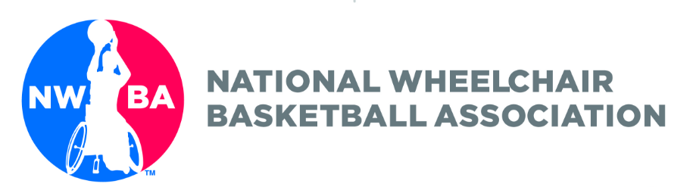

2018 Timothy J. Nugent Academic Achievers

Academic Recognition for Grades 5-9

To receive recognition for your academic achievement submit the following application by Thursday, February 15, 2018.

Kelly Fischbach
601 Canby Street, Vermillion, SD 57069
kfischbach13@hotmail.com

Please do not wait to the last minute to work on your project. It might require more time than in the past.

Student Athlete’s Name:

NWBA Junior Division Team:

Address:

School Name:

School Principal:

School Principal Email Address

Principal or Counselor Signature:

Grade in School 5 6 7 8 9
Older grades 10-12 should apply for Academic All-American

MUST have a Cumulative Grade Point Average of 3.0 on 4.0 scale.

What is your Cumulative GPA ____ Is the number above 3.0 on a 4.0 scale?

Must have all A’s, B’s and C’s in your last grading period to be eligible.

If you have a D or F in your last grading period you are not eligible.

To be eligible for the recognition the student-athlete must include:

- High School, Middle School, or Elementary Report Card

- We would like the student athletes to do a project where they explain how participation in adaptive sports has allowed them to learn and grow. We would like the work to be predominantly done by the student athlete themselves and we will take grade level into account when evaluating the projects.

If you have questions, please direct them to Kelly Fischbach at kfischbach13@hotmail.com.

