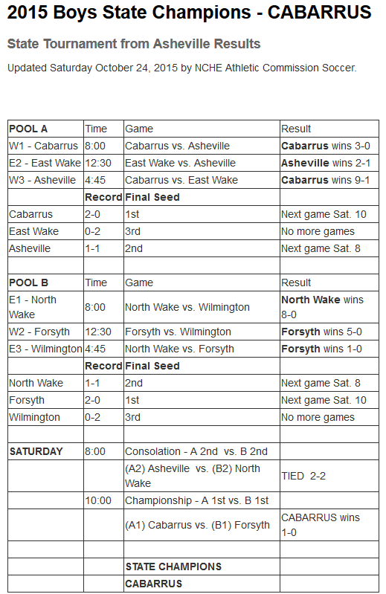

All-Tournament Selections:

Cabarrus | Gabriel Williams, MVP
 | Parker Sorensen
 | Alan Frank
 | Andrew Moore
 | Brian Stepanek
Forsyth | Cole Walker
 | Mark Rowan
 | Ben Rowan
 | Dylan Moye
Asheville | Solomon Love
 | Tristan Torbett
North Wake | Mackenzie Smith
 | Joshua Miller
East Wake | Tim Bizzell
Wilmington | Patrick Deaton

