Roll Call: Terry Johnson, Jay Stark, Travis Steele, Jesse Viall, Tom Johnson, Randy Kruse, Adam Welch, Sean McCabe, Bernadette Schaffer, Josh Colvin, Jaimie Schuster, Adam Hoffman, Brooks Savage, Jason Stoffel, Shannon Callahan, Shane Lanning
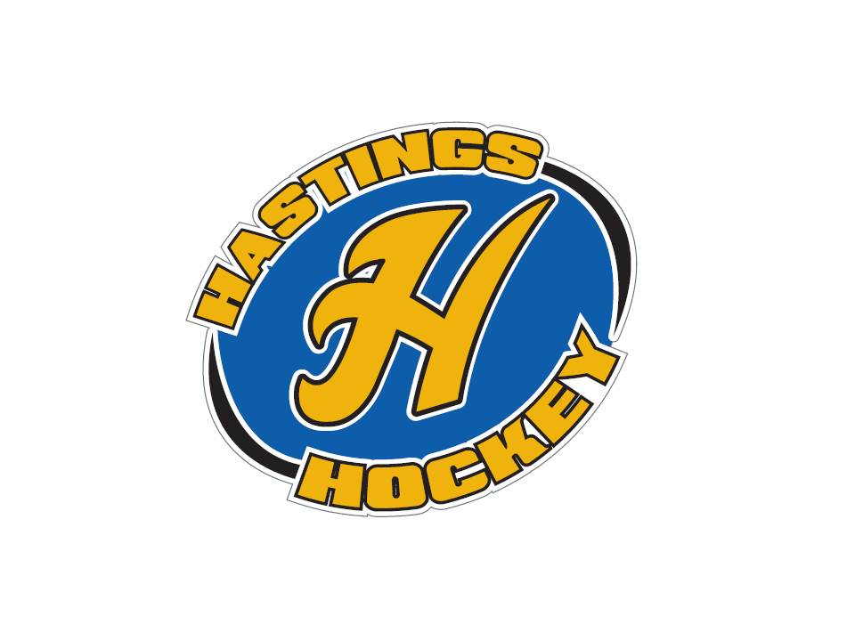

Not in attendance: John Kilmek, Lisa Zaccardi

- Approval of Agenda Adam made the motion, Jesse seconded – motion was passed
- Approval of Minutes - We will vote on next month

Coordinator Reports
- Referee – John Klimek not in attendance
- Registrar – Shannon Callahan
Volunteers need safesport and background checks done, and team managers need to be rostered
In house – need birth certificates or they won’t be able to be put in the system
Coaches can’t be rostered without safesport – now until Sept 18th will be a refresher course or else it’s a full course
Out of Town kids need waivers – even the in house kids and this needs to be done yearly – send to Terry at home
Shannon I feel like I missed something here?????
- Technology – Randy Kruse not in attendance
- Tournament Director – Lisa Zaccardi not in attendance
- Sponsorships –
- District 8 – Jay Stark
A long discussion about squirts

- Goalie – Josh Colvin
First fall goalie clinic – had 12
Figuring out equipment – please email Josh if you need to exchange equipment
- Secretary – Bernadette Schaffer

Officer Reports:
- President – Terry Johnson
October 25 – Chipotle fundraiser – will get out info soon
Terry and Joe Harris had an interview with MN Hockey about our squirt program – others in the state are very interested in how we run our program – see the next issue – in October
Approved for positive coaching alliance – will try and find a weekday night for this to attend, it will be mandatory for coaches and parents to attend – trying to change the culture of youth sports and show where we are trying to go with our program
Tim Collins met with all associations in the City - needing help with passing the referendum… Please let Terry know if you are interested in making phone calls - it will be October 9th

- Vice President – Jay Stark
October 7th Level 1 CEP for coaches clinic - scheduled 8-noon at the high school lecture hall with an hour of skating 1:00 – 2:00 – sign up at US hockey will be coaches from all different towns attending
2 goalie hours added October 1st (boys) and 7th(girls)added for tryouts - Josh is looking for people outside of town for help evaluating
Ready to run schedule – send emails ASAP so that things can be changed

- Treasurer – Jaimie Schuster (Approval of the Financial Statements)
Jesse made the motion, Sean seconded - motion passed

Director Reports:
- Volunteers – Shannon Callahan
Trying to get an idea for putting dibs out for skate with a friend night – Sept 29th
Equipment hand out – October 2nd and October 9th 5 -8
Will need volunteers for tryouts as well
Team manager meetings – Monday the 16th
In house team manager meeting Nov 6th
- Director of Hockey – Adam Welch
October 22nd – youth coaches meeting - mandatory 4:00 mites and squirts, 5:00 is above squirts at the ice arena
Inside out Coaching – 20 copies the # of coaches for each level - Girls – 6 coaches, Bantams 4, Peewees 4 Junior Gold 1 U16 1

- Operations – Adam Hoffman
Equipment handout – inventory done
Will be ordering jerseys with bantams - Jaimie made the motion, Adam seconded and the motion passed to order jerseys
- In-House Girls – Shane Lanning
Working on figuring out ice hours and times
- Travel Girls – Travis Steele
Registration closed – numbers lower than he hoped
U15 goalie from Inver Grove
Make the motion to approve Adam Hoffman as the other U12B coach – Travis made the motion, Jaimie seconded it – motion passed
- TerMites – Tom Johnson
74 total at this time, hoping to get many more as we get closer
- Mighty/Super Mites – Jesse Viall
Fall clinics started….
28 supers mite 2 signed up
35 for mighty – mite 1
- Squirts – Jason Stoffel
54 signed up – will be 7 more signing up
6 will not be playing
45 will be traveling
- Peewees – Sean McCabe
Numbers good

- Bantams/Jr. Gold/U16 – Brooks Savage
- 50 skaters with 4 goalies and will have another most likely goalie
4 teams

Old Business:

New Business:
Bring a friend skating Sept 29
Try Hockey for Free Nov 4th – move this to a later date like after the snow falls
Squirt Traveling - 3 teams
Handbook Changes will work on language for mite level physical altercations – The level directors can bench players for malicious physical altercations Adam made the motion and Sean seconded it – motion passed -
School Board Volunteers

Board Comment
Membership Comment
Adjournment Sean made the motion, Travis seconded – meeting adjourned at 9:30

Next Meeting: October 3rd 2017

