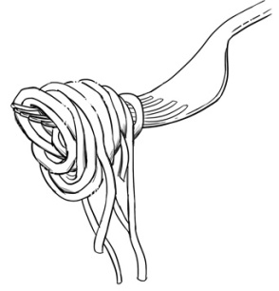
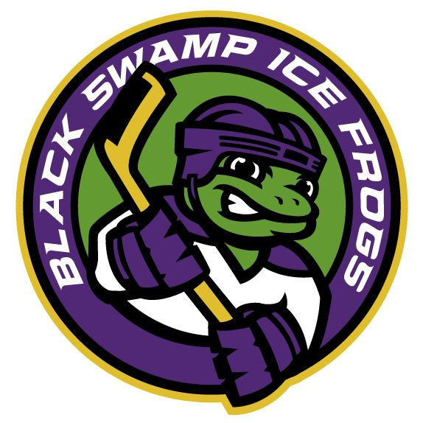
Spaghetti dinner!
BAKE SALE!
silent auction!
Black Swamp Ice Frogs
A 501(C)(3) hockey team for individuals with disabilities, based at the Slater Family Ice Arena in Bowling Green.
For the…

Saturday, February 3, 2018
4:00 p.m. to 7:00 p.m.
First United Methodist Church
1526 East Wooster Street, Bowling Green

Tickets Purchased by 1/25 – Adults $7.00, Kids (ages 5 - 14) $5.00
Tickets Purchased at the Door – Adults $8.00, Kids (ages 5 - 14) $6.00
Purchase By Phone, Email, Facebook, or from Players (cash, check, credit):
(419) 575-7466 or https://facebook.com/BlackSwampIceFrogs/ or blackswampicefrogs@yahoo.com
*All you can eat spaghetti, with salad, garlic bread, dessert and drink*
SILENT AUCTION DONATIONS ARE NEEDED!
Please contact Kathy Dibling using the information above if you can help.
Thank you!

