YOU DON’T KNOW LAX
We bet when you hear the word lacrosse, you think “oh, that’s a very rough sport”.
Well, guess what… you don’t know LAX.
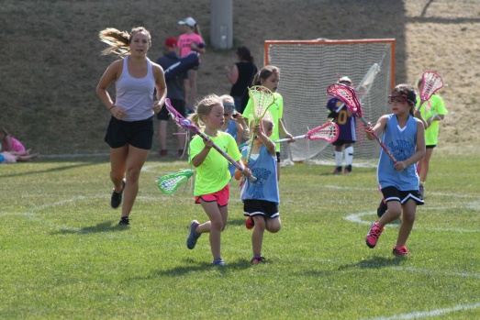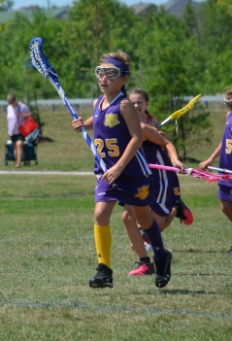
“LAX” is short for lacrosse and in Girls Field Lacrosse there is
NO BODY CONTACT.
No hitting. No cross-checking. No Slashing.
Girls Field Lacrosse is all about speed, agility, teamwork and skill,
and, it’s the fastest growing sport in North America.
It’s the perfect summer sport for girls who enjoy a fast, fun, team sport.
Here in Canada we have the world’s greatest winter sports.
Hockey, Ringette and Basketball are just 3 examples.
Now, in KW, girls can play the amazing summer sport of
Girls Field Lacrosse

We offer programs for girls ages 3 and up in both
House League and Rep categories.

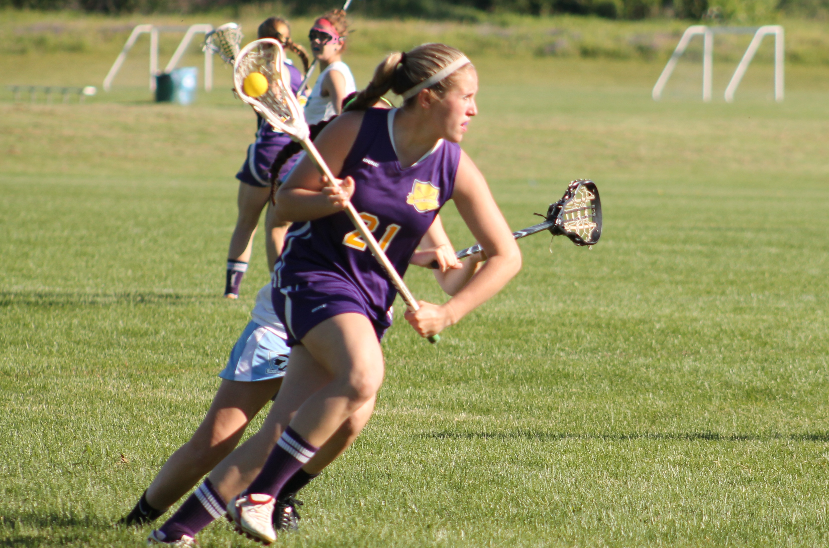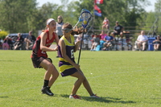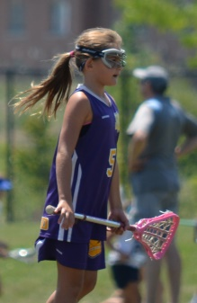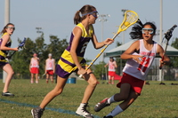

Check out www.KWMLA.com for more information
or email kwgirlsfieldlacrosse@gmail.com

