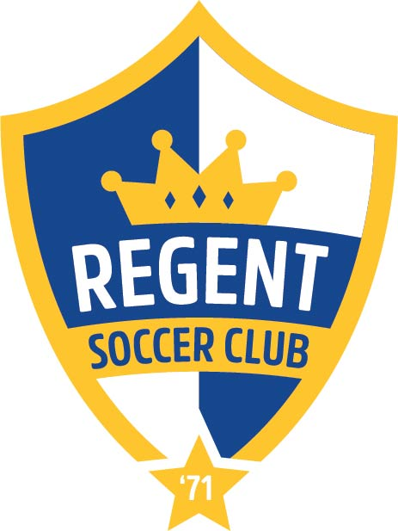 REGENT SOCCER CLUB
MADISON WI

Our Club
Regent Soccer Club is a nonprofit youth soccer organization based on the near west side of Madison. Our goal is to allow players to develop a love for the game by keeping it fun, affordable, and kid-centered. Our mission is to serve the community by providing an inclusive, fun, learning environment for youth soccer players. We believe that our club should:
- ● Provide a safe environment
- ● Be affordable and available to all
- ● Show respect to all, including players, officials, coaches, parents and fans
- ● Value player development at all skill levels while promoting good sportsmanship and
encouraging a lifelong love of the game
- ● Strive to continuously improve the facilities we use, the coaching we offer, soccer
officiating in the Madison area and our club leadership
- ● Be school/neighborhood based
- Board of Directors

- ● Board members provide guidance on club policies
- ● The Board of Directors shall consist of not less than six nor more than fifteen individuals.
- ● Board members are selected by current Board members based upon their interest,
expertise and potential contributions.
Expectations of Board Members
- ● To attend and participate in monthly meetings. Attendance is required at a minimum of nine meetings per year.
- ● To serve as volunteers/ambassadors during one special event during the year.
- ● To actively support the goals and policy objectives of the Club.
- ● Board members are asked to contribute by serving on various committees or assisting
with fundraising activities.

PLEASE RETURN TO REGENTSCBOARD@GMAIL.COM

REGENT SOCCER CLUB
MADISON WI
Board of Directors Application Information Profile
NAME: __________________________________________________ DATE: ________
Email Address:___________________________________________________________
PHONE: [CELL] _________________________ [HOME] ___________________________
Occupation/Company: _____________________________________________________
Please provide a brief statement about your interest in serving on the Regent Soccer Club Board of Directors.
Check any skills / expertise / networking that may apply to you:
Financial Management
Administration
Accounting
Banking
Fundraising
Law
Marketing
Strategic or Long-Range Planning
Public Relations
Non- Profit Management
Other:

Are you able to commit to a monthly board meeting ____YES ____No [meetings typically occur the 3rd Monday of every month. 7:30-9.

___________________________________________________________ [signature]

