SEVEN LAKES BOYS’ TRACK & FIELD
Scan to fill out the information sheet so that we may get in contact with you
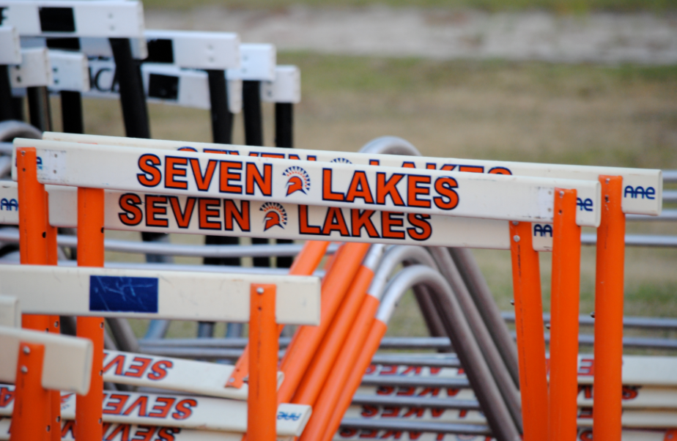
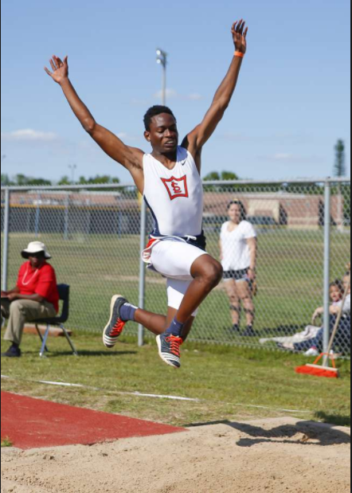

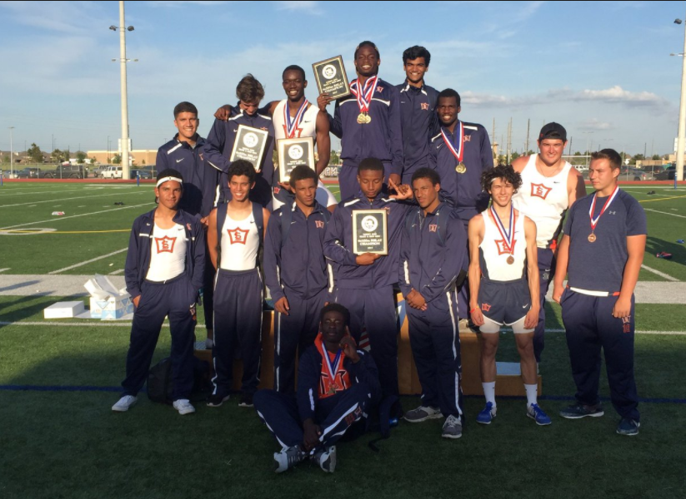
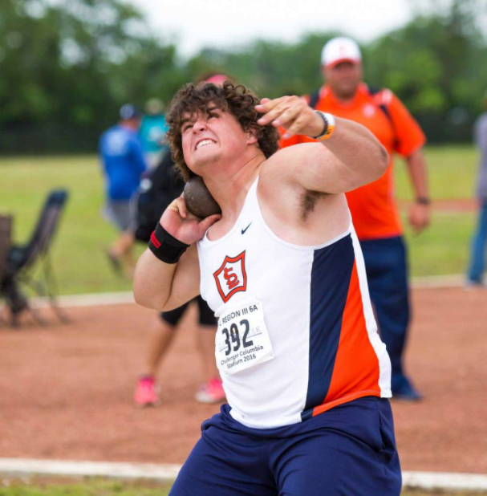

State Meet Qualifiers
2007, 08, 09, 10, 12, 13, 14, 15, 16, 17
Area Champions
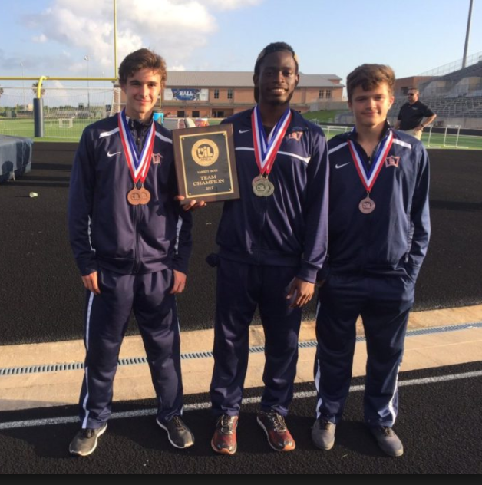
2012, 13, 17
Area Champions
2012, 13, 17
Head Coach
Marvin Rathke
281-435- 5280
marvinwrathke@katyisd.org
Assistant Coach
Scott Kenney
281-658-3835
scottakenney@katyisd.org

