3-1 Drill
This drill has 1-3 players on first and pitchers on the mound. Pitchers go through the motions of pitching, with a finish in a Fielding Position, the coach hit/rolls ground balls in between pitcher and first. The ball should be hit/rolled to pull the first baseman away from first. The pitcher should run to first in an arching direction to first, the goal of the pitcher is to be running along the foul line when the ball is underhanded to them. The first baseman is to field the ball and underhand the ball to the pitcher going to first. The underhand to the pitcher should happen as soon as possible to allow the pitcher time catch the ball and then find the bag to step on. First baseman, will need to be instructed to lead the pitcher the ball and as soon as possible. This drill should be ran a good 10 minutes continuously.
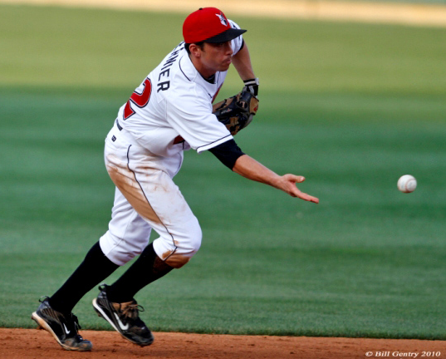
A good example of this is seen on the following links:

Ripken Baseball - Pitcher Covers First Base

1B - Feeds to Pitcher Covering First Base - Winning Baseball

