Second Base Double Play Footwork Drills
This drills works on the Second baseman's footwork during the double play throws from Third baseman or Shortstop. The first part of this drill is have the coach throw easy throws to the second basement in different spots to have the player practice receiving the ball when it comes to them in different spots and how to work their feet for a good throw to first. Instruct player on the footwork needed when different throws come to them.
The next part of this drill is to work players at short taking ground balls, then throwing to Second base. These throws should have the players work different areas of their position, i.e. closer to second to give the second baseman a good underhand toss. The next will have the shortstop deeper, to have the throw become an overhand throw. Then Third baseman throws over to second.
When working with the players at short and third, begin with underhand throws or light hitting to them. The players should focus on a good fielding of the ball, then good footwork to the throw to second at the same time second baseman are working on their footwork.
This drill should have the players rotate through the drill at a good pace.
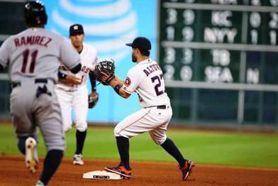
A good example of this is seen on the following links:

Second Baseman Double Play Footwork the Ripken Way

Ripken Baseball Fielding Tip - 2nd Base Double Play Pivot

