Outfield drill 1
Players are to focus on good posture, footwork, and quickness.
Drop Step Drill
This drill has the player setup in the ready position. The coach says GO RIGHT, or left, and the player steps, crossover as he drops back for the catch. The ball should be thrown so the player can run at a good pace to catch the ball the coach has thrown for him to get.
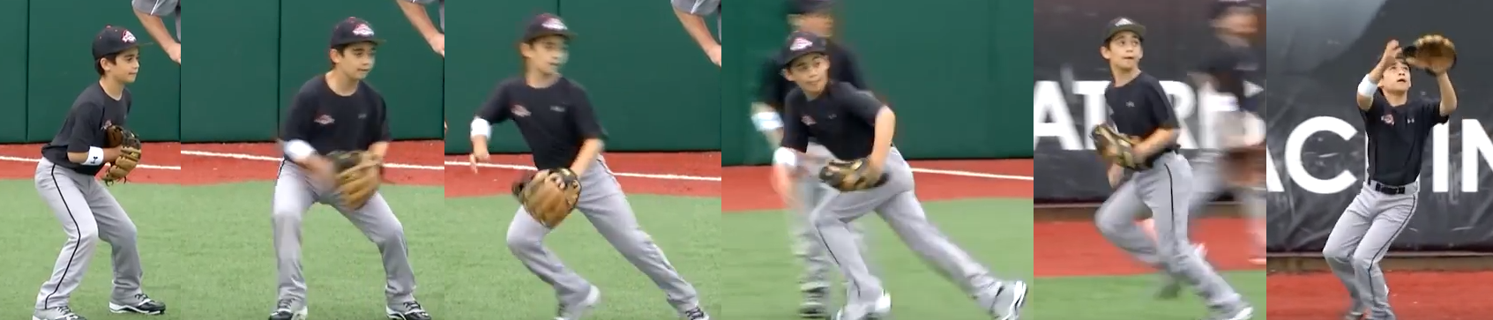
Drop Step Drill 2
Each player has a ball and sets up like the previous drill. The player now underhand tosses the ball to the coach. He will then drop step in the direction of which hand the coach catches the ball with. This is to help the player to react to the direction instead of anticipating the same drop step pattern.

