MAPS & DIRECTIONS

Scheels Arena is conveniently located off Interstate 94 (5225 31st Ave S, Fargo) and is within a mile of several popular hotels and restaurants.

Travelling from the north

1. Drive south on I-29 and take exit 62 for 32nd Ave S.

2. Turn right on 32nd Ave S and travel 1.5 miles.

3. Turn right on 51st St S and travel .2 miles.

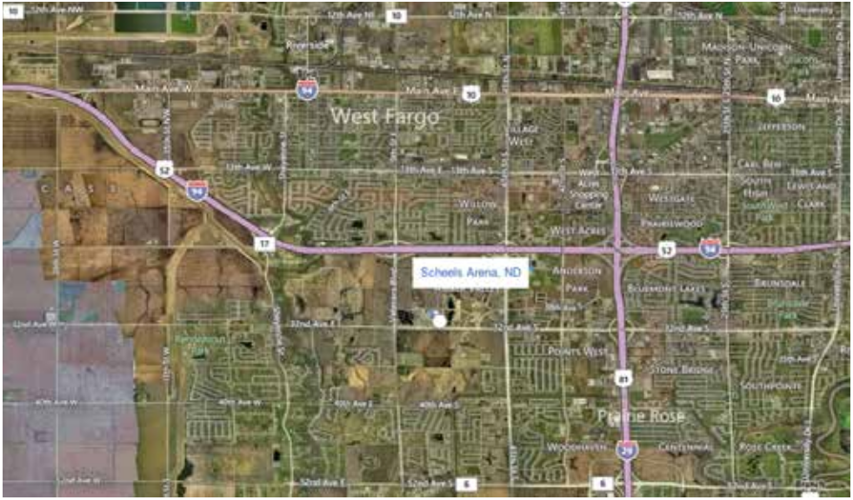
4. Turn left on 30th Ave S and arrive at destination on right.
Travelling from the south

1. Drive north on I-29 and take exit 62 for 32nd Ave S

2. Turn left on 32nd Ave S and travel 1.5 miles

3. Turn right on 51st St S and travel .2 miles

4. Turn left on 30th Ave S and arrive at destination on right.
Travelling from the east

1. Drive west on I-94 and take exit 349A for I-29 south.

2. Travel 1 mile and take exit 62 for 32nd Ave S.

3. Turn right on 32nd Ave South and travel 1.5 miles.

4. Turn right on 51st St S and travel .2 miles.

5. Turn left on 30th Ave S and arrive at destination on right.
Travelling from the west

1. Drive east on I-94 and take exit 347 for Veterans Blvd.

2. Turn right and travel 1 mile to 32nd Ave S.

3. Turn left on 32nd Ave South and travel .6 miles.

4. Turn left on 51st St S and travel .2 miles.

5. Turn left on 30th Ave S and arrive at destination on right.

