Baseball Fundamental Cheat Sheet
These are some basic things to look for when teaching the fundamentals of youth baseball.
Ready Position for Fielding
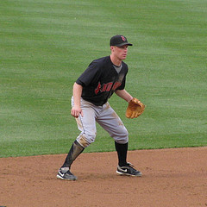 | - This is a good ready position. Players should be in this position as the pitch is delivered to the plate.  - Slight bend in the knees (Not really low).  - Kids can move right or left from this position.  - Player should be on his toes a little bit. Ready to move.  - Hands are relaxed and ready to move.

Fielding Position
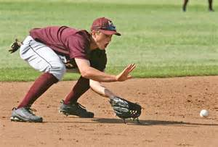 | - This is a good fielding position for receiving a ground ball.  - Back is flat.  - Hands are out away from the body.  - Hands form an “alligator mouth”  - Bend at the knees, not the back.  - Eyes are watching the ball come into the glove.  - Glove is on the ground. A fielder should field the ball from the ground up. They should not stab down at the ball. Get the glove down early.

Hitting Stance
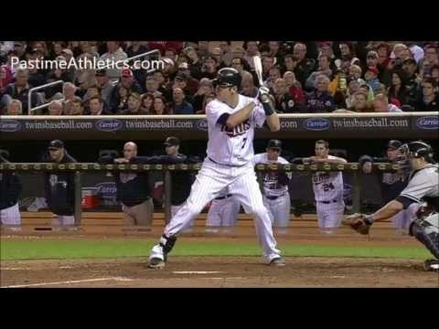 | - Joe Mauer has a very good stance.  - Hands are just up off the shoulder. The barrel of the bat is not wrapped around his head.  - His head it turned towards the pitcher and his eyes are level.  - Slight bend in your knees  - Feet are a little wider than should width.  - Elbows are hanging down in a strong position (back elbow is not up)

Hitting Contact
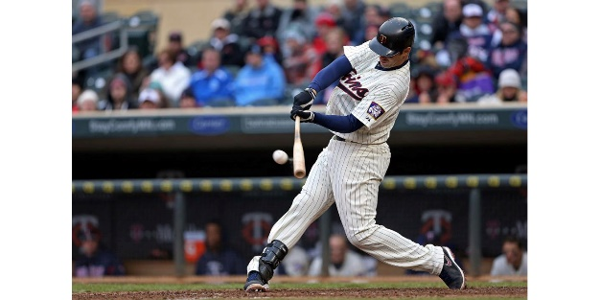  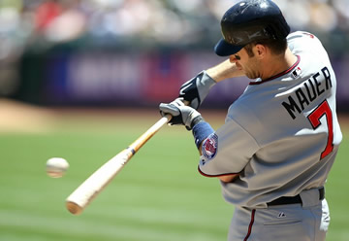 | - This is a good contact position.  - Good Balance  - Pivot on the back foot  - Top Palm is up, Bottom Palm is down  - Bat is flat through the hitting zone.  - Head is down and eyes are on the ball  - Bottom picture is a good example of where the elbow should be. Close to the body to create a short swing.

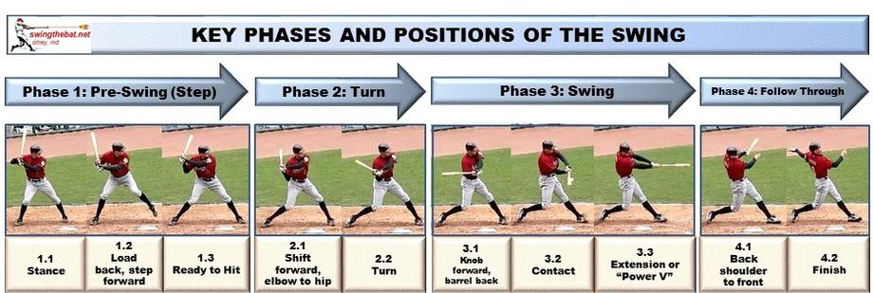

Throwing
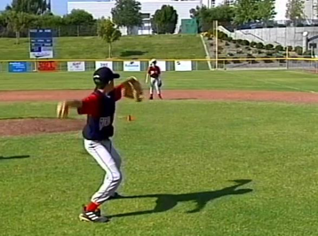 | - When throwing a baseball from any position we want our glove side shoulder to pointed at our target (your feet should look like you are standing on a skateboard)  - Once you have your shoulder at your target you should break your hands so you look like a T. (Like the picture on the left)

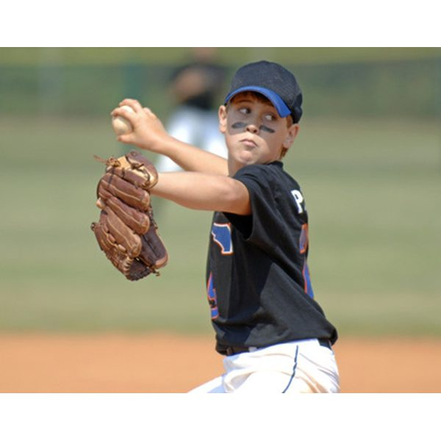  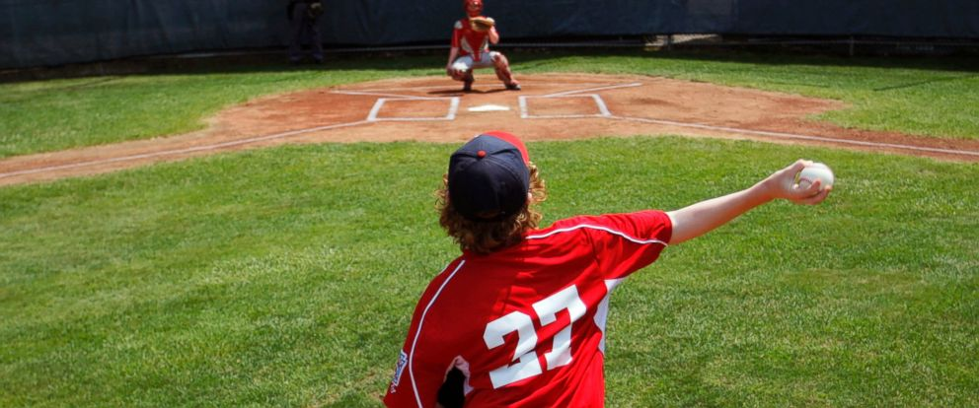 | - When you go back to throw you want your fingers on top of the baseball and your thumb below.  - Top Picture on the left is good.  - You DO NOT want your fingers below the baseball. Bottom picture on the left is not what we want.

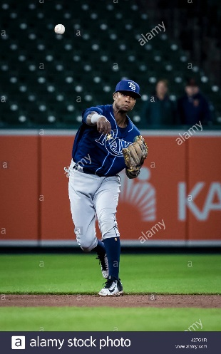 | - After we throw we want to make sure we follow through across our body by our opposite hip.

Pitching
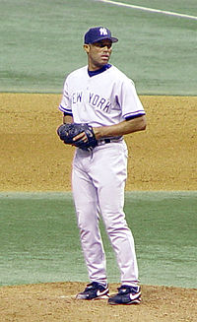 | 1. At a young age, we like to start all pitchers from the stretch. Picture on the left is good place for all pitchers to start.
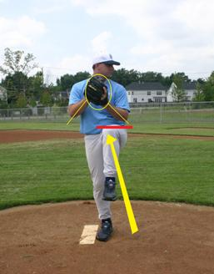 | - Once the pitcher is set they should bring their knee up to parallel with the ground. Their toe should be pointed to the ground.  - Back should be straight, maybe a little forward bend. DO NOT LEAN BACK.
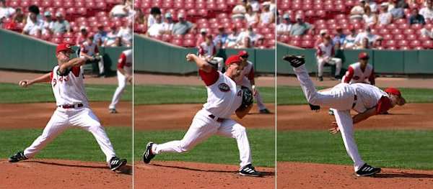 | - Once the pitcher delivers the pith to the plate make sure they come forward and pick up the back leg. Many young kids do not move the body forward. The pictures on the left show a good sequence of using the whole body.  - The first picture shows a good positon with the front elbow pointed towards home plate.

