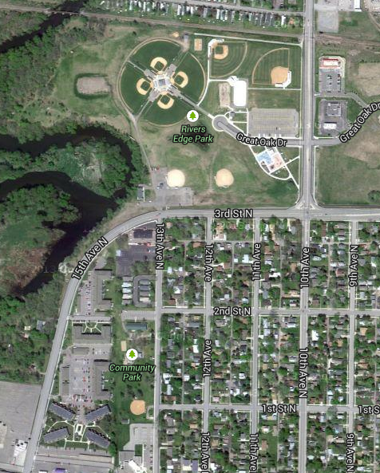
Rivers Edge 1
Miller Builders
Rivers Edge 2
Pepsi
Miller Carlin
Anderson Trucking
Rivers Edge 3
Darrell Rapp
City Park
River’s Edge Park (Main Complex) in Waite Park, MN – Great Oak Drive
- Corner of 3rd Street No & CR138 (or 10th / 54th Ave No)
- 60’ to 70’ bases (46’ to 50’ portable mounds), covered dugouts, grass infield, 220’ fences
- These fields are used for our softball program and 6 to 12 year old baseball programs

