2018 Player Letter of Intent
Invitational Tournament and All Stars

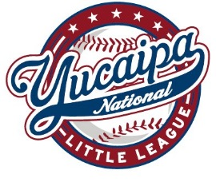

Dear YVNLL Board of Directors:

I, , would like to be considered for a 2018 Invitational Tournament or All Star player position.

I played in the Division,

on the Team.

My complete date of birth is .
I will arrange my schedule to be available for the duration of the tournament. Practices may begin as early as June 1st and the tournament may run through the end of July, possibly later. I understand that these teams require a full-time commitment from both my parent(s) and me. If for any reason I am unable to fulfill my commitment or I miss practices, I may only play the minimum required play time or be removed from the team to allow another player the opportunity to play. I understand that there will be an approximate fee of $85 for uniform expenses. I understand that some divisions will be required to travel to other cities for games and that I am completely responsible for those expenses. I also understand that if for any reason I do not meet the obligations of the all-star commitment; my parents/guardians will be held responsible for reimbursing YVNLL all costs incurred for my play on a team.

Sincerely,

Player Signature:

Parent Name:

Parent Signature:

Date:

This Letter of Intent must be returned to the President no later than 5/18/2018.

