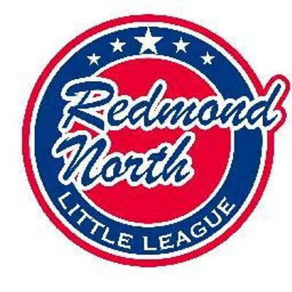

May 14, 2018 Meeting Minutes
Attendees:
Alec Weintraub
Bill Bieber
Jorge Novillo
Kathy Duncan
Elaine Gunn
Josh Sattler
Scott Miller
Meghan Dosch
James McBain
Steve Murawski
Ellen Reed
John Kim

Initial Business

President, Alec Weintraub, requested updates from all committee members. He began by offering the board the following updates:
- Drawings for batting cage facility will be done this week
- He requested a vote on All-Star Managers, noting that there is only 1 candidate for each division; the entire Board voted yes; All-Star coordinators are in place, they will help with uniform orders to start; stated that we are hoping by Friday that all commitments are received so that uniforms can be ordered this weekend; Stated that decision cannot be announced until June 1st so if we have any information, it needs to kept under wraps and not shared with players to avoid leakage
- D9 has asked us to buy a $500 ad in D9 All-Star program; Board agreed to request; Alec stated that we need help with putting together a copy edit; Meghan will reach out Dick’s to see if they want their logo & Alec will reach out to JD for advertising with our credits.
- Stated that RNLL is hosting the All-Star Tournament for 11s on June 30th-July 4th and that we need to do a few things including stretching the fences and tie them up. Discussion arose about this being an opportunity to buy new fences since they are hammered. James offered to find out where we bought them and Alec will check on costs. He also noted that signs for fields 1 & 2 are needed, and he will connect with King County to get some honey buckets for event. Also, he stated that we have tables and PAs that work, and that JR scoreboard is working but touchy. Finally, Red-West orders shirts and metals for tournament so that is taken care of.
- Stressed Board recruiting for 2019. He ask Board members that as they are going to games, talk to people, see what we you can do to recruit. Ideally, recruiting should be figured out before All-Stars. Also, he stated that if you have a current position and you want to stay, that is fine and if not, talk to see if someone will step into the role.
- He suggested surveys be sent out earlier in year and solicit comments about the coaches and even coaches from other teams. The Board discussed current questions and Jorge will edit questions and send to us for our review.

Vice-President, Bill Bieber provided an update on JR Tournament. It went great. He received very positive feedback and Coast families were very happy; kids enjoyed the games and the food worked out great; Next year is was suggested to shorten Coast day down a bit and Board agreed.

Safety Plan Update

Safety Officer, Scott Miller stated that there were no new volunteer requests. There was one incident regarding one Majors player who sustained a serious injury. He stated he was surprised that LL is not requiring flaps for helmets. Alec said he is looking at that for All-Stars helmets.

Fundraising & Sponsorship Update

Meghan Dosch, Fundraising and Sponsorship Coordinator, had no updates.

Scorekeeping/Player Agent Update

Ellen Reed, Player Agent/Scorekeeping provided an update on Mariners tickets. She ordered 400 and originally 348 were ordered but due to late orders, she has now sold 384 tickets. The Board discussed what to do with the remaining tickets, and Ellen suggested that the extra tickets could be given to those with financial hardships. The Board agreed. She noted a scheduling problem with call-ups to AAA. When Wilder has their 5th grade trip, there are problems with AAA players being available. It was decided that this date will be checked on next year to avoid scheduling problems. She also stated that there were a couple of AAA teams that are hanging flags on inside of the fence and noted that it can be distracting to fielders and in dugout. Alec suggested she send a friendly reminder email to managers to post items in the outside of fence. Alec also stated that a general email needs to go out to managers about scorekeeping requirements due to some issues. Ellen will send out to all managers at all levels reiterating all requirements.

Chief Umpire Update

John Kim, Chief Umpire, will get final games on Arbiter to see if we can get our umps for our tournament game and he will put together a plan. Three incidents have come up with UNW. Alec will provide an update to UNW and a friendly reminder for some improvements to avoid future incidents.

Training Update

Kathy Duncan, Training Coordinator,discussed All-Star Manager training and stated that all three managers plus assistants need training. Discussion arose among the Board about the training. It was suggested that training not be generic but focused on All-Star with perhaps ½ discussion on ump perspective (perhaps Jeff could provide this) and rest of time can talk about strategy, as a more casual approach. The Board believes the training will get more value with an open discussion than have someone speak to them. The date of May 31st was suggested perhaps or managers can work together on a mutually agreed upon date.

Web Update

Jorge Novillo, Information Officer/Webmaster stated that website went down for three days and stated that he had some complaints from AAA as games were disappearing from Game Changer. He called Game Changer and found out that someone apparently had deleted them, and it was determined that the deletions were due to a coach who did it by accident. He will highlight RCT in newsletter again and perhaps add a link to a website that has more info about RCT format, rules, etc.

Miscellaneous
- Alec wanted a check on Microsoft employee volunteer submissions. Jorge will send a reminder about this to everyone.
- There is a need to fine tune RCT rules, and a general note needs to go about rules to managers. Alec will send out a reminder email.

Next Meeting

- June 11, 2018, 7:00PM @Ixtapa

