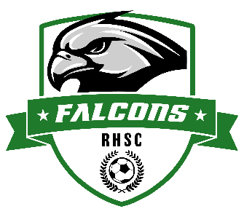

**Rush-Henrietta Falcons Soccer Club**

**Fall Saturday Morning Clinics**

Players born in 2013-2019 come join us for FREE Saturday Morning Soccer Clinics!

**This program is open to all players!**

**If your child has played for our Travel or Recreation programs, or has not played before, these sessions are tailored to a variety of ages and skillsets.**

**WHO:** Players born in 2013-2019

**WHEN:** 8/9, 8/16, 8/23, 9/6, 9/13, 9/20, 9/27, 10/4, 10/11, 10/18 (10 weeks total)

* **Session 1:** 9am - 10am for players born in 2016-2019 (U8-U10)
* **Session 2:** 10:30am - 11:45am for players born in 2013-2015 (U11-U13)

**WHERE:** Martin Road Park Field #7 (Parking available in the front parking lot)

**HOW:** Come ready to play with cleats, ball (size 4), shinguards, and water bottle

**Please register by going to rhsoccer.org, select the Registration tab, and choose the Saturday Morning Clinics registration.**

https://registration.teamsnap.com/form/33514

For any questions or concerns, please contact the RHSC Directors of Coaching at [DOC@rhsoccer.org](mailto:DOC@rhsoccer.org)