Dear Participant of our YOSA Sports Exchange Program,

NETS OF HOPE: MONAI, Open arms, Open hearts!

The purpose of this program is to assist The Alliance of the Americas-YOSA in its missions to provide quality of instruction for talented young people from across the Americas to participate in the Volleyball International Program (V. I. P.) during the spring, summer and/or fall. All members of our program must register and login at [www.partners.net](http://www.partners.net) and fill out the volunteer/waiver form of YOSA. <http://www.partners.net/individuals>

As a host family, the volunteers agree to provide meals, a decent room and a family environment for the Alliance YOSA international athletes for a period that best fits the needs of the family. The itinerary and schedule of activities of international students is set by YOSA and it is very flexible. For the most part, student-athletes will attend English classes, or go to high school in the mornings, or even practice in specific sites such as at the Northside Aztlan Center, or at the CSU Recreational Center, or at the Summitview Church, or at the Blevins Middle School. All students have health insurance, speak English at the intermediate level and are very independent. On the Sundays or Saturdays that YOSA has no previously scheduled activities, the families can make arrangements to visit educational sites or to organize safe field trips with their hostess. Overall all international students are assigned to be members of the U18 boys and girls team of YOSA and as such the girls will have games every other Sunday at various cities in Colorado and the boys will have their tournaments on Saturdays.

Your assistance and desire to host our student-athletes is greatly appreciated. Hosting or being hosted is a special privilege! As members of Partners of the Americas, YOSA has developed several exchange programs that have been a success in Colorado, U.S. Virgin Islands, as well as in Brazil.

The development of a long-term friendship is a true miracle! We are all brothers and sisters!

We hope that when you write your profile you understand that in life, first impressions are a result of an heart, open arms and hope homes! Hosting embrace the art of openness, the courage to help others thus it is an act of love! Thanks for participating in our YOSA NETS OF HOPE, Summer Camps and in our International Sports Exchange program. We need to host 8 people! Three girls and three boys and two adults will need your support. We will provide transportation to practices and games!

Sincerely,



Dr. Gylton B. Da Matta – Alliance YOSA President and NETS OF HOPE Founder

Hi we are the members of the Alliance YOSA V.I.P 2019 (Volleyball International Program 2019)

My Family: Daniel Isernhagen (Middle Blocker)

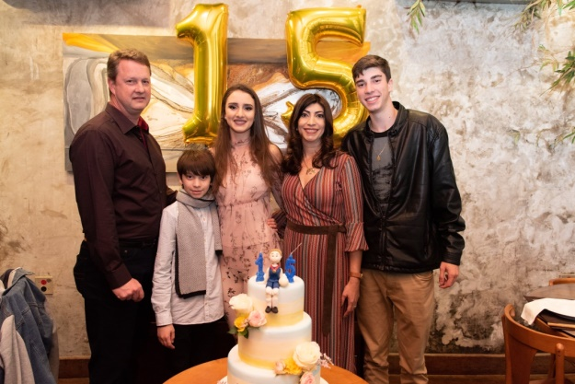******

*June 2018- Birthday of my sister Yasmin. Daniel is coming to YOSA from January through April 2019.*

***Carlos Isernhagen:*** My Dad 47, he is agronomist engineer. My father played volleyball when he was a teenager and inspires me.

***Simeia Isernhagen:*** My mom is also 47, she is pharmacist and supports me a lot.

***Yasmin Isernhagen:*** My Sister she is 15 and play volleyball like me, but in a different club.

***George Isernhagen:*** My brother he is 10, He´s starting to play like him and is planning to come to YOSA in three years.



Coach Danilo Arruda – FIVB Coach & Instructor Level International III

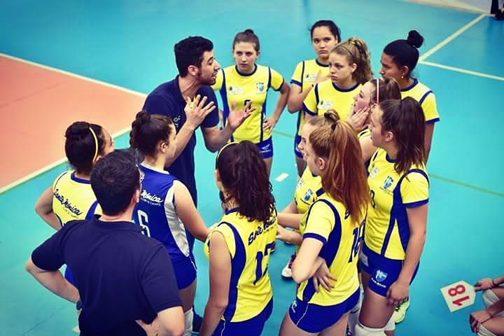 My name is Danilo Arruda and I’m 26 years old. I’m Brazilian and live in Curitiba, the capital of the state of Paraná in the south region of Brazil. I’m coach of volleyball since 2010 and choose this field because I was a volleyball athlete and ever liked any kind of sports and competition and because this I decided to do a college of Physical Education. But most important, I really decided to have this career as my profession, because I was really falling in love with all the aspects in being a Coach. You must be a psychologist, manager, counselor, and beyond of the technical/tactical/physical aspects, you must, to deal with the parents, group issues, and this is another very difficult task, and because of all that I choose to be coach, how harder is, better is for my own improvement.

*Tiago Ethan, Sauro, Erica and His Sister live in Belo Horizonte which stands for Beautiful Horizon, can you see why?*

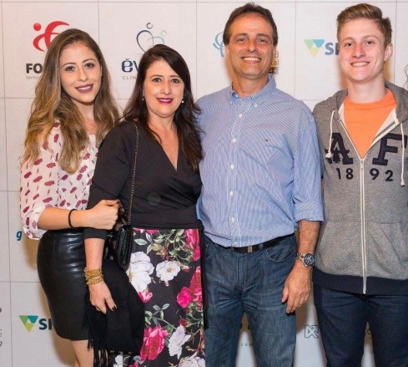 

*Tiago Ethan, is joining YOSA Boys team in 2019. Tiago is a hitter and loves setting as well.*

*Matheus Carvalho Franca, Alessandra Lo Russo, Roberto Lo Russo (played volleyball with Dr. Da Matta from 1983-1986) and his sister. Matheus has been the MVP of the Brazilian National Championship – Copa Minas for two consecutive years. Matheus attended the Alliance YOSA program in 2018 and now is returning as team Captain and Senior.*

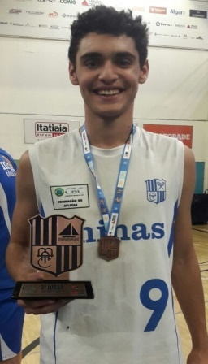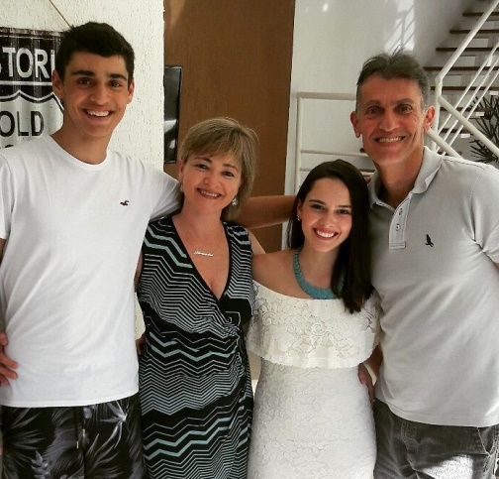

*Ronaldo Calleia, Gabriela and Camila Calleia*

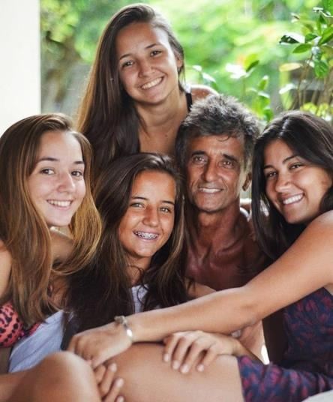 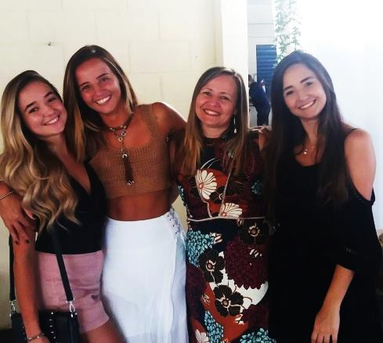 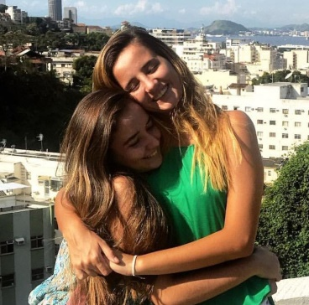

*Camila (studying Law and International Business) and Gabriela Calleia (OH – Senior HS) will join YOSA in 2019. The father, Mr. Ronaldo Calleia, teaches Math, Physics and Sciences in Brazilian High Schools. They live in Araruama, Rio de Janeiro, Brazil.*

*Lucas, Guilherme and Family (Lucas is three-time Brazilian National Champion in Volleyball - YOSA Rio Partner*

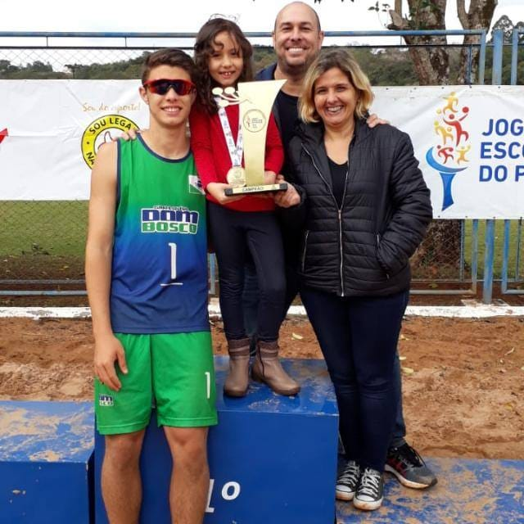 

*Guilherme (father) works at Fundacao Getulio Vargas and his son Lucas Sampaio is joining YOSA Boys team in 2019.*

*Monica, Rodrigo and Family - YOSA Rio Partner*

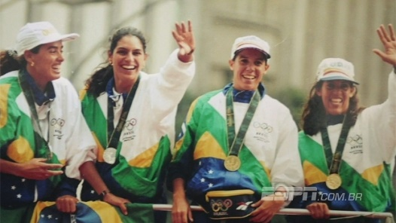 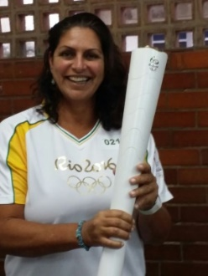 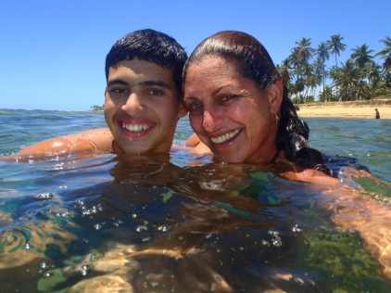

*Adriana and Gabriela Figueiredo _ YOSA Guarapari Partner*

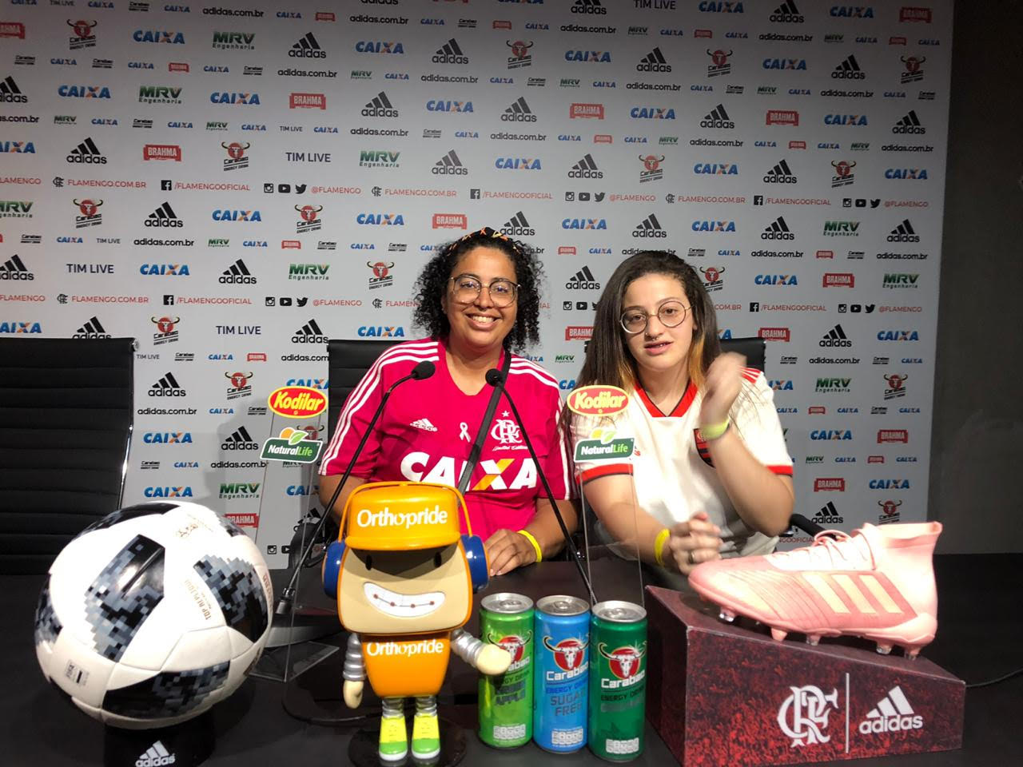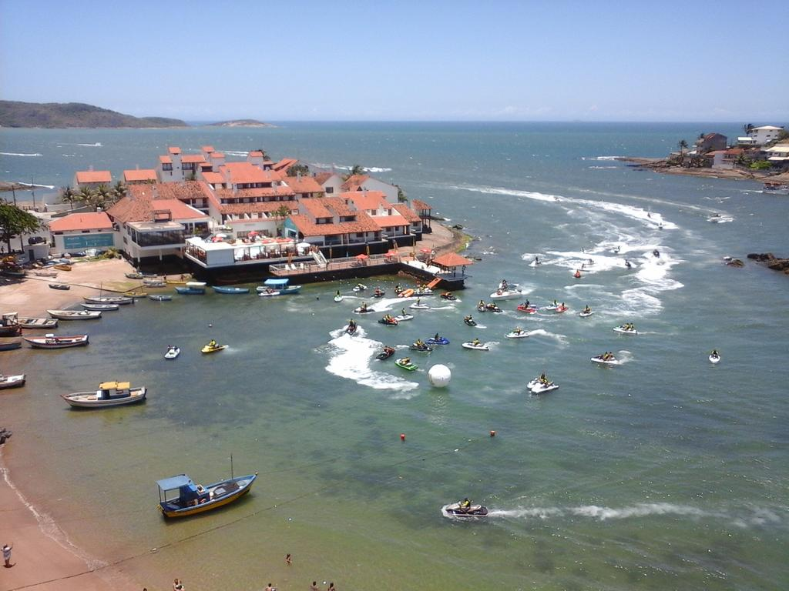

Kalme & Kalina – YOSA Rio Partners: Kalme is a top volleyball player in Brazil. She is a middle blocker and right side. She joins YOSA and hopes to earn a scholarship in a Division I volleyball program. Kalme plays all around and will also play Beach Volleyball at YOSA.

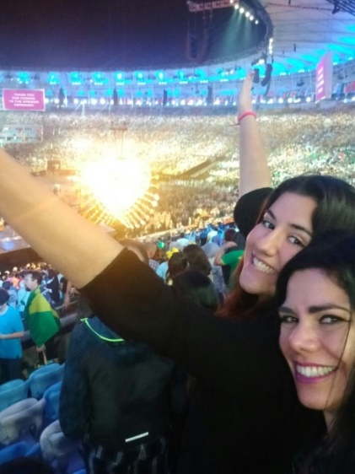 

YOSA Rio 2019 – Our official Partners in Brazil

  

This is Rio de Janeiro Brazil, where YOSA has more than 12 families who are affiliated to Partners of the Americas. Now an Olympic City, Rio de Janeiro is also the site where the national team of Brazil practices soccer and volleyball. Alliance YOSA has done five study abroad programs in Rio to visit the Olympic sites, Olympic training centers, the Brazilian Soccer Development Center and the Brazilian Volleyball Development Center, in Saquarema, Rio, Brazil.

**

YOSA Araruama, Camila & Gabriela Calleia, Rio de Janeiro, Brazil.

“Don’t forget to show hospitality to strangers, for some who have done this have entertained angels without realizing it!”



**Name: Natalia Andrea Ospino Castro**

**Date of birth: April 26, 2002**

**Height: 1’75 cm**

**Phone: (+57) 316 2711520**

**E-mail: nataliia.ospiino@gmail.com**

Hello my name is Natalia Ospino I am 16 years old, I live in Bogota Colombia with my father, my mother and my dog. At home we always collaborate with each other and the trust, love and respect are fundamental values for us. I like to say that I live in a hospital because my father is a doctor and my mother is a nurse, but I really love this because they always take care of me. I have studied all my life in “La Enseñanza” School, and it has grown to become a really special place for me, due to all the teachings and experiences that I have had, such as the importance of being responsible, committed, disciplined, and the value of friendship and family. I play for the National Team of Colombia for two years and I cannot wait to train with the coaches at YOSA!

Laura Camila Espejo

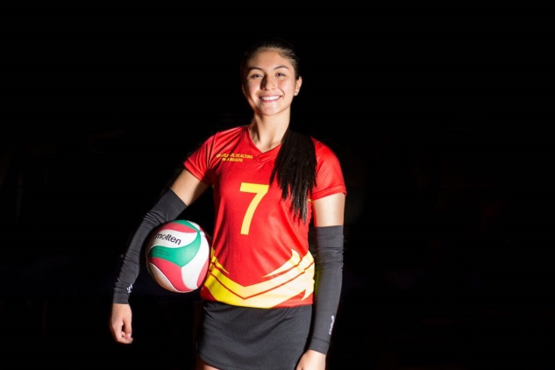 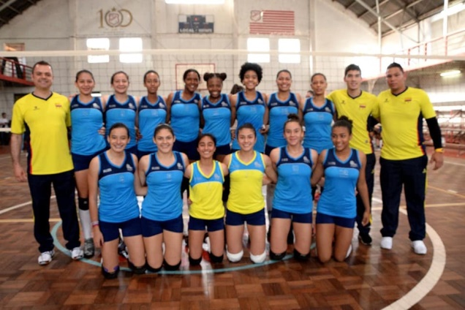

* My name is Camila Espejo, I am 16 years old, I live in Bogota, Colombia, I am in the last year of the schooI, I have been always studied in the same school, it is called Rosario Santo Domingo. That is the place where I started to play volleyball when I was 9 years old, also since that age I have played in the Bogota´s league and since the last year I am part of the Nacional team and now I am a permanent member of the Olympic National Training Volleyball program of Colombia. Being in the Colombia selection has given me unforgettable experiences that has marked my life tremendously because I have been able to know different cultures, travelled to different countries such as China, Israel, Europe etc. I have also made lots of friends and learnt new things in my life! I want to play at YOSA where my sister played last year and she absolutely loved it! We have been playing volleyball and training with coaches from all over the world and we think that the coaches of YOSA are our favorite people because they are so knowledgeable, humble and so kind to all athletes! My sister and I hope to coach at YOSA someday!

“In my Father’s house are many rooms, I go to prepare room for you.”

HOME STAY – FAMILY FACT SHEET – We like to introduce our families to the families of exchange students so they can feel the assurance that our program is friendly and safe. For instance, we write our names, add a picture and briefly introduce ourselves.

Who: Hi We are the Da Matta’s

Names: Gylton, Louise and Alex

Picture:

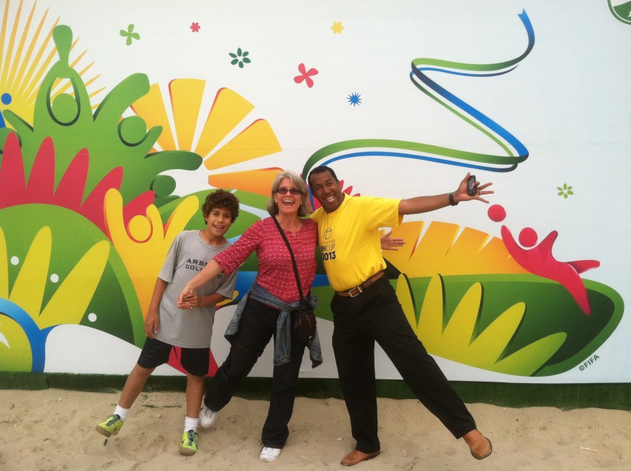

What do we do:

Hi my name is Gylton Da Matta, I am the Director of the Youth Sports Academy. I teach Qualitative Research Methods at Colorado State University and coach volleyball as well as supervise all aspects of YOSA for our homeschool programs, school of sports programs and competitive clubs. I also consult for FIVB as a technical evaluator. We (Da Matta’s) live in Fort Collins since 2009. Louise Jennings is my wife. She is a professor at the Colorado State University, School of Education. Louise graduated from the University of Harvard and from the University of California in Santa Barbara, where she has many friends whom support YOSA significantly. And Alex Da Matta, our son, attends school at Poudre High School and also attended at Lesher Middle School in Fort Collins, CO. He loves playing soccer, volleyball and saxophone. We have hosted more than 18 friends from Brazil since 2002. We love Brazil and we are looking forward meeting our friends from Minas Tennis Clube. I love cooking, dancing and I enjoy a great moment by just looking at nature and admiring the creation of God!

At YOSA…Somos todos irmaos! At YOSA…we are all brothers and sisters!

Contact: Dr. Gylton Da Matta [gdamatta7@gmail.com](mailto:gdamatta7@gmail.com)

1256 Sunflower Drive Fort Collins, CO 80521 USA skype: Gylton.damatta

1.803.807.0785 Cell 1.970.672.8809 (Home) [allianceyosa@oulook.com](mailto:allianceyosa@oulook.com) (Yosa)

SAMPLE FORM TO BE FILLED BY HOST FAMILIES IN FORT COLLINS

Hi my name is (Name of the Athlete or Person Hosting),

I am a professor at CSU and a volleyball coach at YOSA. My daughter, _____________ plays at YOSA and she looks just like me! I have a call for hosting people and showing them around the Northern Colorado area!

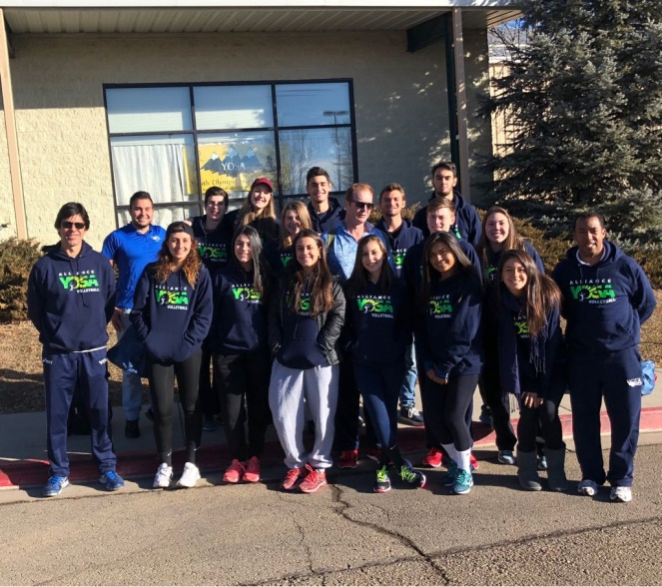

What do we do:

I work tirelessly towards helping many organizations (and also people) to be successful. I volunteer at schools, I go to the Foundations Church and play competitive Tennis and enjoy volleyball a lot. I am married with Mr. Johnson and I have two more children, Patricia and Melanie who also play volleyball at YOSA. I have no preference in hosting boys, girls or young adult members of Alliance YOSA because I think that this program is impacting the lives of hundreds of people not only in Fort Collins, but also in Brazil, Portugal, Spain, Argentina, Chile, Colombia, Peru and in the United States Virgin Islands. I help people! I think that the people from Brazil who came to my home were extraordinary and very talented. I absolutely love them and I am in touch with all of them! I work for almost five non-profit organizations, play tennis, volleyball and enjoy watching American sports! I believe in God and I believe that we are all brothers and sisters across the Americas! Patricia Johnson.

Player: Aubrey Johnson (14 years old); Family: The Johnson’s Address: 1256 Sunflower Drive Fort Collins, CO 80521 E-mail: [allianceyosa@outlook.com](mailto:allianceyosa@outlook.com) Phone Number: _________________

HERE IS ANOTHER HOST FAMILY; FOR INSTANCE, THE DA MATTA’S AND THE ARNETS ARE ACTUALLY HOSTING 5 PEOPLE THIS COMING SEASON.

Hi we are the Arnets! We have hosted more than 8 Brazilians from YOSA and we want to host many more.

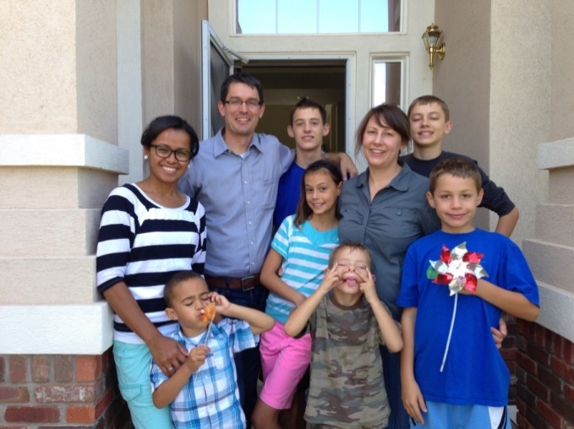

We are the Arnett Family. Dad is Jeff, Mom is Kim, Sam is 17, Adam is 15 (but he will turn 16 on May 23rd!), Grace is 13, Elijah is 11, and Seth is 8. We are a big family! Jeff is an engineer, and Kim takes care of the home and family. All our kids go to Liberty Common School, and our daughter, Grace, loves playing volleyball with YOSA.  We like to ride our bikes, explore new places, spend time with family and friends, and some of us like to read a lot :)  We also love Brazil! Jeff was a missionary for two years in the Sao Paulo/Campinas area. This is a picture of us with some Brazilian friends who visited us last year. We look forward to making some new friends! At YOSA… Somos todos irmaos! At YOSA…we are all brothers and sisters!

Kim Arnett's cell [970-443-4310](tel:970-443-4310) 5840 Huntington Hills Drive Fort Collin, CO 80525 [arnetteight@gmail.com](mailto:arnetteight@gmail.com)

In this page we show previous groups from Latin America who have visited Ft.Collins, CO.

International Volleyball Camps 2015 – Partners of the Americas- YOSA Coaches to Coaches Program at USA Volleyball High Performance Coaches Clinic with USA Head Coach Karch Kiraly.

Below is Coach Ben, Dr. Da Matta, Coach Kiraly, four players from U.S. Team and Coach Raquel Peluci Sidinger (Olympic Bronze Medal in Sidney Australia 2000 Olympic Games). On the right, Dr. Gylton Da Matta gets an official support from Head Coach Kiraly towards NETS OF HOPE INTERNATIONAL and the outreach program Yosa has with the Poudre School District.

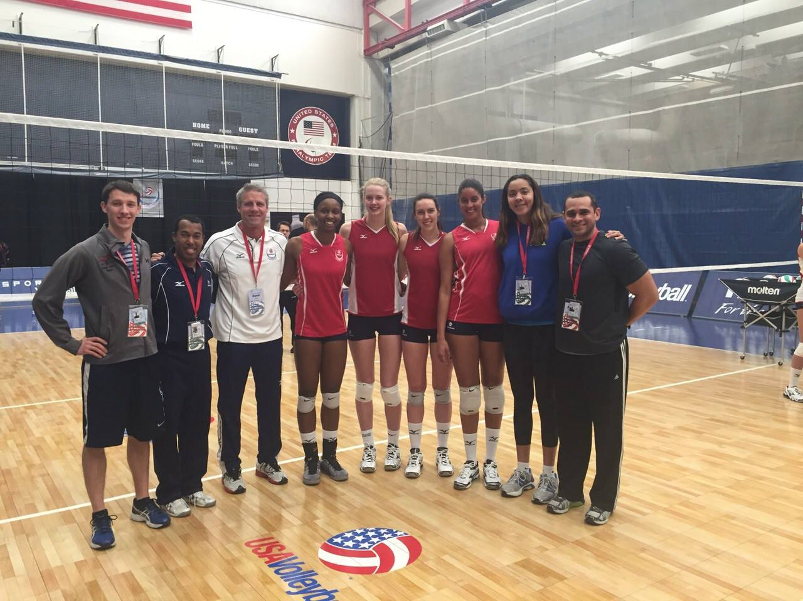 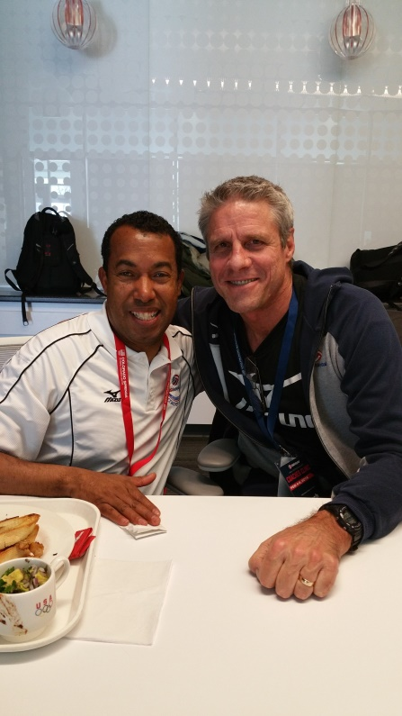

Indoor and Outdoor International Volleyball Camps in Brazil and in Fort Collins, CO.

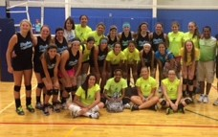 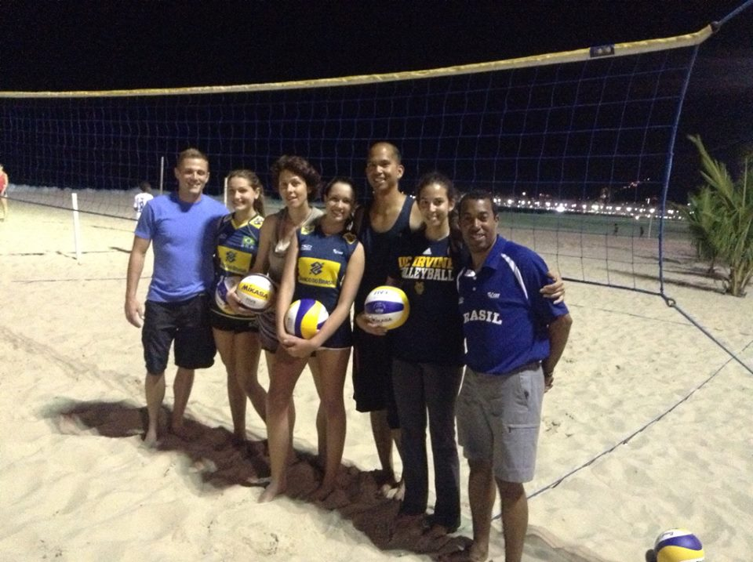

11 volleyball players came in July 2015! Five American coaches visited Rio in 2014!

Minas Tennis Club of Belo Horizonte, Minas Gerais Brazil. 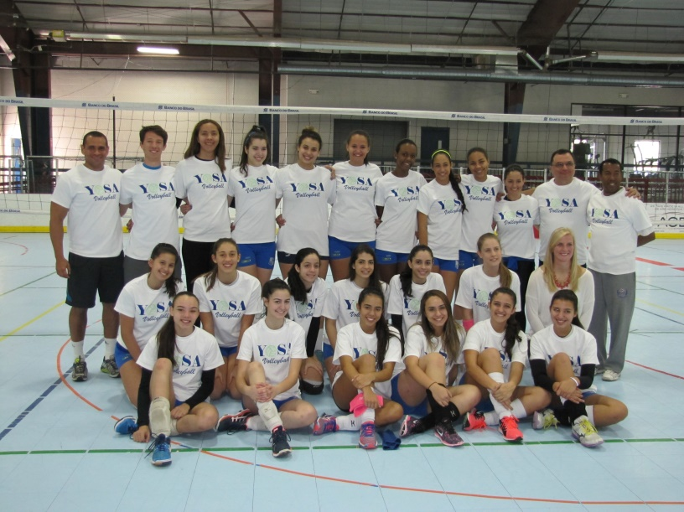

20 volleyball players and three coaches from Minas Tennis Club (Team Great Brittain house during Rio Olympics in 2016), visited YOSA in 2013 for three weeks to train with Dr. Da Matta.

Clube Regatas Flamengo, FlaVolley Summer 2016, U.S. Team House at Rio 2016 Olympic Games.

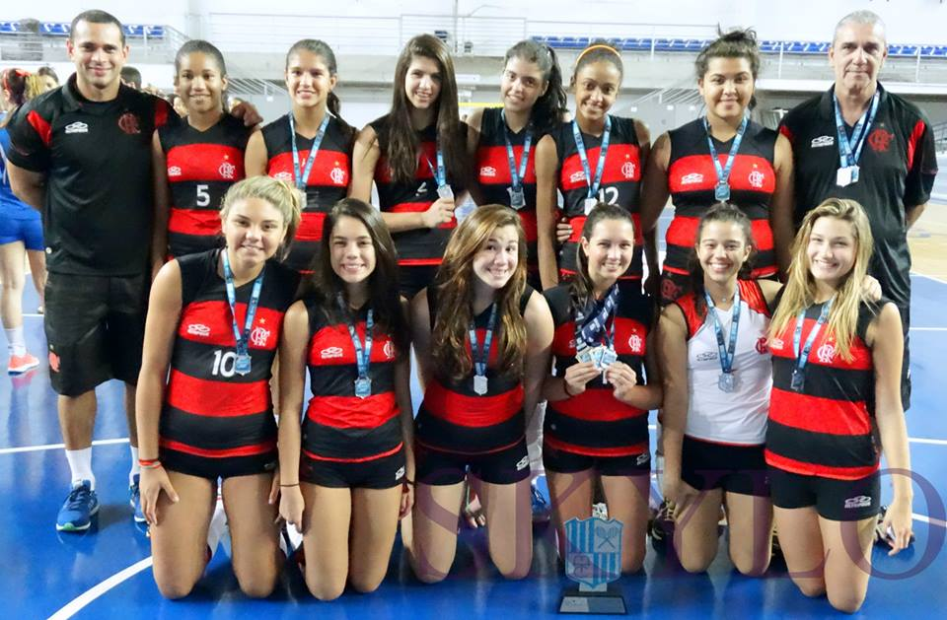 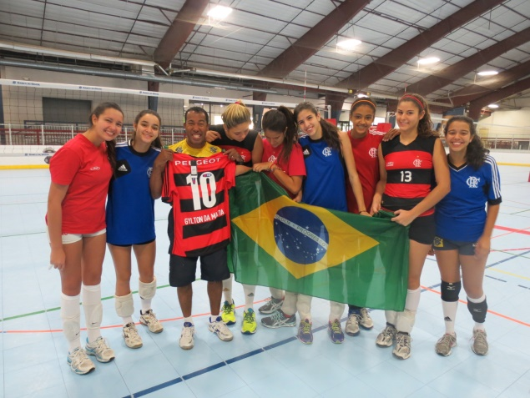

12 Players from Flamengo visited YOSA in 2012 during summer Camps promoted by Dr. Da Matta in Fort Collins.

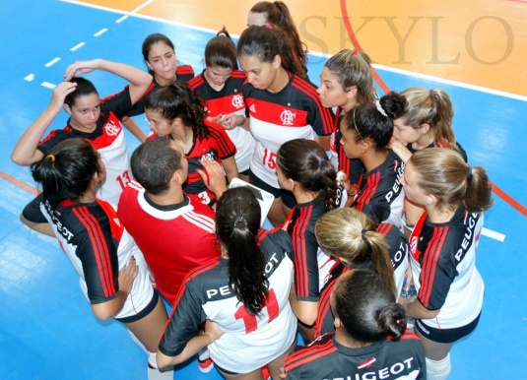 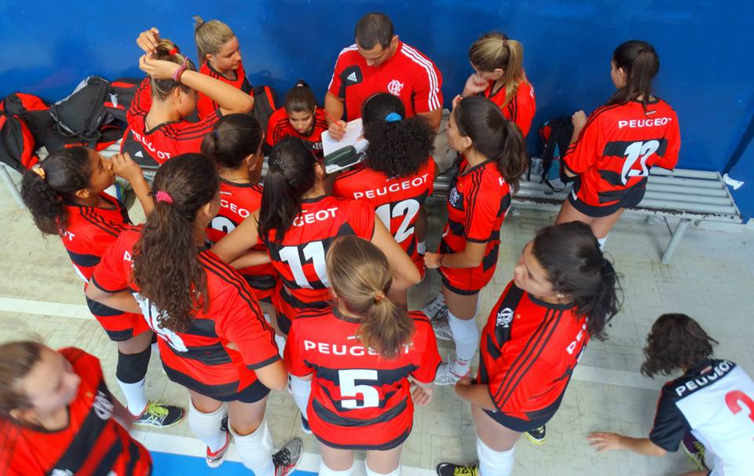

Dr. Da Matta’s YOSA U18 Team of 2017

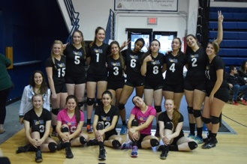

Dr. Da Matta’s U18 Team YOSA 2018 - Fort Collins Boys Runner Up in 2018.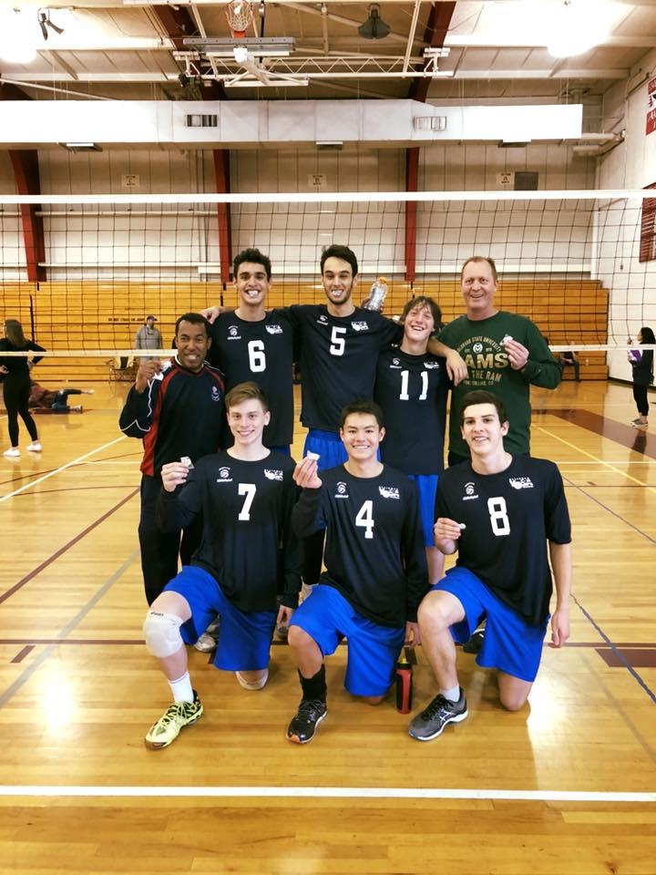 

Dr. Da Matta’s Girls U18 YOSA Team 2018 – Division 2 Champions (Four full scholarships granted).

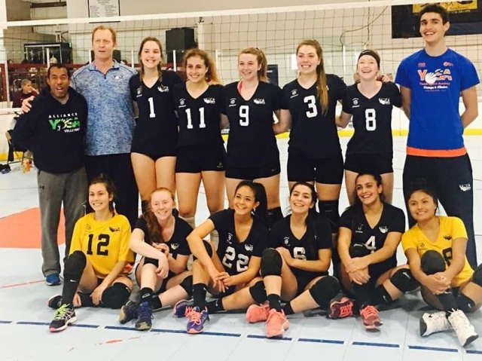

Volleyball International Program with people from Virgin Islands, Peru, Colombia and Brazil.

