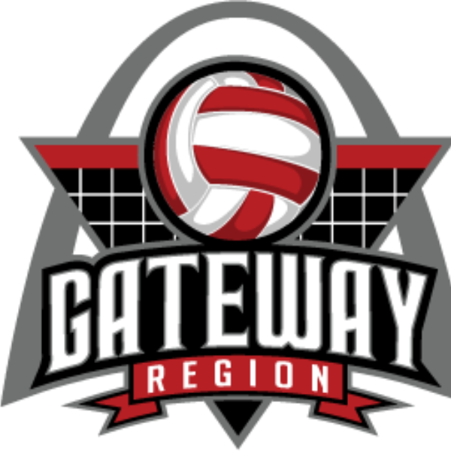
GATEWAY REGION COLLEGE GRANT
APPLICATION FORM

Gateway Region Volleyball is proud to announce the 2nd year of our College Grant Award Program. This is a one time $5,000 Award to 5 high school seniors who will be starting their college volleyball careers.
Eligibility - Nominee must be a senior in high school and a member of a Gateway region club. They must be an incoming member of the college volleyball program which they will be attending. No more than 50% of their financial obligations are being covered by school athletic or academic scholarship awards.
Criteria: Nominee should demonstrate achievements in each of the following areas :
- Academics: Report card and GPA required. Minimum cumulative GPA of 3.25 over entire high school tenure
- Community Service: Must be volunteer service, not a required school activity and when possible an endorsement from someone involved with the program you are involved with
- Athleticism: Must exhibit dedicated, consistent sportsmanship, ability, and attitude.

Timeline: All nominations must be completed and received by March 31st, 2025.

Who chooses recipients?: Gateway Recognitions Committee who will vet each nominee.
Please return the completed application via email to kmattingly.gatewayvb@gmail.com with a Subject line of Gateway College Scholarship Application in the subject line.
Name:
Home Address:

Email address:
Cell Phone: Home Phone:
Education:
Please list high school attended with the pertinent date of graduation and GPA.

Date of
High School Expected Graduation GPA

Volleyball Background:
High School Years of Participation___________________________________________________
Number of Years Club Experience: __________________________________________________

Extracurricular and Community Activities:
Please list any extracurricular, service-learning or community activities in which you have participated.
Organization Dates of Involvement Brief Description

With this application, please attach a copy of the following documents:
- Your résumé (highlighting community service involvement and brief description, educational background, and athletic accomplishments and any references name and email)
- School Aid Package Document Highlighting Amount of Student’s Financial Responsibility
- A 200 word essay on the topic of “What lessons have you learned from volleyball that you feel will be beneficial to future successes not just in the sport but in life?”

