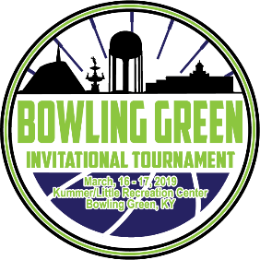

List of Hotels for Bowling Green Invitational Tournament

Hyatt Place Bowling Green
1347 Center St, Bowling Green, KY 42103
(270) 467-0001

Holiday Inn University Plaza
1021 Wilkinson Trace, Bowling Green, KY 42103
(270) 745-0088

Staybridge Suites Bowling Green
680 Campbell Ln, Bowling Green, KY 42101
(270) 904-0480

Hilton Garden Inn Bowling Green
1020 Wilkinson Trace, Bowling Green, KY 42103
(270) 781-6778

Courtyard by Marriott Bowling Green Convention Center
1010 Wilkinson Trace, Bowling Green, KY 42104
(270) 783-8569

The Hotel SYNC
518 Corvette Dr, Bowling Green, KY 42101
(270) 745-0123

Drury Inn Bowling Green
3250 Scottsville Rd, Bowling Green, KY 42104
(270) 842-7100

Country Inn & Suites Bowling Green, KY
535 Wall St, Bowling Green, KY 42104
(270) 781-7200

