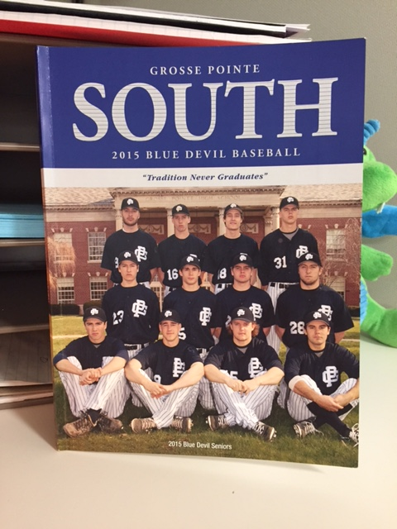
2023 Program Book Advertising
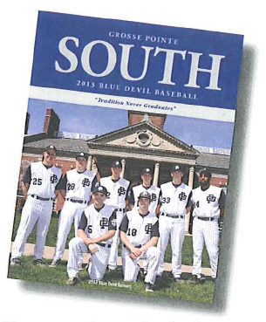

GROSSE POINTE SOUTH DUGOUT CLUB
Supporting Grosse Pointe South Baseball

Sponsorship Information
Advertiser/Company Name:
Contact Name:
Address:
City:
State:
Zip:
Phone Number:
Email Address:
Solicitor:
Program Advertisement (Check One; Ad Size is Width x Height)
❑ Back Cover (7”x 10”) $1,000¹
❑ Team Picture Sponsor (Select Team) $500¹

❑ Varsity  Junior Varsity  Freshman

❑ Inside Front Cover (7.5”x 10”) $750¹
❑ Inside Back Cover (7.5”x 10”) $500¹
❑ Full Page (7.5”x 10”) $300²
❑ Half Page (7.5”x 5”) $150³
❑ Quarter Page (3.75”x 5”) $75
❑ Business Card $40

¹Includes advertisement on front page of GPS Baseball website with link to your company’s website.
²Includes listing on sponsor page of GPS Baseball website with link to your company’s website.
³Includes listing on sponsor page of GPS Baseball website.
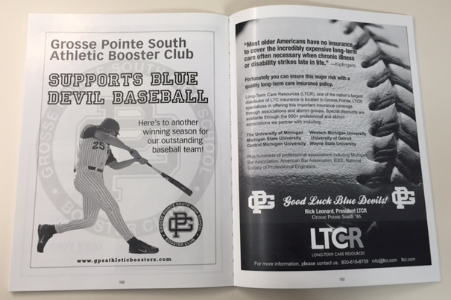
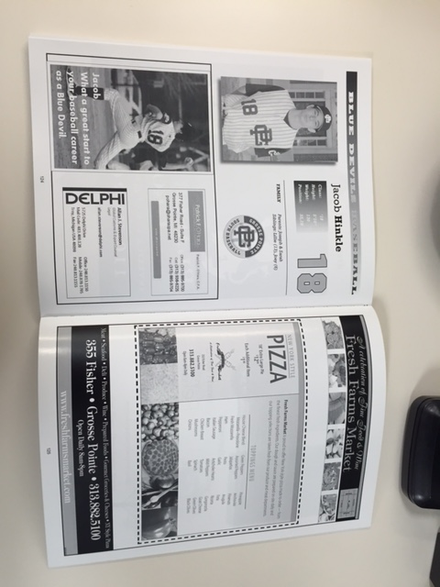
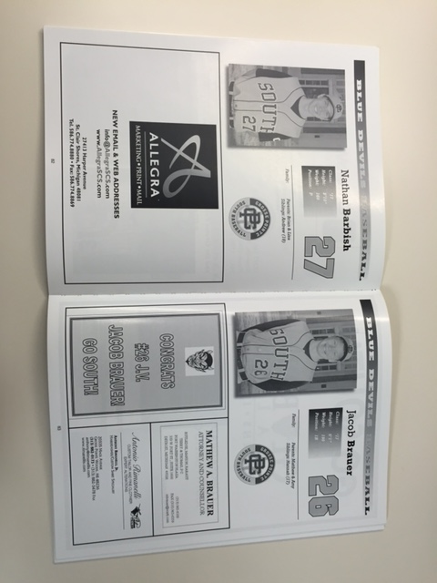
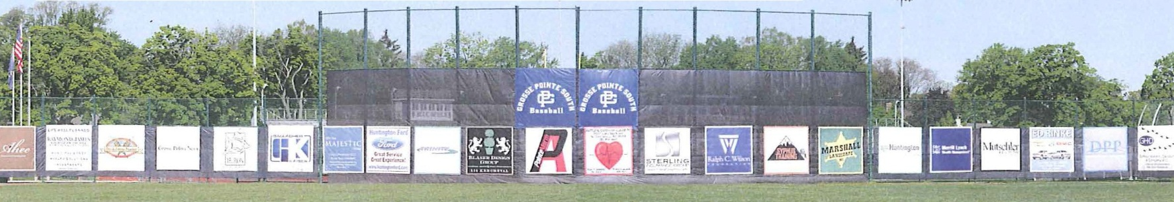
Return this completed agreement with your artwork (pdf files preferred) by May 1st, 2023.
Please send your check made payable to The GPS Dugout Club or Venmo payment to @GrossePointeSouth-DugoutClub

