Phillip O. Berry Academy of Technology
TICKET TO PLAY - GENERAL INFORMATION

All Phillip O. Berry Academy of Technology students trying out for any sport must complete the online registration called “TICKET TO PLAY”. This process is required to be completed prior to the beginning of a sports season. Multi-sport athletes will ONLY need to complete this process once.

Athletic Eligibility will only be available online. The Phillip O. Berry Academy of Technology Athletic Department will not collect any paper documents except for the NCHSAA Medical History and Physical forms. The required NCHSAA Medical History and Physical form can be found under “TICKET TO PLAY” tab on www.cmsathleticzone.com/berry. All other forms must be uploaded to the online portal. Be sure to access the NCHSAA forms from the website to ensure you have the updated information.

To initiate the “Ticket To Play” process, please proceed to the Phillip O. Berry Academy of Technology‘s Athletics website and complete the registration process. This process can ONLY be done online (Paper copies will not be accepted). Please note that a physical is valid for 395 days, and if you have had one within this time frame, that will count. However, you are responsible for getting one before it expires or you run the risk of being ineligible.

You need to upload the residency documents (Column A & Column B) with the online process. These documents must be dated after June 1, 2018. Below is an image that list documents that will be accepted for each column.
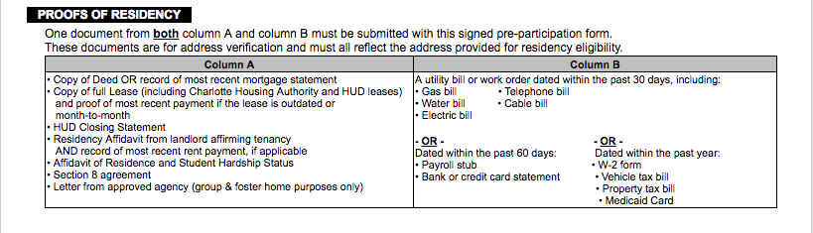

After completing this process, please print a confirmation along with the required NCHSAA forms and turn it into the sports specific coach. This will inform the coach that the student has completed the registration process and is eligible to participate in ANY team activity.

If you have any questions or need assistance with completing the ticket to play, please feel free to contact Mrs. Barnes-Parkins via email at tricia.parkins@cms.k12.nc.us.

