

**NEFC Tournament Series Digital Check-In Procedures**

**Step 1. Login to your team account via** [**www.gotsport.com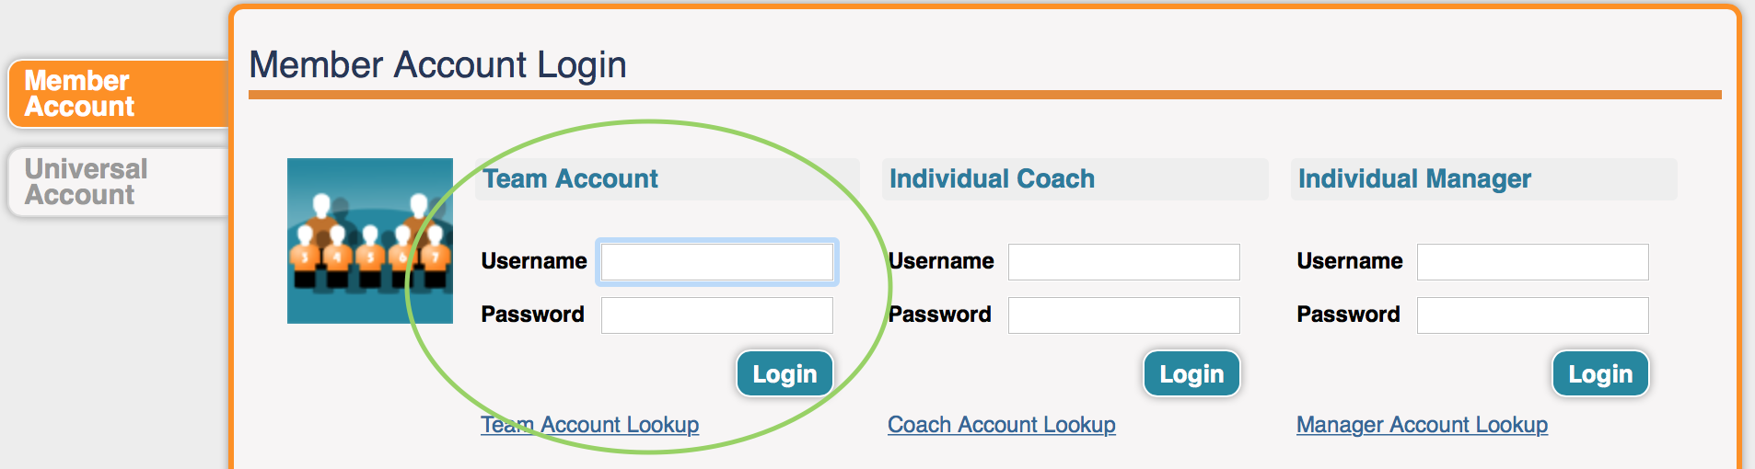**](http://www.gotsport.com)

**Step 2. Select the NEFC Preseason Tournament by clicking on the link in your team account.**

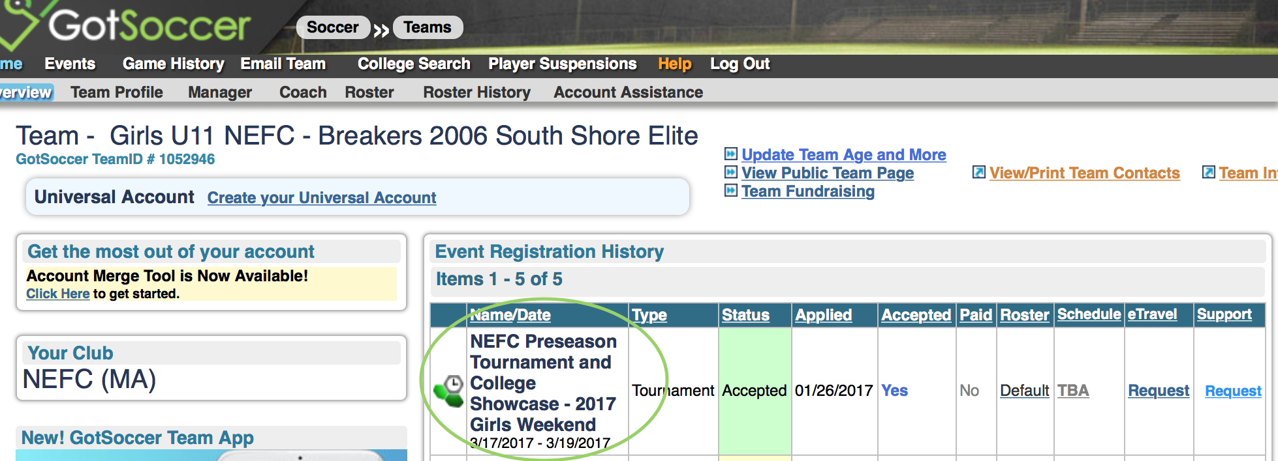

**Step 3. Select the Documents tab by clicking on the tab, Then from the drop down select the appropriate document description you wish to upload.**

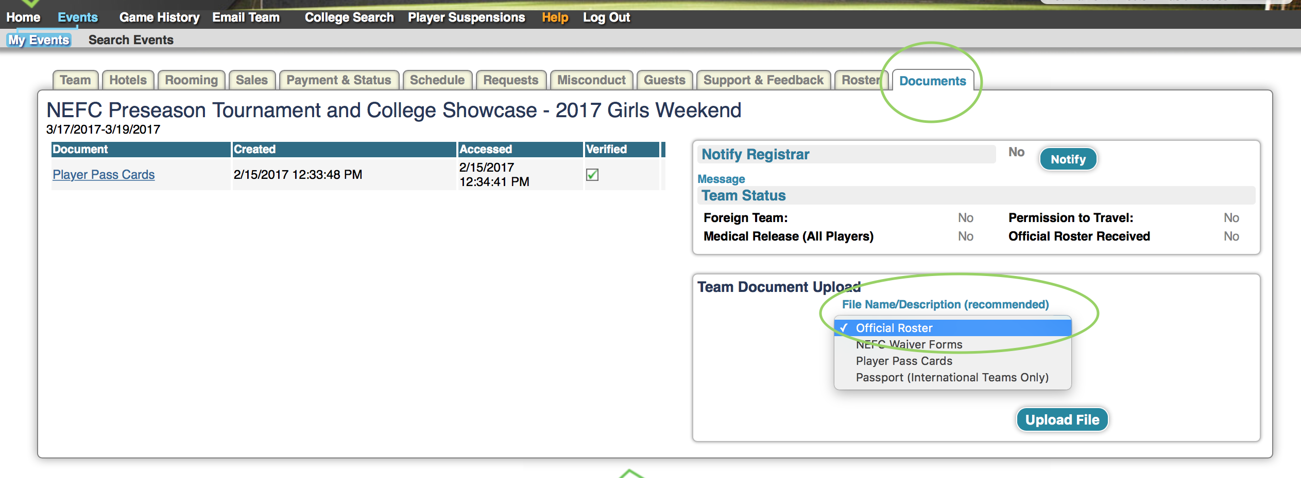

**Step 4. Select file by clicking choose file and selecting the saved file from your computer. Click Upload File to successfully upload the file. You will then see the file added on the left hand side of the window with an orange question mark under verified. This means the file has been uploaded and is waiting for verification by the tournament staff. When the File has been verified you will see the green check mark showing verification complete.**

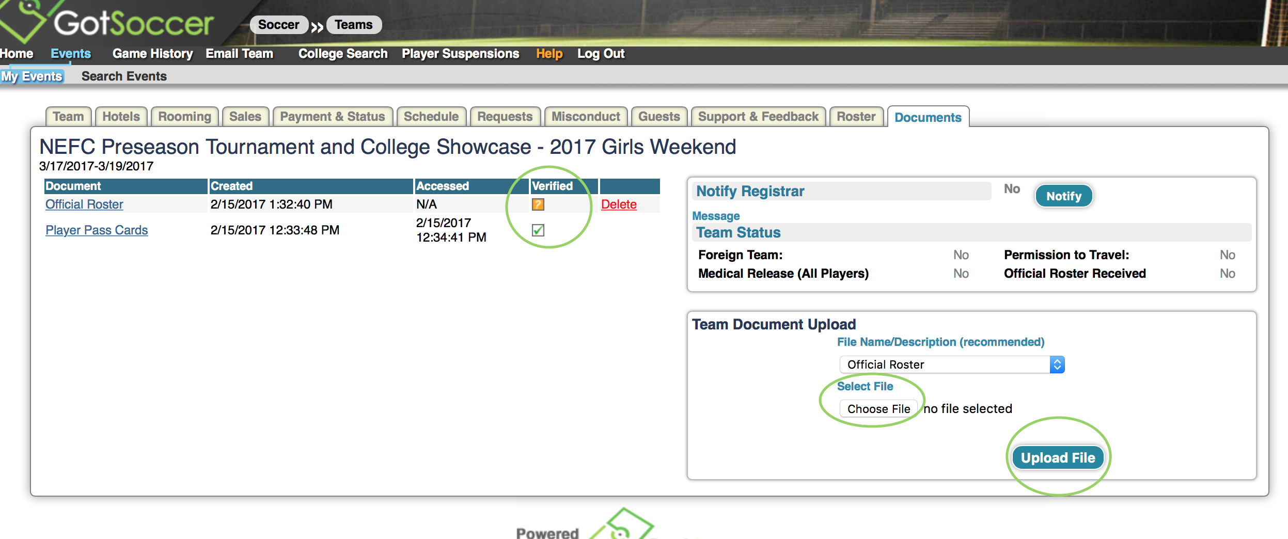

**Step 5. Repeat steps 3 & 4 for each of the appropriate files needed to complete your team’s check-in.**

**Each team will need to upload the following as well as have all items present at the field for the entirety of the tournament.**

1. **Official Roster including all guest players**
2. **Player Cards**
3. **NEFC Waiver Signed and fully completed (Club Waivers not accepted)**
4. **Copy of passports for all players (International Teams Only)**