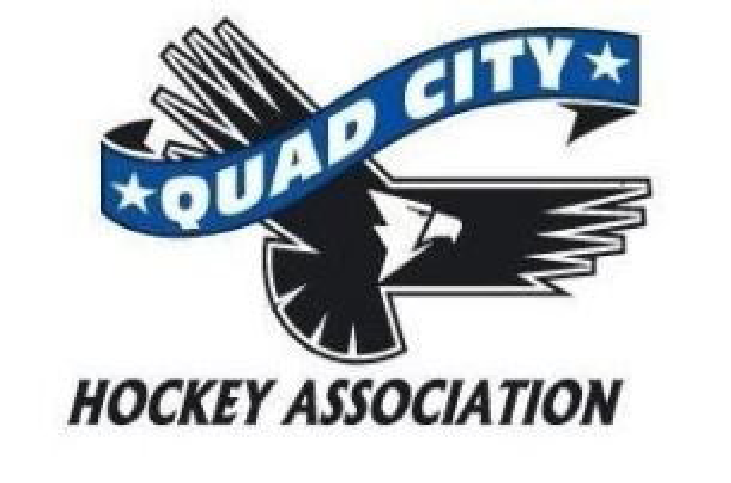
Agenda
Thursday, February 15, 2024
6:00 pm River’s Edge Conference Room

10 min | Call to Order: 1800  Approved Absences – Zach Honert, Kerry Toporowski
45 min | Director Reports  President – Andrew Quinn  - Delay in publishing January meeting minutes until the board can align on proper documentation.  - Request to form 2 committees  - Alcohol policy committee, clarify the stance from our association on its relationship with alcohol including but not limited to its reference in social media, its sale at events hosted by the QCHA, ability to accept sponsorship and use in fundraising.  - Gift Baskets, serving during events, etc  - Megan and Heather note that they would be willing to help  - Goal of this would be to come to a consensus on policy for the QCHA  - Develop a clear policy regarding the use of the QCHA, Blues, and Lady Blues branding including:  - Apparel creation  - Use in social media, clarity around YouTube, Facebook, Instagram, X, and other platforms including content creation and associated comments  - Who is authorized and what the expectations are of those individuals.  - Goal of this would be to  - Question about trademarking comes up and Melody looked into this in 2019 and it was somewhat costly to trademark. There are some other legal protections. Melody notes that apparel would need to be approved by the board.  - Logo usage policy is what is wanted but trademarking is still not the goal at this time.  - Question raised about how to police the policy and who would do this  - Source One is available to allow people to get whatever they wanted logo-ed.  - Squad locker has many more items that can be obtained and runs in parallel with Source One  - Melody states that she will be on this committee  - Safe Sport Update – Blues Coach suspended until March 4 which was 60 days total, 2 other Blues issues are completed by the affiliate, One SafeSport issue also in progress of investigation above the level of the association.  - Member request to serve alcohol at the Blues benefit game – The view by several board members including John Gray as high school director would rather not have alcohol in the rink at all this season. There is consensus amongst the board members that this is wise and will continue to follow the QCHA policy  - New rink Internet – Needed for Point Streak at a minimum. Janna Patten will help get it set up for the end of the season and then there will need to be a more formal plan moving forward for internet access  - Bantam parent concerns about moving to the Blues and Anderw is asking about a meeting with the Bantam families to quell rumor and give information – Hoping to have John Gray and Traci Huskey involved  - Open issues list  - River’s Edge contract – Delinquent at this time, meeting with Ryan Devlin with Andrew, Heather, Megan to work on this. Other members of the city will be present. There have been some discrepancies in rates in the past that are concerning as well as the concerns that there is not an in writing contract  - Need to fill open Safe Sport coordinator position  - Skill sessions  - Audit plan  - Players wearing incorrect jerseys  - Parents developing their own apparel  - Define requests to update by-law or policy  - Conflict of interest disclosure  - Does the QCHA need electronic storage?  - Does the QCHA need a privacy policy?  - Does the QCHA need a record retention policy?  - Plan for QCHA president position – Anderw does not want to hold the position as president and has been VP for 5 years. He notes that Todd Mahoney would step up and he would like to nominate Todd to take in as president to continue through the term that is present  - MOTION: by Andrew Quinn - Todd Mahoney be interim president until the end of the term in 2025. Second by Libby Montenguise. Discussion involving the ongoing lawsuit as well as the possibility of having a special election. Discussion about filling the role with someone with experience. Discussion about the fiduciary responsibility for the QCHA and that this is a very important role and there is a legal responsibility as well to the QCHA. It is noted that Todd would have no tie to a player and that would allow him to be very impartial.  6 yes (Wright, Montenguise, Tysma, Ashby, Quinn, Blunk) 3 no (Harms, Hoffman, Gray), motion passes  - Discussion that past president is an issue as the by-laws note that they are to be in the role for 2 years.  - Some discussion of by-laws vs policies  Vice President – currently vacant  Past President- Melody Wright – some discussion about findings at national USA hockey and cross ice vs full ice for mites later in the season. The discussion included that AAU runs full ice and that USA hockey and AAU cannot interact with crossing of players/coaches/etc USA hockey ADM is for cross ice and that is a big driver for the reason for cross ice through the mite years  Treasurer – Megan Hoffman  - Jersey and sock payment to change to the start of the season next year – Looking to change the policy and set this that until these are paid for they are not obtained for the players. This would be for house, select and travel  - Change in banks – TBK is not meeting our needs at this time so there will be a proposal to come at a future meeting  - Invoices not sent out to teams yet as there is not an ice contract yet  - 1099s were sent to the refs  - Working on getting the gambling report for the Storm 50/50 as well as other fundraisers that would qualify  - No ice bills from the city still  - $154,000 in the bank account at this time  - MWAHA will be reimbursing for the Bantam tournament  - Travel teams have budgeted for the highest ice costs possible  Secretary – Rich Blunk – No report  Coaching – Zach Honert – Absent – no report  High School – John Gray  - Clinch State for Varsity and it is likely that JV will make the tourney  - Shirts getting ordered for State, bus and hotels are ready  - Some concerns about security after a group of high school students who were not with the team, interacted with the visiting team  - Isaiah Conrad did beat the point record  - The board appreciates Doug Dietz as coach  - Working on internet access for the back rink  - Discussion again about the Blues organization leadership having a meeting with the Bantam families  Travel – Kerry Toporowski - Absent  House – Phil Harms  - End of year tourney will be March 2 and 3  - Additional 2 weeks of house league will be available and there will be practices scheduled in these times after the tournament  - Uniform policy and volunteering will be discussed heavily in the upcoming years  - Applications for elections due Feb 23 at midnight.  - Squirt select coah on the ice who was registered not rostered and that has been rectified  DHSD – Dillon Fournier - Absent  One Goal – Allen Arndt – Absent  - April 29th and May 15th will have One Goal on Mondays and Wednesdays  At Large – Volunteerism –Heather Tysma  - Able to set up volunteer spots for the Bantam tournament.  - Bantam select won Bantam Silver championship  - Ice scheduling is going well at this time  - Spring scheduling for skills and One Goal upcoming.  - 2 of the 4 NIHL teams made playoffs Bantams finished 3rd and peewee travel finished 1st  At Large – Asset Management –Libby Montenguise – no report  At Large – Community Engagement and Storm Update– Kate Oswald and Storm Staff  - Golf Outing – Committee being formed with Blues, Travel and House representatives. Pint will be a primary sponsor/partner. Pints will be doing the logistics and the QCHA will be working on raffle items and etc. Using Pints as a partner will help get more golfers to the outing.  - Question about policy on cancellation for inclement weather to give some guidance when having to travel. NIHL policy also will need to be a part of this conversation. This will need follow up with NIHL rep for the QCHA  - April John will be looking for feedback about the Storm and the QCHA-Storm relationship  - Idea to work toward a written agreement with the Storm about the 50/50.  - Hockeytown QC March 30th hoping to have good QCHA representation  - Storm are working to have a bigger push in “Hockey is for Her” with a PWHL game and perhaps a girls tournament that weekend  At Large- Girls Team- Todd Ashby – Notes that all throughout his child growing up in the organization the goal was to make the Blues and for the girls now it is for the Lady Blues. He hopes that the Lady Blues can also help the Blues to reach out to the youth in the program  Registrar Update - Michelle Arndt - Absent
15 minutes | New Business: Neck guards will be mandatory starting in August for all USA Hockey on ice activity will need to look at adding this to One Goal and Try Hockey for Free  Discussion about SafeSport coordinator that will be vice president and what this entails
 | Adjournment: Motion: Andrew Quinn Second: Kate Oswald passed unanimously

Next Meeting: Monday, March 4, 2024, 6:00 p.m. River’s Edge Conference Room

