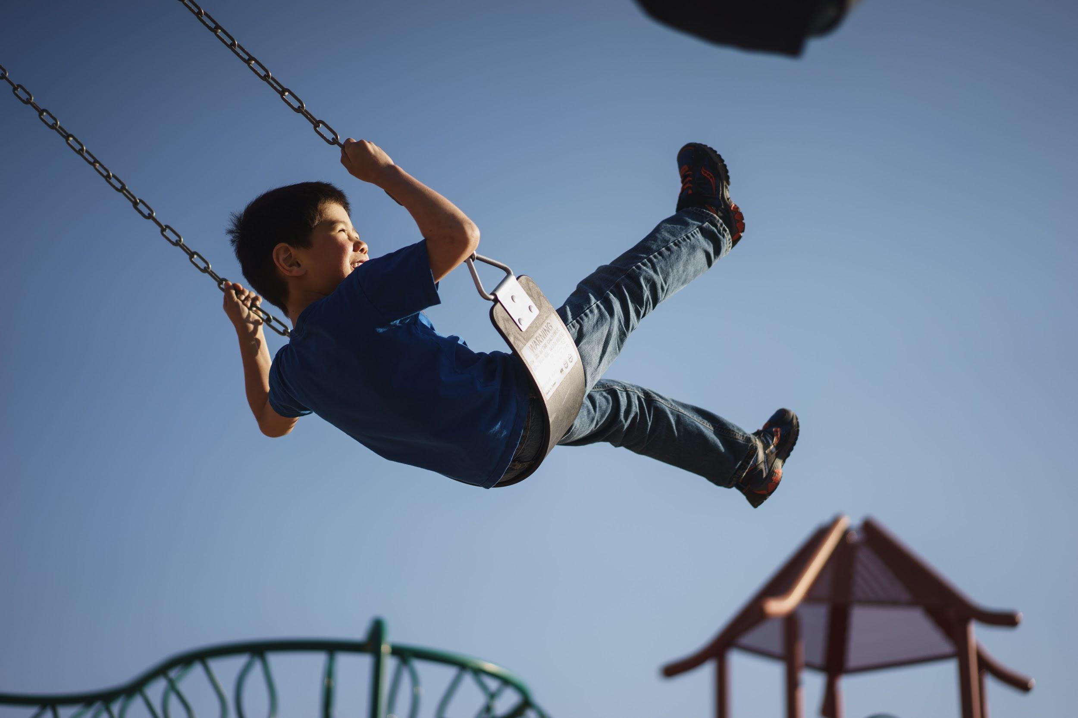

The Great Outdoors: Battling Nature-Deficit Disorder

Too many of us spend most of our days indoors. This is as true for kids as it is for adults, and it’s having serious side effects on our children’s health; insufficient access to sunlight, nature, and fresh air, for example, can cause major health issues. From an increased risk for obesity to mood disorders like anxiety and depression, the effects of nature-deficit disorder cannot be ignored. Here are a few ways to fight this in your family.

At-Home Tips

How to Plan and Plant a Garden for Kids
9 Great Outdoor Learning Activities for Springtime
Can Outdoor Chores Curb Aggressive Behavior in Kids?
Turn Your Backyard Into a Personal Playground
Easy Outdoor Art Ideas That Kids Will Love

Out and About

15 Tips for Hiking with Kids
17 Fun Things to Do at the Park
Birding with Children! Tips on Getting Started
7 Tips for Biking Longer Distances with Kids

On Vacation

Taking the Kids Camping? 11 Genius Tips for Camping with Kids
The Best Resorts in the U.S. for Getting Back to Nature
Top 10 Reasons Why Summer Camp is Great for Children
Beach Safety for Kids

Ultimately, you must lead by example if you want your children to spend more time outside. Getting out as a family and exploring your national, state, and local parks – as well as your own backyard – will make a massive difference in their lives.

Photo Credit: Unsplash

