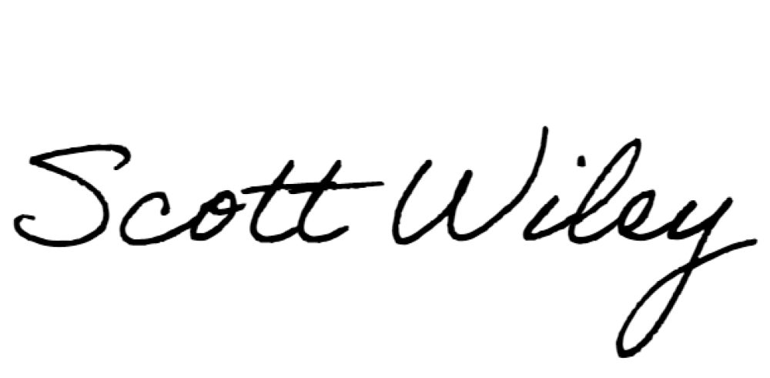

St Vital Minor Hockey Association 580 St. Anne’s Road
Winnipeg, MB
R2M 3G4 Manitoba Liquor and Lotteries
Winnipeg, Manitoba

October 1, 2022

Re: Application for Licence to sell 50/50 Tickets

Dear Ms. Killen,

This letter is to recognize (name) as a team official for the ( ie U13 Chill A3 team) of the St Vital Minor Hockey Association.

(First Name) will be overseeing the team’s fundraising. The application for the licence is to sell 50/50 tickets during home game between November 1st, 2022 and March 15th 2023 to raise money for the ( team name) hockey team to pay for hockey programs to further develop the skills of the players and enhance the team spirit.

( First Name) will be supported by ( name) who is also applying to be on the licence.

( List names who appear on Licence ,… ie below)

Bryn Saunders vpchillhockey@gmail.com 204-999-4703
132 Wainwright Crescent

Richard Sherring dicksherring@hotmail.com 204-333-5779
132 Wainwright Crescent

Best regards

Scott Wiley Executive Director

SVMHA
Phone: 204-805-4368
E-mail: stvitalea@gmail.com

