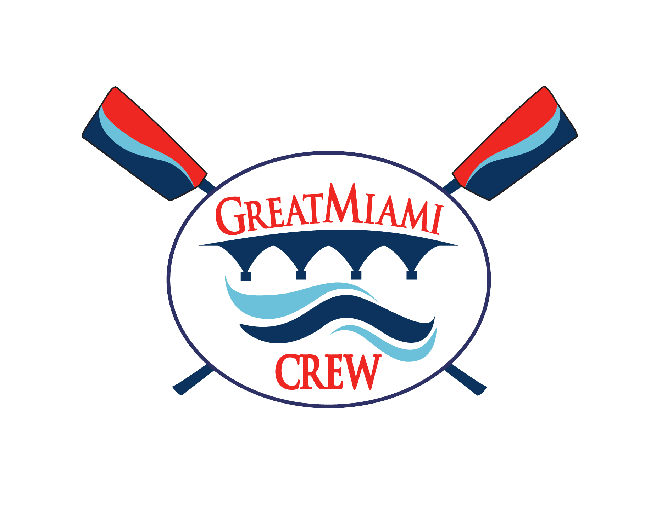

WAIVER RELEASE OF LIABILITY, PHOTOGRAPHY RELEASE AND MEDICAL AUTHORIZATION

In consideration of allowing me or my minor child (as the case may be), who is the registrant (“Participant”), to participate in the activities of Great Miami Rowing Center (GMRC), Inc. (the “Club”), I acknowledge and agree to the following:
1. I understand the nature of rowing and paddle sport activities, both on water and land based, and I understand that there is a risk of serious injury from the activities involved in this event, including without limitation risks associated with participation in any open water activity. I understand that boats do sometimes capsize and that the weather and open bodies of water are inherently dangerous and unpredictable.
2. I understand that I am responsible for consulting a physician concerning the health and fitness of Participant and Participant’s ability to participate in all Club activities. I believe Participant is in good health and in proper physical condition to participate in all Club activities.
3. Although the Club may require third party certification of swimming ability, I understand that I am responsible for determining whether Participant possesses sufficient swimming ability to participate in Club activities. I certify that I am familiar with Participant’s swimming ability and that Participant possesses sufficient swimming ability to participate in Club activities, including the ability to swim and tread water competently in open water without using a personal flotation device (“PFD”), and I consent to Participant’s participation in such activities without use of a PFD.
4. For myself and on behalf of Participant and Participant’s heirs, assigns and personal representatives, I hereby release and hold harmless the Club, and its directors, officers, members, officials, agents, coaches, volunteers and other participants (“Releasees”), with respect to any and all injury, disability, death, loss or damage to person or property, whether arising from negligence of the Releasees or otherwise. I further covenant not to sue, and agree to indemnify and hold harmless each of the Releasees from all liability, claims, demands, losses, and/or damages relating to Participant caused or alleged to be caused in whole or in part by the negligence of the Releasees or otherwise and agree that if, despite this release, I, the parent and/or legal guardian of Participant, or anyone on Participant’s behalf, makes a claim against any of the above Releasees, I will indemnify and hold harmless each of the Releasees from any litigation expenses, attorney fees, loss, liability and/or damage as the result of any such claim.
5. Neither the Club nor its directors, officers, team members, coaches, volunteers or other participants are required to transport participants to or from Club sponsored or non-sponsored activities. In the event that Participant accepts transportation from Releasees, I, by signing this form, am granting permission for Participant to accept transportation and releasing the driver and the Releasees from any and all liability in the event of an accident.
6. I hereby grant to the Club permission to take or have taken still and moving photographs and films and consent and authorize the Club to use and reproduce the photographs, films or pictures and to circulate and publicize the same by all means, including but not limited to, the Club’s website, newspapers, television media, brochures and pamphlets.
7. If, in the judgment of any of the Club’s coaches of other adult representative, Participant needs immediate care and treatment as a result of any injury or illness, I do hereby request, authorize and consent to such care and treatment as may be given to Participant by any physician, coach, nurse, hospital or Club representative. I hereby appoint the Club’s coaches and adult representatives, acting individually, as my attorney-in-fact and in my name, place and stead to approve medical treatment and health care for Participant as such individual(s) may determine to be in the best interests of Participant. This power includes the authority to sign releases to health care providers who may render medical care and services. I assume all liability for payment for all medical and health care services provided to Participant and agree to indemnify and save harmless the Club and its directors, officers, agents, coaches, and other representatives from any claim by any person whomsoever on account of such care and treatment of Participant.

I Accept the Terms and Conditions
Print Rower’s Name:​
___________________________________________________
Signature:​
___________________________________________________
Print Parent/Guardian Name:​
___________________________________________________
Parent / Guardian Signature:​
______________________________________________________

Date:​ __________________________________

