How to use an iCal

- Go to www.schenectadyyouthhockey.com
- Go to your team page and click on iCal 
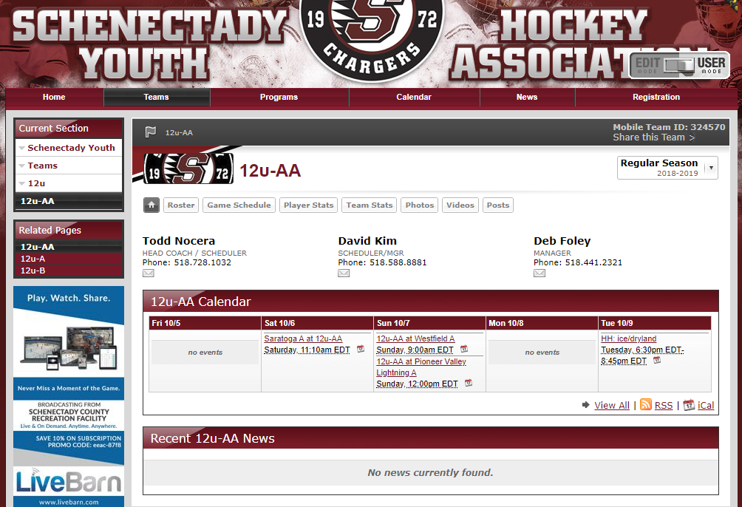

- Copy the iCal link
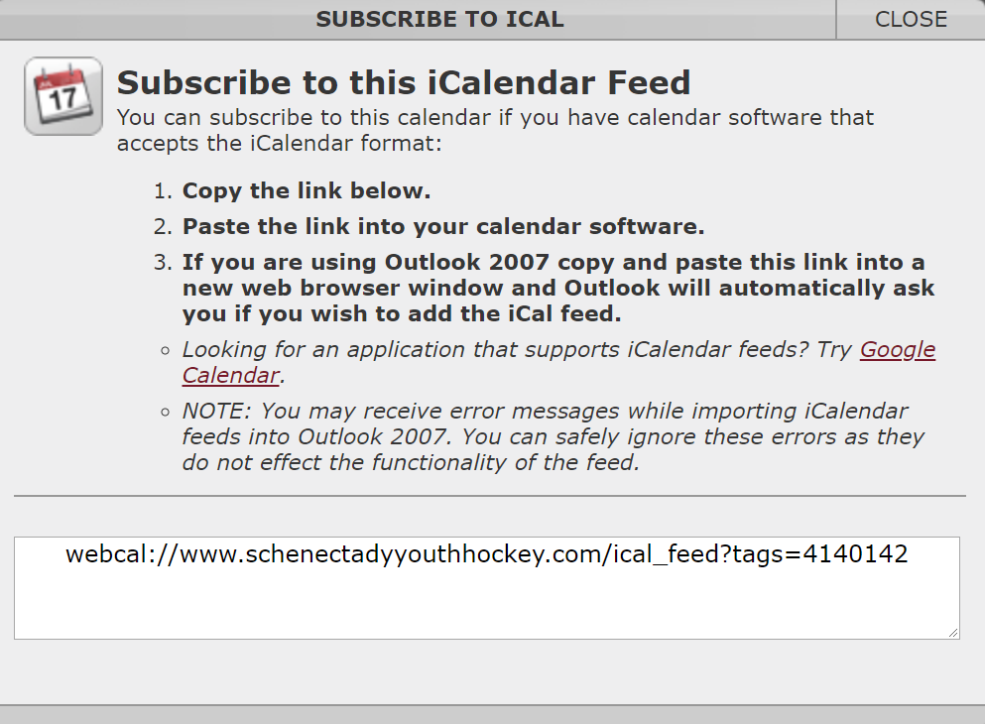
- Import link into your calendar. For example, in Google Calendar:
  - Click on “Add a friend’s calendar”
  - Click on “From URL”
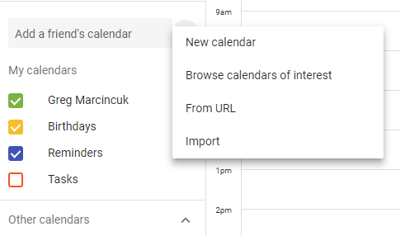

- Copy and paste URL that you just copied into “URL of calendar”

- Click “ADD CALENDAR”
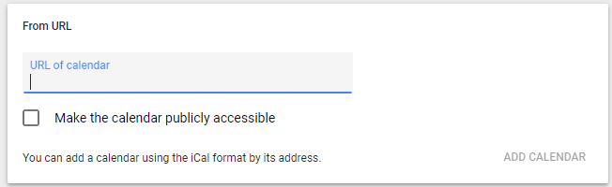

- Your team calendar is now added to your Google calendar. As long as your google calendar is synced with your phone, you will be able to see all of your team events on your phone’s calendar (you might have to enable the calendar in the calendar settings on your phone). All practice and game information will automatically be updated on your calendar (it may take a few minutes to a couple of hours to sync changes made in the SportsEngine calendar).

