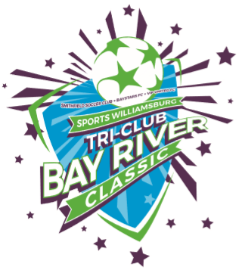
Sports Williamsburg Tri-Club Bay River Classic Soccer Tournament
August 25-26, 2018
McReynolds Athletic Complex (formerly YCSC)
Ages U9 through U19
U9-U10 (7 V 7), U11-U12 (9 V 9),
& U13-U19 (11 V 11)

*** Tournament Entry Fees***
U9-U10 $400, U11-U12 $450, U13-U19 $550
10% discount 5-9 teams per Club 15% 10-14 teams
Medals for 1st & 2nd Placement in each age bracket
Registration deadline July 28th, 2018 or brackets full
For more tournament information contact
Chris Moller: (757) 251-8761 chrissoccer3@verizon.net
https://www.visitwilliamsburg.com/topic/sports-williamsburg
https://vipunitedfc.sportngin.com/register/form/384471117

