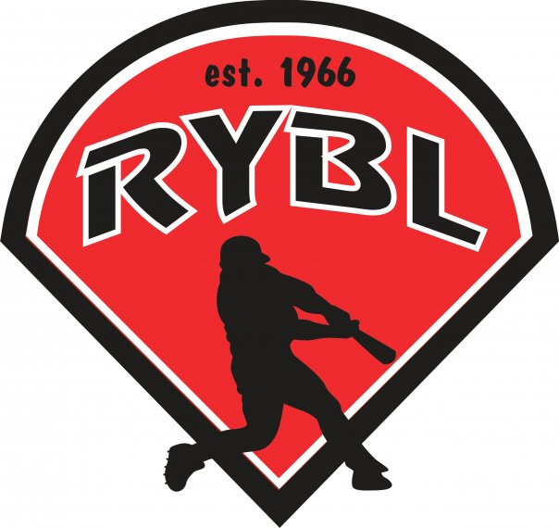
RYBL June 2022
Board Meeting
06/30/2022 7:00 PM
- Call to Order
- Opening Prayer
- Previous Board Minutes Approval – Andy Keogh
  - May 2022 Minutes – Approval
- Treasurer’s Report – Adam Brock
  - Current Bank Balance: $
    - Outstanding Bills: Umpire Fee to Dan Adams ($300) paid / $95 cash incoming for umpires / $2,042.43 to Mid-Central Trophy / Adam going to pay taxes by July 18th
    - Accounts Receivable: $35,000.00
- Office and Committee Reports
- Secretary – Andy Keogh
Fall Ball Director – communicator job – 7 weeks –– how many teams? – registration ends on Aug. 5th / season is from Aug 21 start date- oct 28 – radio broadcast -
- President – Bryan Altmaier
Fall Ball: Registration will be July 5th thru July 29th
-Last year cost was $45, I recommend going to $60 per player this year with cost of baseballs and shirts going up
-Dates this year August 28th thru October 9th no games on Labor Day weekend
-What age groups do we want? The biggest complaint I remember was minor league was pitching machine and parents didn’t realize that when signing up their child.
-Recommend Age Groups
* Rookie league (ages 6-8 years old per 2023 eligibility) pitching machine 38mph
* Minor League (ages 9-11 years old per 2023 eligibility) pitching machine 48 mph
* Major League (ages 10-12 years old per 2023 eligibility) live arm
* Minor and Major 9 -12
Do we want to do a skills camp that first week of fall ball or just play games? Ideas are to see if IUK can come out and do skill camp or we can run our own. I won’t be available for fall but if someone wants to run this I think it would be great. NO CAMP
- 1st Vice President- Chris Pavey
See what managers want to coach a fall ball team
- 2nd Vice President – Mickey White
See what managers want to coach a fall ball team
- Player Agent – Zac Reser - assign players -
You will need to assign players to teams by last year teams first and then fill in players as needed.
NW usually brings their whole team, one for each league
- Equipment Manager – Dawn Hyman
Fall Ball Jersey Prices and Options, also how much time is needed for uniforms? $1,740
Baseballs for fall ball prices and options
- Umpire in Chief – Matt Adams
Fall ball umpire clinic
- Unfinished Business
- J&J on update for light project cost, trying to get major league done by end of July before fall ball, will plan to do minor league the following year with new poles and wiring My hopeful estimate is $20k
- New Business
Summer Projects
- Pot holes in outfield
- Nets on batting cages
- Nets down first base line on rookie field
- Nets behind major league home plate
- Poles and wiring and replacing a few bulbs on major league left field side
- Bullpen areas on major league diamond
- On deck circles on major league
- Pitching mound on major league
- Lip around infield on major league sod 3 feet in on the infield Rossville has a sod business to work with
- Cut out baselines on major league and Tball field
- Tball bases to be installed
*Field Material replenishing costs
Leffert Stone $95 to deliver to Russiaville 2 pallets of material
Play ball Conditioner $12.45/bag x 40 bags= $498
Drying Agent $9.95/bag x40 bags = $398
Total $991 for field material
- Burlington Park maintain at least 3 fields about 10 min away, I want to talk to their park board about getting practices scheduled out there next spring and see about using their barn for winter practices as well. They have two cages and a big open area for fielding. I think it would be a great addition to our fieldhouse/Bullpen practices we schedule for teams. This can also be used during the season for practices and we might be able to use fields for overflow on games during the season. We might need to see about a mobile concession stand or even a food truck to come out for a couple hours for the games? I would like to see about costs and if maybe we can do some interleague games against NW out there as well.
- Next board meeting is Thursday August 18th at 7pm
- Adjournment

