
Boys Hockey Booster Club
March 5th 2025

Board Members:
Keith Bridgeman President | Allison Fuller Vice-President | Brian Soucy Treasurer  In Training | Jason Conway Treasurer
Shavon Anderson Secretary | Dave May Head Coach ABSENT | Jennifer Miller At-Large | Dave Bennett At-Large ABSENT
Dave Rodgers At-Large | Brad Farrell At-Large ABSENT | David Marsh At-Large ABSENT | Gavin Bade Volunteer
Mike Budde At-Large | Joleen Budde Volunteer | Rob Donahue At-Large | Stacey Farrell At-Large ABSENT
Melissa Gylling Volunteer | Todd Gylling Volunteer | Megan Grant Volunteer | Andrea Urbach Volunteer
Jeff Weinberger Volunteer | Tom Whirley Volunteer

CALLED TO ORDER: 706pm

Coach’s Updates: no updates
(Dave May)
Treasurer Update: sent email with reports, bal 48 quickbooks, 45 at bank: payments need reconciliation 35k potential bal
(Brian Soucy, Jason Conway)

Remaining payments due ADD BUS UPGRADE – hockey fights cancer check – banquet additional costs etc – HS tickets get to Soucy (check with Sue/Badger on inv) – still meet with Al regarding audit
- Brackets Crossing need to pay
- Benny Lego - $920 PAID
- TPE - $2500 – PAID
- SmithSchafer - $65 ($32 per month for Quickbooks) need to pay
- BSN – Bags - $3666.63 - PAID

Tiger Fan Club liaison / 501-C3: no updates
(Keith Bridgeman, Brad Farrell, Allison Fuller)
Attend monthly TFC meetings normally on Wednesday.
- Letter has been received so this process is complete.

Apparel Coordinator:
(David Bennett, Brian Soucy)
Player apparel orders, Family apparel order site

- Sale of remaining apparel. Will be done at the Banquet. Cash only

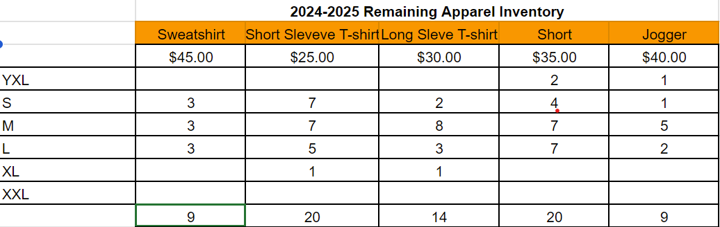

FHS Girls’ Program Liaison: (Allison Fuller) no update
Connect with girl’s president to find ways to work together on things like pictures, Hockey fights Cancer and other events. Share costs on things like programs, etc.

Team Building/Community Outreach Coordinator/FYHA Liaison: no updates
(Shavon, Allison, Jen, Joleen)
Fun events for the boys, like paintball, or volunteer events. Work with FYHA on any projects or events. Cost sharing when possible.
- Nothing New

Fundraising Coordinators – getting started (Todd/Steve Jelmo assisting)
(David Rodgers / Mike Budde)
Gun raffle, or any other income events

Sponsorship Drive / Jersey Sponsorships no updates - start June/July
(Dave Marsh)
Contact business for sponsorship money. Last year we had 20 that provided sponsorship. Update sponsor letter around July. Primary Sponsor, Jersey sponsor, Program Sponsor and Game Day sponsor amounts. Gather logos and great warm-up jersey done the last two years at CA Gear.
- Nothing new
Game Day Production / Rink no updates
(Keith, Team)
Run rink-lights, spotlights, fog machine before game. Prep team for timing of each item.
- Nothing new

Game Day Programs Coordinator no updates
(David Marsh, Stacy Farrell)
Find printer, gather logos, pictures and all other items needed to great program with Girls Booster. Find printing solution and quantity.
- Nothing new

Photography Coordinator no updates
(Keith Bridgeman, Stacy Farrell)
Work with Hight School photographer for team and individual pics (Picture This), Other Banner and posters pics currently done by Athletica (Benny Lego).
- Game photos that Benny will be at to take pictures.
  - Feb 20th Sections

Senior Night Coordinators no updates
Allison, Katie, Joleen
Choose Senior night game, provide any senior gifts, make sure photographer is there.
- Complete

Social Media/Webmaster/Communications Coordinator: Megan Grant
(Keith Bridgeman)
GameDay posts, Game updates by period, player goal posts and other game updates. Senior Spotlights, Hockey Fights cancer posts.
Tiger Fan Club website – Update calendar, Meeting Minutes and booster documents. Important links, Fundraisers, Summer STP, Sponsors.
- Transition Social Media game updates to Megan Grant. She has access now to X, Instagram and Facebook. Will get her access to Gipper next. She has access

Team Meal/Snack Coordinator: no updates
(Jason / Allison)
Away game meals, team meals, Snakes for all games.
- Team meals at peoples’ houses or FHS.
  - Team meal the week of sections?
- Subway, Noodles, Culver’s, Chick Fil-A have been used for out-of-town games.

Alumni Liaison/Legacy Fund: no updates
(Jen Miller)
Any D3,D1 college players to be added to rink wall
- College Photo Wall, nothing new

End of Season Banquet Coordinator: ready to go
(Keith, Shavon Anderson, Andrea Urbach, Megan Grant, Candy Sandborn, Katie Sullivan, Rob Donahue, Gavin Bade, Aaron Mackie, Kristin Donahue)
- Sign-ups complete – 125 total attending.
  - Managers included
- Linen and food selections provided to Brackett’s – Complete.
- Cookies and cupcakes ordered
- Balloons ready day of. Megan has ballons and Budde’s provided helium tank.
- Candy Sandborn creating 4x6 pics framed for players
- Center Pieces – Skates, Carnations. Need puck cut for skates.
- Senior slide show with music completed by Kristi Donahue
- Individual player slide show ready.
- Coaches’ requirements and schedule has been provided
- Backdrop from Badger
- Get Senior posters from Maki along with 12x18 pictures to give to all kids plus senior posters.

Event Schedule
  - 4:00 PM: Client Arrival & Setup
  - 4:10 PM: Client to Pre-Set Family Dessert
  - 5:30 PM: Guest Arrival
  - 5:50 PM: Call to Dinner by Coach
  - 6:00 PM: Welcome by Coach
  - 6:05 PM: Buffet Opens
  - {BC Staff to Dismiss Tables}
  - 7:00 PM: Program Begins + Awards by Coach
  - 8:30 PM: Estimated Departure
Open forum for new/existing issues/things to keep in mind:

- End of season all varsity players other than seniors need to hand in Sponsor jerseys. These jerseys need to be collected and delivered by player to each of the sponsors. Communicate with Dave to check with his personal connected sponsors – collect at banquet (small committee to gather jerseys (20): Rob, Shavon) April – May for reaching out!
- 20 Student State ticket packages and 12 adult tickets packages (6 to boys’ coaches and 4 to Girls coaches) where delivered by David Rodgers. High school purchased tickets, and the booster will need to pay them back. 6 Coaches are covered by the booster. Girls coaches’ tickets will be covered by the girl’s booster. The rest will be collected by David and Keith and a check will be written to the High School. Waiting on invoice info from Badger

- Board member openings. Voting for each position – ALL VOTED ON, NO OBJECTIONS
  - President – Rob Donahue outgoing Keith Bridgeman
  - Vice President –Tom Whirley outgoing Allison Fuller
  - Secretary – Shavon Anderson
  - Treasurer – Brian Soucy outgoing Jason Conway
  - Treasurer in Training – Andrea Urbach (treasurer in training) outgoing Brian Soucy
  - At Large - Joleen Budde outgoing Stacey Farrell
  - At Large - Megan Grant outgoing Brad Farrell
  - At Large - Dave Rodgers
  - At Large - Todd Gylling outgoing Dave Bennett
  - At Large - Mike Budde
  - At Large - Gavin Bade outgoing Dave Marsh
  - At Large – Katie Rodgers outgoing Rob Donahue
  - At Large - Allison Fuller
  - At Large - Melissa Gylling
Approval of Minutes:
Meeting adjourned: 734pm

Future Meetings
New president confirm with Sue Hurtgen on future dates.

