THE WESTONKA WAY (FUNDAMENTALS)
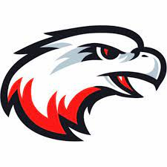
YOUTH BASKETBALL DEVELOPMENT & COACHING MANUAL
Westonka White Hawks
Mound, Minnesota

TABLE OF CONTENTS:

- Attitude and Philosophy
- Age-Appropriate Development
- Triple Threat
- Shooting
- Dribbling
- Passing
- Defense & Team Defense
- Rebounding & Outlet Passes
- Offensive Concepts
- Fitness Challenge
- Practices – Generally

PURPOSE OF THIS GUIDE

The purpose of this guide is to give volunteer coaches a refresher of the fundamentals of basketball and to help coach all Westonka players in a consistent form and manner. A consistent approach to the fundamentals will form a great foundation for our program and help prepare the players for future leagues. You can’t build a building without a firm foundation!

Many of us parents are very knowledgeable about basketball and we have all played at some level. But being a player is not the same as being a coach. Even the most experienced basketball players find themselves asking: “Where do I start?”. Hopefully this guide gives you an idea of instructions we can use with our kids that are basic enough to grasp the fundamentals. But we also hope that this guide is detailed enough to give even experienced players and coaches an idea of how to fine-tune the skills the kids learn as they grow.

This guide was developed with guidance from the Board and based upon research and information gained at several coaching clinics and player clinics provided by the Minnesota Youth Athletic Services (MYAS), other observations from other professional training clinics in the Twin Cities, and research from various coaching guides authored by professional coaches around the world.

POSITIVE COACHING PHILOSOPHY

POSITIVE COACHING PHILOSOPHY:
Before we start educating kids on the game of basketball, the coaches need to be a pillar of what we expect out of our kids and coaches should give some thought into what their mission is for being a coaching role model. As such, Westonka endorses the Positive Coaching approach followed by the Positive Coaching Alliance (https://positivecoach.org/chapters/minnesota/) where the mission is to create a youth experience that improves not only sporting skills but life and character skills by promoting an inclusive and positive culture.

At the end of the day, our mission as coaches is to leave each player better than we found them.

GENERAL PHILOSOPHY:
Each coach will have his/her own philosophy of what organized sports missions are. However, we should try to start with these basics:
- Basketball is a game so it should be fun every day.
- Basketball is a skill game so we should focus on improving every day.
- Winning is not everything! But, basketball is a competitive game so we should prepare and play to win, but also be prepared to lose.

POSITIVE PSYCHOLOGY
As part of the Positive Coaching, we should stress the below to the players almost every practice, so it becomes a part of their basketball DNA.

- The Big Three – These Will Never Slump!
As a coach you will come across players of various skill levels. Some kids develop faster than others and some may never develop to be the best kid on the team. However, we can help kids of all skill levels understand that sport is not about just being successful on the field. Sport is about believing in yourself, trying your best no matter what, and striving to improve something, anything, about yourself everyday.

As such, we should focus on the below three things that are 100% within our control in basketball and life and no one can take these away from us unless we let them. It takes zero athletic skills to practice these and I can guarantee that the person that masters these will be an all-star more times than the person that ignores these.

While every coach is different, I teach the following and set expectations up front on what I demand in terms of behavior on and off the court – all of which lead to being successful in anything you do. But I frame these lessons as the “Secrets of Basketball”, so they listen and take them to heart more:

- Focus
The #1 secret to basketball (and anything in life) is focus on what is important. I stress that any time a coach or adult is talking their focus should be on the eyes of the coach: “When you’re talking, I stop talking and listen to you – please do the same for me” … “That’s why god gave us two ears and one mouth – so that we can listen twice as much as we talk.” … “You should be able to tell me what color my eyes are.”

It’s never too early to start teaching respect for others and good listening skills. I stress that this type of focus makes you a good student and an overall good person in the world because people will respect you back if you give them your attention and listen. “Respect is like a boomerang…what do you want coming back to you?”

In terms of actual basketball, focus is applicable because there is only one ball in the game and we should never take our focus off the ball and we should be focusing on what is about to happen and what we want to happen.

- Hustle
The #2 secret to basketball (and life) is to always hustle and try your hardest regardless of the score or other circumstances! The difference between an all-star and a person watching from the stands can be hustle. The difference between an easy bucket and a blocked shot can be a split second. That is why we hustle! Think about if everyone hustles on every play and we add up all that hustle. That can (and will) make the difference between a win and loss someday soon. “Hustle doesn’t cost anything – but it means everything!”

Also, hustle shows the coaches and the team that you respect the game and the coaches and that you’re enthusiastic about the game. “What if you asked me to play one-on-one with you and I dragged my feet, hung my head and made it look like we are headed to the dentist? How would you feel?”

- Positive Attitude
“Attitude Makes the Difference.” A positive attitude can be contagious. A positive attitude can help bring up a player and cause them to focus more, hustle more, and enjoy the game more. A loose and positive player is an instinctual player that just plays to play and forgets about the fear of making mistakes or performing a throw or swing using the proper technique. A positive attitude means that mistakes will not define you as a player or person. Mistakes are acceptable. If they are not acceptable by the coach, then they are not acceptable by the player, and if a player is scared to make a mistake they play stiff and robotic.

- Positive Attitude = Rebound from Mistakes:
Probably the biggest factor that reduces growth of skills or prevents kids from continuing to play basketball is the number of mistakes made and how each mistake is internalized by each kid based on how the coach or parents react to mistakes.

We should start with the basic lesson that everyone makes mistakes. Basketball (like any game and like life) is a game of mistakes: “All-star NBA players fail 40-50% of the time by missing that many shots”… “LeBron James commits turnovers…misses free throws, etc.”

While we can tell the kids to forget about the mistakes, the first step is let the kids know that not only will mistakes happen, but that they are acceptable on this team. Mistakes are just ways to learn how to get better.

To paraphrase one of the most famous quotes about failure, when a reporter asked Thomas Edison: “How did it feel to fail 10,000 times when inventing the light bulb?” Edison replied, “I didn't fail 10,000 times…I just found 10,000 ways that didn’t work. I only needed one way to find it to work.”

A coach should not get angry at typical mistakes and errors – they are inevitable and acceptable as these kids experiment with basketball. Provide constructive criticism on mistakes of what can be done next time to get better, but coaches should never make mistakes unacceptable like Sensei Kreese in The Karate Kid. However, some players tend to hang their heads and let mistakes ruin the rest of the game. Be sure to remind your players that what separates “good” players from “exceptional” players is a short memory when it comes to making mistakes.

PRO TIP: Correcting Mistakes Using the “RRR” Method:
After the player makes a mistake and gets upset at their own performance, start to instill the “RRR” psychology thought process used by many sports psychologists to help them improve:

Reset
Throw away the mistake – come up with a saying they can repeat after mistakes. I have my players say: “what’s next?” Then I have them mimic balling up the mistake in their glove and then have them make the throw-away motion over the fence, or have them wipe it off their shoulder, flush it down the toilet, etc. Tell them “thank you” for recognizing the mistake and moving on.

Reflect
Have the player reflect on what went wrong and what could have gone better. Tell them what went right, but what could be tweaked, added, improved on the next try. Or ask them what they think they forgot to do and have them self-examine. Tell them “thank you” for thinking about it and ask them to move onto the next play.

Refocus
Have the player refocus on the next play to implement the correction to the mistake and remind them to say “what’s next?”.

- Everyone Belongs Here – What is Your Strength:
It is very important to have every one of your players feel like he/she is an important part of the team. Help them understand that they each belong there and deserve the opportunity to play, have fun and learn.

We all have unique strengths. We are all different in some ways. But we are all similar in some ways. Being a great team member involves encouraging each other and supporting each other. Being kind to each other and trying hard together. Encourage your athletes
to make each other feel good about being on the team. And even have some of the stronger players teach other players one-on-one. As most coaches know, there is no quicker way to build camaraderie than taking pride in teaching someone something new. This will not only make it fun for everybody, but it will also help everyone improve and play well.

IMPROVEMENT IS FUN:
Basketball is a complicated sport with many moving pieces and things to think about at once. The ploy is to arrange practices and skills training so that the kids are Jedi mind-tricked into developing muscle memory (i.e., “Wax on, wax off Danielson”). But it is still important to teach them that good ball players are developed through three very important things: practice, practice, practice. I stress that coming to a team practice is only half the battle. The other half is the time spent practicing at home where the true muscle-memory is built.

So, in the end, I try to celebrate the successes wherever I see them. Improvement will occur during every practice and every game. Kids will be able to do things that they couldn’t weeks, days, or even minutes ago. Coaches should try to stress every day that they are getting better – but be sure to follow it up with the fact that they’re not getting better because of any certain magic. Getting better does not just appear out of thin air, but because they are trying hard and wanting to get better and focusing on getting better. Everyone, especially kids, just need to know that they are on the right path and doing a good job.

WINNING IS ALSO FUN!
Winning isn’t everything, but it’s pretty damn fun when you win and can be heart breaking when you lose. Being focused on winning isn’t a negative, but it shouldn’t also be the only and main goal of your team. Rather than stressing winning as the end goal, use the micro-goal of “let’s be competitive.” Being competitive is a combination of the non-physical skills we already stressed: focus, attitude, and hustle. In order to compete, you need all three otherwise the possibility of winning falls apart.

And the term “winning” is relative. Sometimes it’s winning a game. Sometimes it’s hitting a shot after missing the prior five…sometimes it’s just dribbling a ball without getting it stolen. I stress to the kids to find that competitive nature to drive themselves to win against themselves and get better whether it’s focusing and playing hard to win, or to get over a hitch in your shooting motion. Some of the biggest smiles I’ve ever seen have come after the lowest skilled player on the team made a shot in a practice.

Also, while we as adults want to win, in the end, we need to remember that this is a game for kids, NOT adults and our desire to win a youth basketball game should never be put in front of our kids’ emotional or physical well-being.

HOW TO TEACH - GENERALLY
We have to remember that as youth coaches we are educators first and coaches second. First, we need to teach these kids how to walk before we can run. Fundamental’s training should come first before we start “coaching” how to run a motion offense. However, there are a few key tenets about teaching that apply to teaching/coaching that deserve consideration:

- Different Learning Styles: We all learn differently and what works for one kid may not work for another. So be prepared to be flexible in how you coach and recognize when a kid just isn’t getting it and try to be creative to find a way to teach that kid.

In terms of teaching anything to anyone, people learn through a few key ways:

- Doing (kinesthetic learning by doing an activity first and learning from mistakes);
- Visual (watching or reading a description or diagram to understand then doing); or
- Aural (listening and processing instructions then doing).

It is always best to present new information in each of these three ways when coaching. For example, when trying to show a kid how to shoot a ball properly you could start with oral instructions, then show a diagram breaking down each action of the shot form, then you show them how to do it slowly then full motion, then have them actually shoot several times to get a feel for what works best for them.

A good coach also reads their players and starts to understand how they best learn. As such, your instructions may vary per kid depending on their learning style.

- To Yell or Not to Yell?: I was coached in the 80’s and 90’s when coaching was a bit different and more aggressive. Research has shown that yelling at a player for yelling’s sake reduces the learning and confidence of players. They start to shut down if everything said to them is yelled (would you like your boss yelling at you constantly?) and the learning and enthusiasm for learning decreases significantly.

However, the term “yelling” is relative and oftentimes it is necessary to get the attention of a large group of kids. Use raising your voice as a last resort and not as a technique to “teach” but more as a way to get their attention. And, it should go without saying, that yelling to demean a kid for making a mistake is never acceptable. We should still hold kids responsible for staying focused and being good listeners, but yelling at a kid because they can’t make a layup is unacceptable. Remember these are kids!

A better technique is to pull a kid aside and take a knee so you are eye level with them and explain what they are doing wrong and how to get better. Start with the positive of what they are doing, then describe their mistake, then end with a positive and that they can get better. If it is a behavior issue you are dealing with, you need to calmly explain what the expectations are and the consequences if they continue to misbehave (i.e., sit out practice time, call your parents, etc.). If bad behavior persists, then speak to the player’s parents and escalate to the Board if it continues and intervention is needed.

- Have a Plan: Before you start teaching/coaching a practice, go in with a plan of key components to cover during practice. Let the kids know, what will be covered during practice. It also helps you organize your drills and items to cover so there is as little downtime as possible.
GOALS AND MICRO-GOALS

Study after study has shown that the top-performing human beings for any sport, job, trade, or artistry are those who assess themselves in the past, present, and future by setting and striving towards their goals.

As a coach, you can set micro-goals for yourself that vary practice by practice. It can be overwhelming to try to teach the entire game of basketball in one practice, so try to set goals for each practice and don’t try to boil the ocean.

For example, you may want to have a theme for each practice where you work primarily on a set skill or technique (“today we work on defensive stance and help defense” – “today we will work on proper shot form and off-dribble shooting”).

The same mental technique applies for training the players. They can get equally overwhelmed with the amount of information they need to know for such a fast-moving sport. So, to that end, identify micro-goals for the team as a whole and for each player that they can focus on for improvement.

When each micro-goal is achieved the player will feel a sense of accomplishment and the game of basketball will start to feel less daunting for them. You may want to think about rewarding the micro-goals by giving candy, playing a fun game, etc.

TRIPLE-THREAT

The first concept we should start with is the offensive concept of triple-threat. This is the standard position that should be taken when receiving and holding the ball on offense. This position is the basis and starting point that all offense skills center around. Here are the key points:

- Stance = Stand in a balanced basketball position – feet shoulder width apart. Toes even with each other to start, then one foot becomes the lead pivot foot that is in front of other foot.

- Ball position = held to either side of hip, not in center of body, with both hands.

- Holding Ball = one hand on side of ball, other on bottom side (shooting/passing position). Fingers spread apart and use finger pads (not finger tips!!!) and not the palms to hold ball.

Key Concepts:
- Explain that when you get the ball this is the first stance you should take because you only have three options when you receive the ball (in order of importance):
  - Shoot,
  - Pass, or
  - Dribble.

- This position puts your body in the best position to accomplish either of these three (thus, the “triple threat”).

- The main idea is to protect the ball if you are not shooting and keeping the ball mid-high and tight to the body so that you can move quickly to shoot/pass/dribble.

Drills for Triple Threat:

LEVEL | DRILL NAME | DIRECTIONS
Basic | Triple Threat – Motion only | - Players have a partner 5 ft. across from them.  - Pass the ball to one another.  - OFF player has hands up near chest ready to receive a pass (say: “make a diamond” with your fingers) and is in a basketball/balanced stance  - As soon as player receives the ball, they put ball near hip, bend knees and get into ready position to shoot/pass/dribble. Have them use the pivot foot to get into proper basketball stance  - Repeat 5-10 times  - Then progress to 5-10 reps each of:  - receiving pass -> triple-threat -> shooting motion  - receiving pass -> triple-threat -> passing motion  - receiving pass -> triple-threat -> dribble
Intermediate | Triple Threat – Actual | - Same as above, but have the player actually shoot, pass, and dribble.  - Shooting: Have player receive, pivot and square up to basket and shoot 3 ft, 6 ft, 9 ft, etc. (5 reps on each R/L side of key)  - Passing: Receive ball, pivot towards target and make chest, bounce, overhead passes (5 each)  - Dribble: Receive ball at FT line from passer near 3pt line, pivot towards basket, then dribble to layup. 5x each with R/L hand.
Intermediate | Triple Threat – Pressure to pass. | - Two players. One stands on FT line, one on baseline.  - DEF player on baseline passes ball to OFF player on FT line.  - OFF player catches in triple stance  - DEF player closes out on OFF player with defensive stance and hand up to pressure OFF player (have them try to steal, but not too aggressively)  - OFF player pivots and keeps ball tight to hips, or high as they pivot around defensive pressure. Teaches them to protect ball and move ball and pivot to avoid the steal.  - Have them pivot 2-3 times then pass to next person waiting in line at baseline who will become the next DEF player. The player who was just pressuring the ball, then turns toward baseline and becomes the OFF player.  - DEF then becomes OFF player and rotate through 3-5 times per player.
Expert | Triple Threat – 2 v. 1 | - Two OFF players (one at top of 3pt line, one near 3pt line on R or L of other OFF player), one DEF player at baseline under hoop.  - DEF player passes to OFF player at top of 3pt line.  - DEF player closes out on OFF player at top of 3pt line and says “Ball” or “I got ball”.  - OFF player then decides to shoot, drive, pass. Play it out until there is a score, or a DEF rebound.  - IF OFF scores, they keep the court and new DEF competitor steps up.  - Key Concept on OFF is spacing, cutting, screening.  - Key Concept on DEF is closing out, movement, and blocking out.

SHOOTING

Shooting form and style may vary from player to player, but there are some fundamentals that apply across all shot styles. At an early age, you may not see perfect form due to strength, but we can start forming the proper stance and form at an early age

Main Coaching Points for Basic Shooting at Any Age:

- B.E.E.F. Method:
- BALANCE – All great shots begin with proper balance. Feet shoulder width apart, head centered, shooting hand toe slightly tilted inward, weight on toes.

- EYES – Eyes are always on the hoop. Choose to stare at back, middle, or front of rim.

- ELBOW – Lock the elbow (not bend) in an “L” shape and keep it high and parallel to court.

- FOLLOW THROUGH – Finish with a high hand and point five fingers to ground (“cookie jar”). Both hands should form a “field goal post” to prevent off-hand from pushing ball.

- Stance:

- “Show me Triple Threat”: Have the player start in the Triple Threat position with a balanced stance, one hand on side of ball, one hand on the back/underside of ball. Have them start with ball-side/dominant foot forward and slightly in front of the back foot.

- “Little pigeon toe”: Rather than have the player have both toes pointing directly at the hoop, have the shooting-hand side toe pointing slightly inward like a pigeon toe (around 11 o’clock positioning for a righty, 1 o’clock for lefties).

- Dip the Body and Put It On a Platter:
- Make sure the player is squatting and bending the knees to get under the ball. We want them to get used to extending the legs to get vertical lift, not horizontal push.

- “Put it on a platter” or “Wrinkle the Wrist”: As the player dips and then starts the upward ball movement to start the shot, have the player cock the wrist back so that they are holding the ball like a server holds a tray at a restaurant and so their wrist gets wrinkles in it. Ball is still in finger pads and the elbow is directly below the ball on the platter.

- Hands:

- “One on the side, one behind”: Have the player put the non-shooting hand on the side of the ball (this keeps the ball balanced and online with the hoop). The shooting hand goes on the bottom, backside of the ball.
- “Form an L”: The shooting hand should form an “L” with the pointer finger and thumb on the back of the ball. The thumb is placed between 9 o’clock and 10 o’clock. We want the middle finger to be the main “aiming” finger that should point at the rim – not the pointer finger.

- “Spread the fingers”: Have the player spread the fingers naturally wide and hold the ball using primarily the fingertips, not the palms. Start to have the players focus on using one of the below options when shooting the ball. We want them to realize which fingers are aiming the ball and touching the ball last on the shot.

  - Forked Fingers – Pointer finger and middle finger are the last two fingers to touch the ball.
  - Middle Finger – Middle finger is last to touch.
  - Three Fingers – Pointer, middle, and ring fingers are last to touch ball (this may be for smaller and younger players).

- Elbow:

- “Make an L”: Make sure the shooting elbow is locked in an “L” position and tight to the side of the body. Have them “cock” the elbow back towards the side of the ribs and not in entirely in front of the body. It should be at a 90-degree angle to the body as the shooting motion begins.

- “No chicken wing”: Make sure the shooting elbow stays tight towards body and not hanging out like a chicken wing.

- Holding Ball (Finding the “Pocket”):
This portion of the shot progression is about finding a player’s “pocket” where the ball and shot starts. Try to find the spot where the player feels most comfortable, and this should be the starting spot for almost all shots.

- “Keep it tight”: Ball should be tighter to body than farther away.

- “Find the Pocket”: There are two pockets. There is the initial triple-threat pocket that is at/near a player’s waist when the entire shooting sequence starts, then there is the shooting pocket where the ball is “on the platter” and near a player’s shooting shoulder/arm pit.

- “Below your waist – it’s misplaced”: Make sure the ball is held above the waist and not below. Many younger kids try to get more power by bringing the ball low – instead have them use their knees and get “small to tall” as mentioned below. Bend knees first, then put ball in pocket to pocket. A little bit of a ball “dip” is okay after they catch the ball to create power and momentum (and, in fact, it is encouraged to create rhythm), but we don’t want the ball going below their waist. Also, ball should be slightly off-center from the body towards the shooting hand side. Not too much, but not too center – just be on the lookout for the “shot put” shot.

- Mental Focus:
- “Stare down the Rim”: Make sure to teach the psychology of looking at the target and visualizing making the shot. Have the player look at the front or back of the rim (I prefer front), so they put their focus on making the shot.

- “Visualize a Make”: Have the player see the make before the ball falls. Positive thinking cannot hurt.

- Use Entire Body:

- “Go From Small to Tall”: Tell the player to bend knees (small) and stand up (get tall) as they are starting the upward movement of the elbow and starting the actual shot. This concept is the basis of the jump shot. You can also tell players to “dip” slightly when they shoot – this key will also get across the same concept.

- Shooting Motion:

- “Smash the Ceiling” or “Palm to the sky”: As everything else is moving upwards as they go from small to tall – have the player envision pushing their palm into the ceiling. This will teach them to shoot up at the rim in a rainbow where the ball drops through the hoop, and not on a shallow trajectory where they push the ball flatly towards the rim.

- “Shoot Out of Telephone Booth”: Another visual is to have the player envision she is in a telephone booth, and she has to shoot up and over the top of the booth. Again, teaches them to shoot high.

- “Snap the Elbow”: As the ball moves up toward the ceiling, rather than have the player focus on snapping the wrist, have them focus on snapping the elbow first. This will provide the power and the wrist will naturally “snap” and follow the momentum of the elbow’s snap. But as they get older, have the player focus on snapping the wrist and the elbow at the same time. The concept here is that we want to create power and spin at the same time.

- “Aim Middle to Middle”: Have the player use their middle finger as the main finger to create spin and aim at the rim. As the player shoots and follows-through, the middle finger should aim at the middle of the rim.

  - “Create Spin with 1, 2, or 3 Fingers”: As an alternative to only using the middle finger to aim and create spins, have the player experiment with shooting using 1, 2 or 3 fingers to create spin. You can start them off using only the middle finger as the last finger to touch the ball to create spin on the follow through/wrist snap – also as the finger that aims towards the middle of the rim. Then have them try using the pointer finger and middle finger (like a peace sign or a fork) touch the ball last. Lastly, have them try using three fingers (the pointer, middle and ringer finger) as the last three fingers to touch the ball. Ask the player which one they prefer. In future shooting drills have them concentrate on using their preferred fingers to create spin and touch on their shot.

- “Keep it in front of face”: The ball should always remain at/near the front of the face and never behind the head or the side of the body too much. However, each player is different in where the comfortable “pocket” is for starting the upward shooting motion – so have them experiment with what feels best for them.

- Hold the Follow-Through

- “Hand in the Cookie Jar”: The end of the follow-through should look like you are reaching into a cookie jar on the top shelf. Teach the player to hold this pose until the ball hits the rim.

Layups

Layups should be one of the first shots that you teach at any age and they should be practiced a lot using both hands. Basic fundamentals are:

- With ball in triple threat position, take one step towards basket.
- If on R of basket, shoot with R hand and “skip” up and jump off of L foot only.
- If on L of basket, shoot with L hand and “skip” off of R foot towards the hoop.
- Teach them that they are laying the ball up and against the backboard’s square. They are not “shooting” it in the traditional sense.

PRO-COACHING TIP: Also work in two-footed layups where the players go up strong off of two feet but still lay it up. Coaches always want players who can finish strong off of two feet.

Jump Stop to Pivot to Jump Shot
Once players start to understand the mechanics of a proper shot, we can add on the jump stop from a dribble and have them pivot towards the basket for a strong and proper shot. The purpose of the jump stop is to get into a proper position while dribbling away from or while not facing the basket. It can also be used when receiving a pass.

Have the player dribble towards the basket, complete a short jump stop/hop with both feet facing slightly away from the basket, then have them use their inside foot as a pivot foot and pivot the outside foot toward the basket, then complete a proper jump shot.

Basic Drills for Shooting:

NAME | LEVEL | SKILLS DEVELOPED | DIRECTIONS
Lay Down Drill | Basic | Shooting Elbow Form | - Have the player lay on the ground with a ball.  - Put the shooting elbow on the ground next to the top of their hip/lower part of the ribs. Off-hand is on the side of the ball.  - Have the player “shoot” the ball straight up in the air focusing on keeping the ball directly above them. If the ball goes sideways, too far forward/backwards, then form is not correct.  - Also focus on creating rotation by snapping elbow, wrist.  - 5-10x reps  - (Can also be done at home with any type of ball)
Ball Holding Drill | Basic | Hand placement (pre-shot) | - Player drops or spins the ball in front of them  - They grab the ball and put hands and elbow into a proper shooting position  - 5-10x reps  - Teaches how to get into proper position when catching the ball

DRIBBLING

Dribbling is easy to do, but very hard to master especially when there are five other players on the court trying to stop your dribble. But there are several key points that we can stress that will help a player understand more about proper dribbling technique.

MAIN COACHING POINTS AT ANY AGE:

- Use Fingers First, Not Palms
- “Finger tips and finger pads first!”
- Make sure the players are not letting their palms touch the ball first
- Spread the fingers naturally wide
- Can have them start to “carry” the ball and turn their palm up as they receive the ball (this will help them get feel for the ball vs. slapping down on it)

- Snap…No Slap!
- “Push and snap your fingers towards the floor”
- Dribbling should be an easy push and flex of the snapping wrist where the fingers point to the ground – however, the dribble should be fast and hard (a slow bouncing ball is easier to steal!)
- Extend the arm and the wrist at the same time
- No slapping the ball – get smooth
- As ball comes back up from floor, flex the wrist up to accept the ball and absorb the upward force. Feel the ball in the fingertips as it comes up.

- Eyes Up
- The biggest instruction is to have players dribble with their eyes up to get a sense of where the ball is and how they can control it without looking.
- Have them close their eyes or look up at the wall while doing dribble warmups – this gives them a good feel for the dribble without looking at it.

- Keep it Low
- A high dribble is a very stealable dribble. Have the player focus on dribbling below the waist for most circumstances.
- There are times when a higher dribble is necessary, but the for the most part, keep it low!
- Also, keeping the body low is just as important. Bend the knees, lower the butt and stay low so you are ready to move in a moment’s notice!

- Ball Placement
- For the most part, the player will dribble to the side of their body as dribbling directly in front of the body puts the ball in danger of being stolen.
- However, when running fast the ball is dribbled in front of the body.
- Have the player practice getting into the triple threat position and dribbling with the left foot forward/right foot back while the ball is being dribbled on the right side of the body for a right-hand dribble. This helps the player understand how to protect the ball.

- Offhand Protects
- Get the player used to using the non-dribbling hand to protect the ball and body as they move through traffic.

PRO TIP: Start to have the players “palm” the ball where they catch the ball in their hands on the up-bounce and turn their hand slightly sideways so that the ball is palmed and rests in their finger pads (not the finger tips). Then have them practice dribbling hard on the down. Obviously, palming the ball too much in a game is a turnover, but this is a great way to get them to feel and control the ball and not just slap down at the ball.

- Manipulate the Ball
- Practice manipulating the ball back and forth and front to back around the feet and body, not just dribbling straight up and down vertically.
- Just have the player get used to controlling and manipulating the ball in any direction.

ADVANCED TECHNIQUES
Once the player is adept at dribbling with both hands and dribbling while running, it’s time to teach the crossover. Here are some key dribbling moves that should be commonplace by high school:

- Crossover

- “Show me gorilla arms”: Keep arms and hands low so the dribble can be low. Keep the body low as well.
- Bounce the ball in front of the body and in the center of the body.
- Since this is generally an offensive move, the dribble should be hard and fast.
- As above, it is important to use fingertips for better control.

- Crossover Through the Legs
- Variation of the crossover where the ball is bounced between the legs.
- One foot steps forward and the ball is bounced behind the forward foot and through the legs.
- Keep body and hands low. Have hand ready to accept the ball.

- Behind the Back
- The easiest way to dribble behind the back is when you are zig zagging and trying to change direction fast when a defender has closed off your offensive space.
- Step forward and diagonal one direction.
- Wrap the ball behind your back and bounce the ball under your butt towards your other hand.
- Make sure you are changing your body’s direction in the direction that the ball is bouncing.
- As above, stay low, bounce it low and practice, practice, practice.

- Spin/Backward Pivot
- Another great technique to change direction of the dribble if a defender has closed off the offensive space or has cut off the direction of the dribble.
- If dribbling right, plant the left foot as you move diagonally and turn your entire body backwards and towards your left.
- As you spin back to the left, the ball is transferred to the left hand after the bounce and you move to the left diagonally.

Advanced Techniques (Mental Aspects)

- What’s the Plan?
- At an early age there is generally too much dribbling and not enough shooting and passing. Try to teach players that need to prioritize the game in this order: Shoot, Pass, then dribble. If there is no shot, can you pass? If no pass, can you dribble to score or dribble to pass so a teammate can score?
- There should be no dribbling without a plan (i.e., dribble to get out of trouble, dribble to pass, dribble to shoot, etc.)
- Ask players to start thinking about a purpose when they get the ball and dribble. Most offensive moves can be done with 1-3 dribbles and no more!
- Don’t put the ball on the floor if you don’t have a scoring opportunity or anyone to pass to – wait for your moment because it will come!

- Dribble North/South Primarily
- Many youth players who start at the point and get the ball want to dribble to the corner or baseline without getting into the paint because it’s the path of least resistance – they are primarily dribbling East/West.
- Dribbling to the corner or dribbling East/West can really limit a player’s options. Tell the kids to make it easy on themselves and drive towards the paint as there are more passing options and better scoring options than getting trapped in the corner or near the baseline.
- Teach kids that if they are going to dribble to score, they should be going North/South and straight towards the hoop/paint.

- One Dribble is All you Need
- You don’t beat defensive players with the dribble, you beat them with good footwork to get an open step on them – THEN you use the dribble to separate and get your shot or pass.
- Generally, after you beat them with your feet, one or two dribbles is about all you’ll need before you can figure out if you have beat your defender and should drive, shoot, pass, etc.

- Vary Dribbling Speeds – Use the Hesitation Move
- Most younger players only dribble one speed.
- Teach them that varying the dribbling speeds will help them beat defenders
- Show them that hesitating a step or dribble will throw the defender’s balance and timing off and will allow them to beat the defender

- Picking Up Your Dribble
- This goes along with having a plan. Teach the kids that picking up the dribble is one of the worst things you can do unless you have a plan after you stop.
- Picking up the dribble allows the defender to close the defensive space and limit your options. Make it easy on yourself and don’t limit your options!

- Practice Non-Dominant Hand – A lot!
- No basketball player can get away with dribbling with only one hand. Practices and drills should be run so that it forces kids to use their non-dominant hand as much as possible, if not more than the dominant hand.

PASSING

Passing is a difficult concept to impart on youth players as most youth players believe that basketball is all about dribbling (which is an individual skill). We need to get players in the mindset and remind them that basketball is a team sport and it’s about sharing the ball with teammates. As a coach, we should all start to emphasize passing earlier and more often.

All variations of a proper pass generally have the same fundamentals on form and technique, it’s just a matter of how the ball travels to the receiving player. Here are the basic tenants of a good pass:

- Step Towards the Player
Emphasize that a good pass is a strong pass. Stepping towards the receiving player gives good power and increases accuracy.

- “Thumbs Down and Snap”
Have the player put both hands on the side of the ball for most passes. As the player steps forward, have them snap their wrists and fingers out towards the sides of the body with the thumbs pointing down to the ground.

- Aim for Player’s “Pocket”
We want the player receiving the ball to be able to go into the triple threat position immediately. Therefore, the passing player needs to understand this and aim for the receiving player’s lower chest/upper stomach area.

- Show me the “Diamond”
Any player receiving a pass should have their hands ready for the pass. Like a wide receiver in football the receiving basketball player should have their hands form a diamond shape with the pointer fingers touching or almost touching each other, and the thumbs touching or almost touching. Be prepared to put the ball in the “pocket”.

- Passing Variations:
  - Chest Pass – Ball is passed from passing player’s chest to receiving player’s chest.
  - Bounce Pass – Player generally bounces the ball about ¾ of the way towards receiving player so it bounces and receiving player receives it at lower chest/upper stomach.
  - Overhead – Ball starts above forehead – don’t bring behind head. Lean forward.

MENTAL PREPARATION

- Passing is Very Important
Again, coaches should start emphasizing more and more passing and stress that dribbling should occur only if there is a plan on what you intend to accomplish with the dribble (i.e. drive the lane).

We should always look to score first and pass second and dribble last. Basketball is a sharing game where the ball is intended to be passed and shared until one person has an opportunity to score. The more we emphasize this early on, the more players will start to understand how important passing is.

- Anticipation & Leading the Pass
Like any aspect of the game, stress to the players that the most important skill in passing is anticipation. This will take time for young players to develop as their awareness develops. Stress that turnovers are part of the game and each turnover gives us data on what not to do in similar situations in the future.

Also, players need to understand that while a pass is quicker than dribbling, a pass still takes time to get to a player from their hands. This will come with time as well, but, generally, a player cannot wait for a teammate to get completely open before passing, they should anticipate a teammate getting open and pass the ball a split second before they become fully open. Oftentimes, by the time the receiving player is completely open it is too late because the defensive player is catching up or the defensive help is coming. This will come with time and experience, but having them focus on the anticipation factor will help them develop this awareness faster.

DEFENSE AND TEAM DEFENSE

In youth basketball, defense is generally the last item taught. However, good individual and team defense should be a part of every practice and should be introduced early and often. Once the kids start competing, a good defensive team will generally have better results than a good offensive team. Additionally, even if a player is not a strong offensive player, everyone (regardless of skill level) can play good defense if they have good hustle, attitude and focus!

Here are some basic fundamentals to focus on:

- Balance and Stance: Get low!
- Good defense always starts with a stance that is balanced and low. Have the player lower their butt and bend their knees to get as low as they can in a good athletic position with feet slightly wider than the shoulders – no narrow feet!
- Weight should be on front of feet and slightly on the toes. Head over butt, not toes.
- This position moves faster and more efficient than a player that stands up straighter. It’s easier for an offensive player to get around a straight player than a low player.

- Extend Arms and Show Palms: Spiderman Stance
- “Show your Palms”: Palms are always pointed towards ball handler.
- “Hands Mirror Ball”: The side of the body that the offensive player is dribbling the ball should be high (to block a shot). The off-ball hand should be low (to defend against a crossover or bounce pass).
- “Be Spiderman”: I oftentimes tell the kids to look like Spiderman (I just always envision him being very low with one hand extended high and one low).

- Slide
- “Push, not Pull”:
    - Push off of feet instead of pulling them together. For example, if moving right, push off on the left foot, point the right toe to the right.
    - You should always be pushing off on the left foot vs. pulling the left foot towards your right.
    - “Do not click your heels”.
- Good defenders work hard and having quick feet and shuffling around. They only really run when they get beat or have to get back on defense. Otherwise, the remain on the fronts of the feet with a low stance and are ready to pounce at any moment.

- Eye the Ball
- Start stressing that defensive player should watch the ball and where it is going. They should not be looking at the player’s eyes – or at least not staring them down all of the time. Start to have the kids get used to the rhythm of the bounce and understand the timing of the offensive player’s dribble. Plus, if the offensive player tries to make a move the defensive player is prepared because the ball must go with the player.

TEAM HELP DEFENSE BASICS

- Back to the Basket – Eye on the Ball (“Pigeon Eyes” or “Pistols”)
- Pigeon Eyes/Pistols: Keep one eye on the ball and one on your player if they do not have the ball. Many coaches have the player “point their pistols” at the ball and at their off-ball player. Just like pigeons that have eyes on the side of their head to see everything around them, have players get used to shuffling with their backs to the basket and keeping the ball in their peripheral when they are not on the ball. This will help increase their ball awareness and reduce chasing their offensive player around.

- Back to Basket: Good defensive positioning is always with the back to the basket, being between the basket and the offensive player. They should always know where the ball is at, even when off the ball and playing “help” position.

- Keep ‘em In Front: The main concept is to keep their offensive player in front of them while pigeon-eying the ball. All players must understand that the goal is to prevent players from getting into the lane.

- Deny, Help, or Ball
When on defense, each player is in one of three scenarios depending on where the ball is. Start teaching this early so players understand their responsibilities for the entire team defense. We want to start off teaching man-to-man defense, but we want to encourage help defense when someone is beat off the dribble to develop more awareness of team defense.

Deny
    - A defensive player is in a “deny” situation when they are one pass away from the ball.
    - Be between the person they are guarding and the basket (with back to the basket) and very close to the offensive player.
    - The player should have their arm extended into the passing lane where the offensive player might receive a pass. As always, keep an eye on the ball and the other on the player they are guarding.

Help
    - A player is in a “help” position when they are more than one pass away from the ball.
    - Sag off the offensive player so that they can still see the offensive player and the ball (i.e., “pigeon eyes” or “point your pistols”). A “help” defensive player is not as close to the offensive player when they are in the “deny” position.
    - The Help defender is there to “protect the shell” or “protect the lane” on dribble penetrations.

On-Ball
    - An “on-ball” defender is obviously defending the ball handler.
    - They should be in a good defensive position (body low, one hand up, one below waist, on fronts of feet, etc.).
    - Square up the toes to offensive player

- Beat Them to their Spot – Use your Feet and No Slapping!
- “Defense is won with Feet, not Hands!” Good defense is about shuffling your feet to beat the offensive player to the spot they want to go – not to where they are currently at.
- Sliding the feet on the fronts of the feet or the toes (not crossing over our feet) is the quickest way to beat them to their spot.
- Stress that your players should anticipate where the ball handler is trying to dribble or pass and move to that spot first!

- Talk to Each Other!
Part of team defense is talking to one another and making others aware of what is happening around them that will help them execute. Examples of when defensive players should be talking:

- Get beat off of the dribble: “Help, help, help”
- Your teammate is getting picked: “Pick right!” or “Pick left”
- “Switch, switch, switch”
- You pick up the ball handler on a fast break: “Ball, Ball” or “I got ball”
- A shot goes up: “Shot!”
- Wants to start fast break after rebound: “Go!” or “Yes!” or “Yep!” or “Running”

Playing Help Team Defense – The Defensive “Shell”

At early levels (typically up to 5th grade), players are not allowed to play zone defense in an effort to develop individual offensive skills. However, at an early age we should teach our players the concept of “help” and “shell” defense.

We can do this by explaining that all defensive players always play man-to-man, but they still work together to prevent the ball from getting into the lane. We introduce the concept of a “shell defense” where every man-to-man player that is not within one pass of the ball sags off a few feet to form a “shell” around the lane. Whenever one player gets beat off of the ball, the nearest player slides over to pinch the ball and force a pass or a turnover. The concept is that the offense cannot break our shell and if there is a “crack” then the closest person moves over to fill the crack.

The Shell Concept:

Part 1: You can see that even in man-to-man defense the team can form a shell by playing slightly off their offensive assignment.

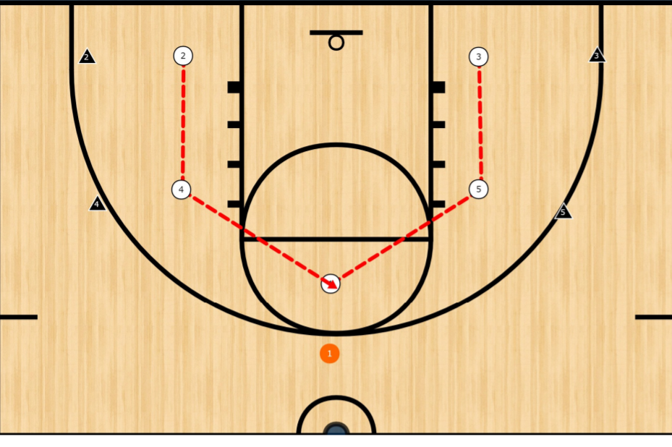

Part 2: You can see that as the PG starts to drive RIGHT, #5 slides over to pinch the PG and “help”. Here, the defender on the PG needs to communicate and say “HELP” to let #5 know to slide over and pinch. NOTE: Be sure that #5 does not completely turn their back to player they are defending as it would allow for a backdoor pass. #5 must still have Pigeon Eyes.

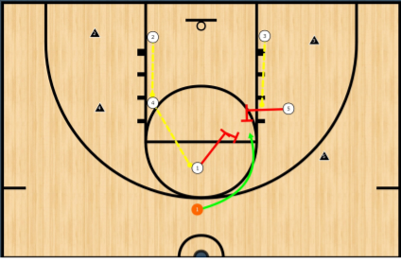

The above is a very basic “help” defense, but it all starts with an understanding of your assignment based on how far away the ball is from you. As the ball moves, the defensive players move to keep the ball and their offensive player in their peripheral.

Basic Shell Drill
The simplest drill to run is having 5 offensive players on the perimeter pass the ball to each other with no driving. Have the defensive players move and say what their assignment is on each pass (i.e. – “ball”, or “deny” or “help”). If this drill is done correctly it will sound like a circus because everyone is yelling out!
A progression of this drill is after a few minutes and everyone understanding their assignment based on ball placement, then have the offense start to try to dribble into the lane. If the offense touches the lane, they get a point. They get 5 tries, then switch offense/defense. Most points win.

REBOUNDING

As part of being a good defensive player, rebounding is an essential component.

BASIC TIPS:

- Team Shouts: “Shot!”
As part of a team defense mentality everyone should shout “SHOT!” as soon as they see it in the air. This helps make everyone aware of what they should do next.

- BBBB Method
- Body – Find a body when you hear/see a shot
- Butt – Lower your butt, spread arms and put your butt into the offensive player
- Box – Continue to Box out by applying pressure to player and moving with their movements
- Ball – Then….Find the ball and anticipate the bounce

As the shot goes up, players tend to watch the ball fly through the air and hit the rim while standing flat footed. Instead, we want them to get into the habit of finding the player they are guarding FIRST (or the nearest offensive player) and start to box them out. After they locate a player to box out, then they can turn their eyes to the rim and find the ball.

- Box Out/Rebounding Details
- “High hands, Low Butt”: Hands should not wrap around offensive player on the box out, but keep them chest high and wide (“Ready Hands”), all while staying low to prepare for jump. A player may have low hands at first to find the player’s body, but then the hands should go high as the player “gets big”.

- “2 feet to 2 hands to Chin”: Jump off of 2 feet, use 2 hands to snag ball, and come down with ball at chin, elbows out and ready for outlet pass.

- Outlet Pass/Fast Breaks
- Once the player gets the rebound get them into the habit of turning and looking for a pass to someone that is running freely up court.
- “Find a Lane”: If passing option is not there, have rebounder dribble up court, preferably towards the center lane and the other offensive players take the outer lanes as they run down the court.
  - Also, train the non-rebounders to fill a lane for the fast break (either right, center, left, or trailing) and run up the court looking for a pass.
OFFENSIVE SETS

- Teach Concepts & Options – Not Set Plays
- We should resist the urge to have set plays every time down the floor for the younger ages. They will tend to stand in “their spot” and not move if they are not part of the play.
- Instead, we want to coach towards free-flowing movement that is created by what we see from the defense: “what options do you have?”.
- Focus on coaching to pick-n-rolls, off-ball screens, reading defense, and communicating with each other to create opportunities!

- When To Use Set Plays
- At the end of close games
- Out of time outs
- Out-of-bounds plays
- To get the ball to a specific player

- Goal is to “crack their shell”
- Teach the concept that most defenses are protecting the lane and playing a shell/help defense.
- Our goal is to move (with and without the ball) to crack their shell and get someone out of position and to confuse or beat the “help” defender.

- Offensive Formations
- When in doubt, Spread it out! Focus on spreading the offensive players and creating space to work. We get into trouble when we bunch up or try to force the ball into areas where there are more than one defender.
- “Good Things Happen in the Lane”: Concept is that all movement starts outside and moves into the lane as a first option. (i.e., rolling on a pick, back-dooring a tight defender, giving and going). The closer we can work the ball into the lane for an open shot, the better!
- Five-Man Out Formation: A great starting point for youth players is with a “Five-Man Out” formation where every player is outside of 3-point line. This encourages team strategy movement by everyone (i.e., picks, give and go’s, etc.). It also spreads the defense and makes it easier to “crack the shell”
- Four-Man Out: A variation of the offensive concept can be a four-man out where there are 4 players on the perimeter and one player roaming the lane to create offensive movements (i.e., off-ball screens, picks for ball handler, etc.).

Options for Set Plays
Again, we should not stress set plays every time down the floor as focusing on a few plays may makes the offense stagnant and predictable. However, having set plays may come in handy when you need a bucket or focus on working together.

Inserting a Motion or Flex offensive set is very complicated, even for older players. We generally want to tend to stay away from teaching multiple offensive sets until 4th or 5th grade. However, if your players are able to understand the premise of off-ball screening and creating open players that do not have the ball, then a great place to start is with the basic “shell” or “box” premise. This is a great starting point where many variations of off-ball screening and movement can be created off of this base offense.

Shell or Box Offense
- We start with the premise that we need to space the floor and the PG will be at the top of the key observing the offensive movements. The most basic positioning is for remaining 4 players to form a “box” or a “shell” along the rectangle formed by the lane (see below where there are two players on the blocks and two players on the corners of the FT line) or a larger box outside of the lane. This shell is similar to the defensive shell where we are standing near the defensive players in the shell, but we break the shell by internal movement.
- As the PG crosses halfcourt, the players on the top of the box (at the FT line), then set down-picks for the two players on the block. The players on the block, then cut up towards the FT line to receive the pass. The concept of any beginner offense should be to form a shell around the lane (or the perimeter) and the objective is to get it into the lane for a layup or close shot versus settling for jump shots.

Shell – Option #1 (Tight to Lane)

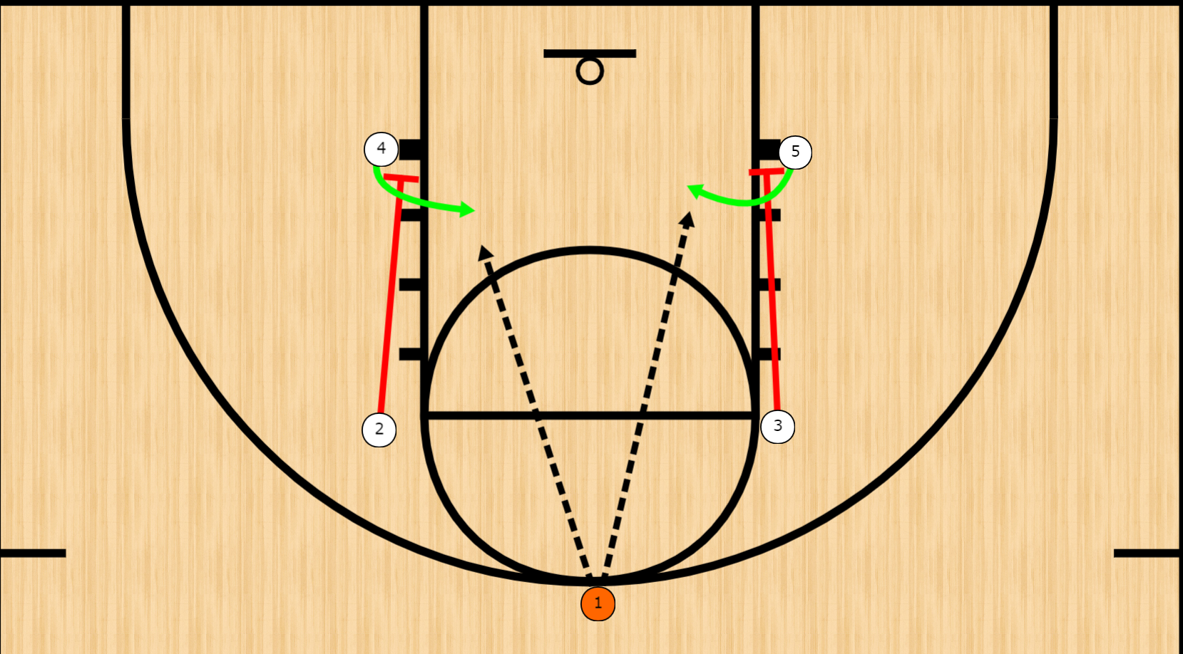
Variations From Shell
Once your players start to understand the constant movement and flow from the shell offense, you can transition to different variations that are based on the basic shell concept. Here examples below where it’s the same concept, just spreading the floor more and using different movement.
Option #2 (Spread)
This variation only spreads the floor and the “box” becomes larger to create more open space in the lane.
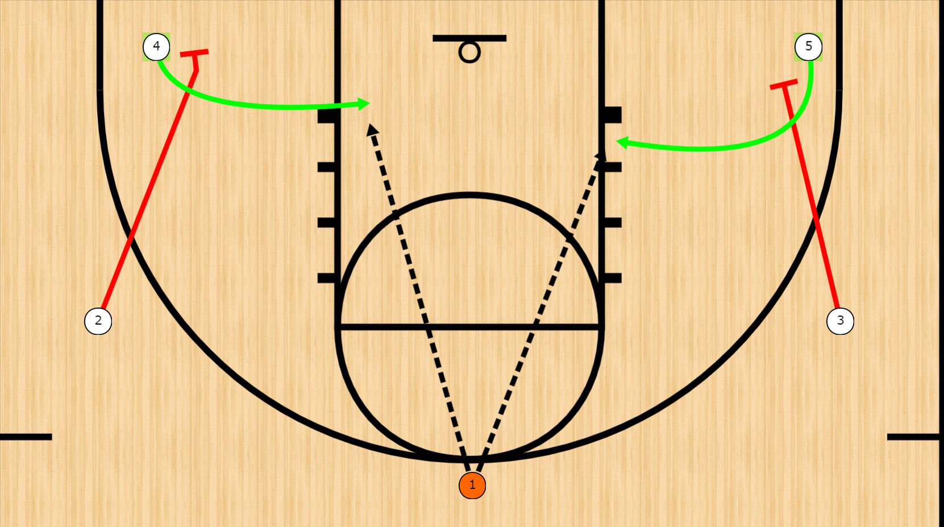

Option #3 (Spread and Up Pick)
In this variation, the wing players are receiving the pick and cutting to the hoop.
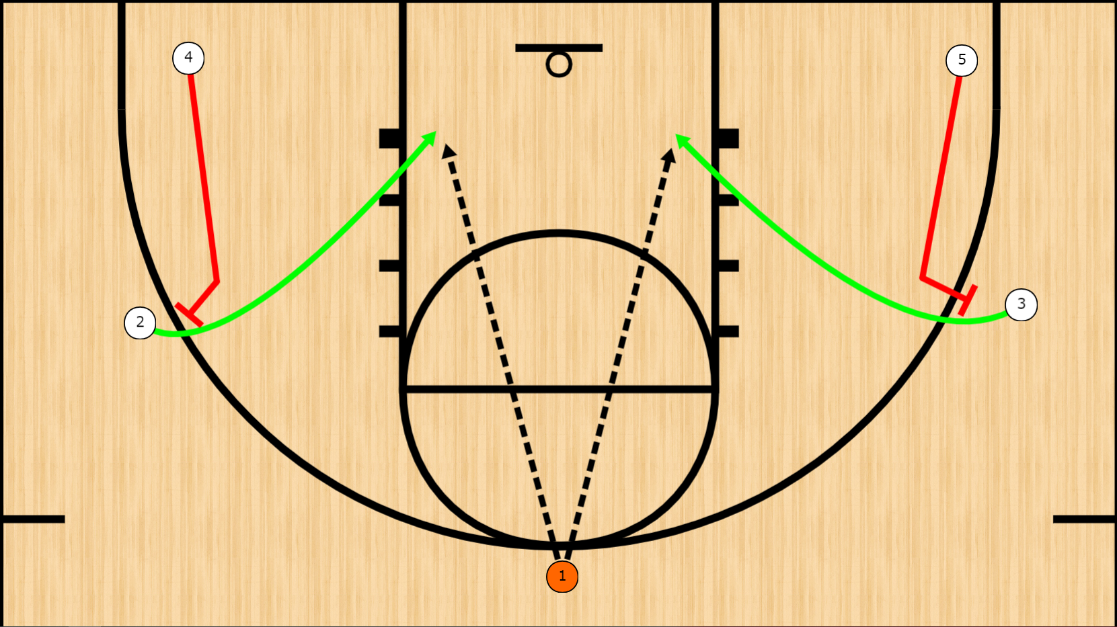
Option #4 (Load Side)
In this variation, the “box/shell” is moved to the LEFT (or the RIGHT) to overload that side and leave the right side of the floor for the PG to drive and dish. The wing players move RIGHT after a pick from the inside players but the PG should be encouraged to drive and use the open part of the floor on the RIGHT while looking LEFT for the crossing players.
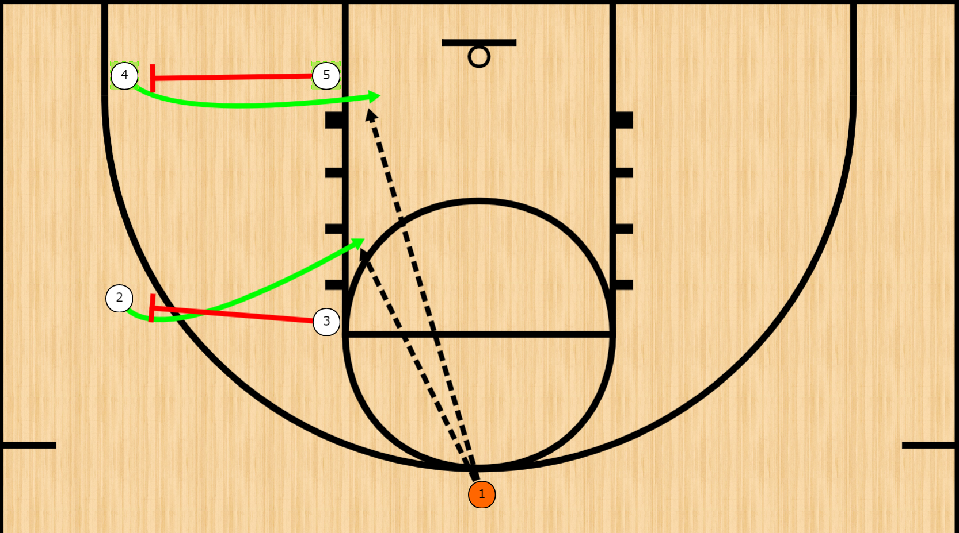

FITNESS CHALLENGE

- Basketball is a physical sport that requires stamina and outstanding cardio to last the entire game. It is never too early to start stressing the importance of physical fitness to your players and why it is necessary to be successful at basketball and sports in general. Generally, at an early age the better teams tend to have the more physically fit players.

- While we don’t want to overstress our youngsters at an early age and force extraneous conditioning upon them, we can still instill in them a sense of pride by taking responsibility for their own fitness. Additionally, we can make their physical fitness an area they can control and by the end of the season we’ll be able to see more development and they can take pride in that development. If you attach a reward to the top few kids who complete the most exercises in a month, you can make it a competition for the top and each player helps push each other to complete the exercises. If all kids complete the exercises every day for a month, week, etc., you can offer a pizza party or have the coaches run laps or some other fun.

- As a way to have the kids take responsibility for their own fitness, we can give them a monthly fitness challenge where we give the kids a tracking sheet with various exercises that are designed to work the muscles most used in basketball (i.e., quads, core, shoulders). The goal is to stress to the kids that they can and will get better if they work their muscles and skills outside of practice. Practice is a time to learn skills from a coach. The real work comes between practices and games at home in the driveway or at the local gym.

- The attached sheet is an example of exercises we can have them perform and feel free to make it what you want. We have also integrated some basketball skills that can be performed by any kid that has a ball. These are fundamental skills that will help with muscle memory and just get younger kids used to handling a ball.

PRACTICES – GENERALLY

MENTAL ASPECTS OF PRACTICE

- Competition & Focus
You’ll tend to notice that if you make your practice’s drills a competition, the kids tend to focus better than if they think they have to do a drill and don’t understand the “why” of the drill. While we don’t want our players to think that winning is everything, we want them to compete hard and understand losing on a daily basis. The opposite of this is just learning skills and never having the kids compete in practice, then when they get into a game scenario, they don’t know how to deal with having the ball stolen, missing a shot, etc. This way we can control the environment for dealing with the loss vs. having a meltdown in the middle of a game.

- Focus
This is the hardest skill to teach kids. We start stressing that practice is a time to focus on getting better and focusing on the task at hand for each drill. We don’t just want them practicing just to practice without realizing why they are practicing and just going through the motions. Coaches should try to stress during each drill there is a main focus or point that they’re getting better at and have them concentrate on that point. Explain to them that the point they are focusing on will make them better in the long run.

For instance, during a shooting mechanics drill, it is common to have kids completely ignore the mechanics you are trying to instill because they are too worried about the result of making the shot. You may want to have them shoot against a wall first and have them concentrate on snapping the elbow or other learning point and have them think about nothing else. Once you believe they are focusing on the mechanics point, move them to the hoop to execute and make sure they still maintain the mechanics you just taught.

- Fundamentals, Fundamentals, Fundamentals!
Every fundamental should be a part of every drill and you should try to incorporate and piggyback a few fundamentals during every drill. At an early age, you may want to have just a dribbling drill where they learn the basics of walking and dribbling. But as they get older, try to piggyback fundamentals in drills. For example, you could build a dribbling drill that works on two dribble moves to move into a balanced shot with proper form.

- Progression of Drills:
It is always good to start with a fundamentals drill that is 1 v. 0. But then move into a smaller competitive drill to uses that fundamental.

For example, 5 minutes of practicing dribbling techniques (crossovers, hesis, step backs, etc.). Then have 1 v. 1 full court scrimmage.

Or, 5 minutes of working on shooting form off of the dribble, then have 1 v. 1 game where defensive player closes out on offensive player at the top of the key and the offensive player has learn to drive or shoot.

- Decision-Making
Basketball is almost more about decision-making than it is raw skill. Structure your drills to include instructions on what options are available in certain situations and how to read those options to make the best decision. So, use some small 3 v. 3 drills to accentuate key decision-making scenarios.

For example, when driving to the hoop and you get squeezed by a help defender, what are your options: 1) push through the double and score; 2) dish to the outlet; 3) stop and retreat; 4) dish to backside cut, etc.

- Scrimmage and Stop
At an early age while skills are still very raw, it is advisable to get the kids playing real speed against each other. At younger ages, start with 3 v. 3 or 2 v. 2 so they can start to understand the basic fundamentals of offensive movement and help defense without the confusion and chaos of having a court full of players. The goal is to get them into a mindset that they are not just covering their assigned player, they are working in tandem with teammates to stop the ball. This is a difficult concept at first, but the more they play against each other they’ll find that teamwork makes it easier.

Additionally, let the players scrimmage with unscripted and unguided instructions for roughly 5-10 minutes. Let them make their own mistakes. Let them call their own fouls and organize their own offense/defense and let them learn how to deal with adapting and overcoming. Observe 1-2 teaching points that will make a difference in how they perform, then stop the practice and focus on these points and ask them to focus on doing it differently once you begin again.

- Be Positive and Have Fun!
Lastly, while we are teaching aspects of being a better basketball player and citizen, we want them to enjoy coming to practice. Try to work in at least one game that are fun for everyone and feel free to jump in some drills and run with your team. I like to take on players in 1-on-1 or the coach vs. the entire team where coaches can’t shoot in the lane. Another fun game we play during the last practice of the week is that the entire team gets to shoot a three-pointer as though it’s the last 3 seconds of the game and their down by 2 points. If one player makes a three, the entire team gets a piece of candy or some other small prize. You’ll be amazed how nothing brings the team together like candy. Plus, if everyone misses it teaches them about how to lose and how to look forward to the next opportunity when the time comes.

