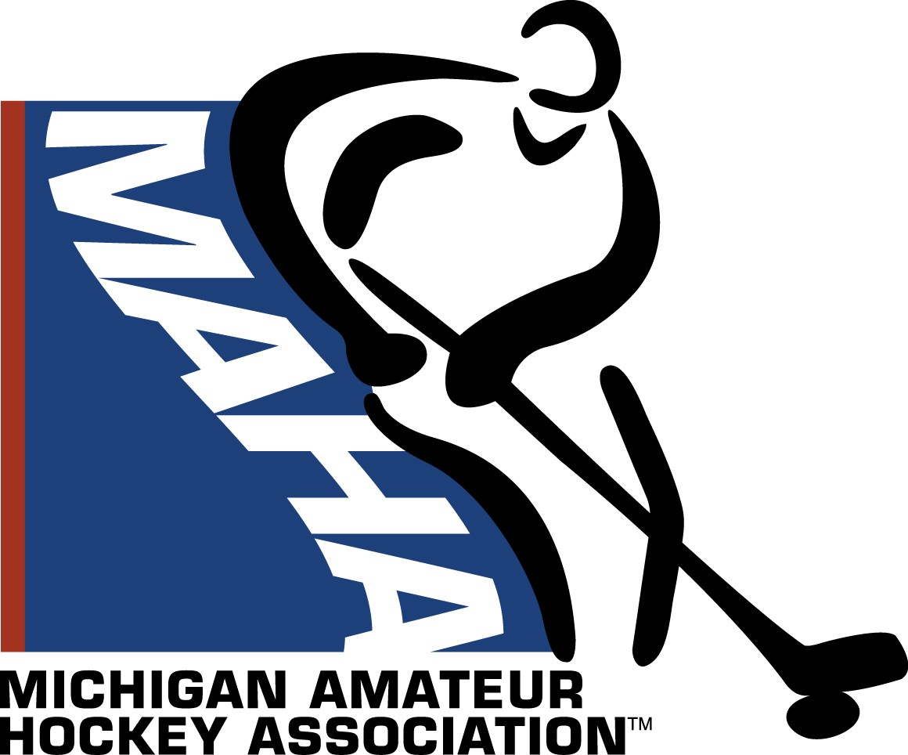**District 4 Growth Initiative Grant Request 2025-2026 Hockey Season**

# District 4 Grant Request Details

* Generally speaking, the purpose of this D4 $2500 grant is to assist an Association(s) in growing the game of hockey. See ideas and concepts at:

https:// [www.usahockey.com/page/show/4963715-grow](http://www.usahockey.com/page/show/4963715-grow)

(examples include increasing participation for the 4-8 year old age group and participation in Try Hockey For Free events and the IIHF Girls’ Hockey Weekend). Note: D4’s total $2500 grant can be split up among multiple D4 Associations so apply for the amount you deem necessary to fund your project or initiative.

Also, associations may not be awarded a grant two consecutive years for similar projects or initiatives depending on the number of applications received.

* Each association is limited to one grant request.
* Please be sure to provide complete details on the program in your proposal.
* The committee will not recommend grant funding for paid instructors/coaching.
* Submit the completed grant request via email to the District 4 Treasurer Shelly-Ann Dow at [sdow@livoniahockey.org](mailto:sdow@livoniahockey.org%20) by the application deadline of November 15, 2025.
* Applications will be reviewed by the D4 Council. Grant recipients will be notified by December 15, 2025.
* Grant recipients are required to submit **paid** invoices or receipts with demonstration of received items by January 31, 2026.
* Questions regarding the application process or your specific request should be directed to Shelly-Ann Dow

# Requesting Association Contact Information

Name of Association:

Association Address:

Main Contact:      Contact Address:      Contact Phone:

Contact Email Address:

# Grant Proposal

1. Description of proposed project
2. Duration of project
3. Description of implementation
4. Description of how the project will grow participation in the association
5. Estimated total cost of proposed project
6. D4 grant request amount