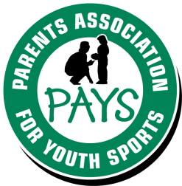

PAYS Parents’ Code of Ethics

- I will encourage good sportsmanship by demonstrating positive support for all players, coaches, and officials at every game, practice, or other youth sports event.
- I will place the emotional and physical well-being of my child ahead of a personal desire to win.
- I will insist that my child play in a safe and healthy environment.
- I will require that my child’s coach be trained in the responsibilities of being a youth sports coach and that the coach upholds the Coaches’ Code of Ethics.
- I will support coaches and officials working with my child, in order to encourage a positive and enjoyable experience for all.
- I will demand a sports environment for my child that is free from drugs, tobacco, and alcohol, and will refrain from their use at all youth sports events.
- I will remember that the game is for youth – not for adults.
- I will do my very best to make youth sports fun for my child.
- I will help my child enjoy the youth sports experience by doing whatever I can, such as being a respectful fan, assisting with coaching, or providing transportation.
- I will ask my child to treat other players, coaches, fans, and officials with respect regardless of race, sex, creed, or ability.
- I will read the National Standards for Youth Sports and do what I can to help all youth sports organizations implement and enforce them.

__________________________ ___________________________
Parent/Guardian Signature Print Name

__________________________ ___________________________
Sport Date
