Follow this link to get started
https://www.zortssports.com/notification/accept?t=32aa5b01-781b-4425-b9b9-60c8aaee84da
You will see this:

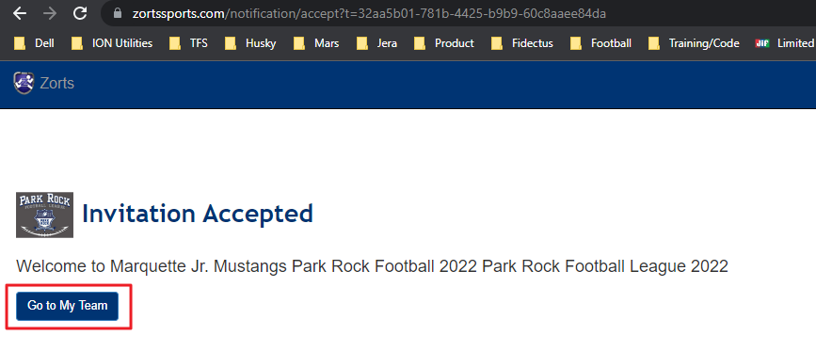
The next screen will look like this:
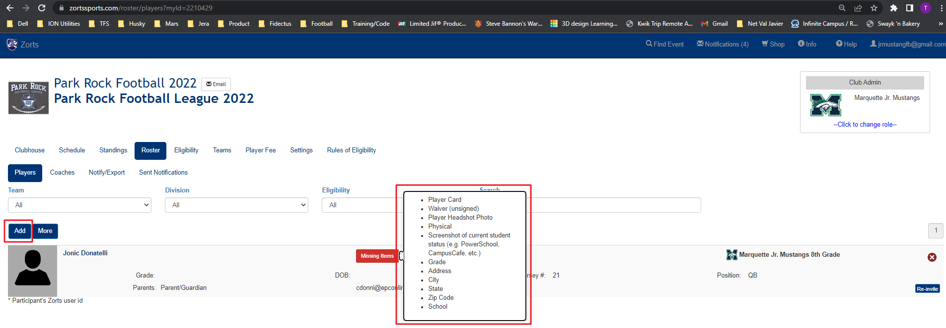
Note that for already invited players, the Red Missing Items button shows this when you hover over it. This will be what you track down for your families. Note that Current Student Status will be Infinite Campus / Campus Portal for Rockwood schools.

To add a new player, hit the Add button noted above on the left side of the screen. You will need to add Player First/Last Name, parent email and player number which you can get from Sports Engine App. The

Click the Add button (RED BOX):
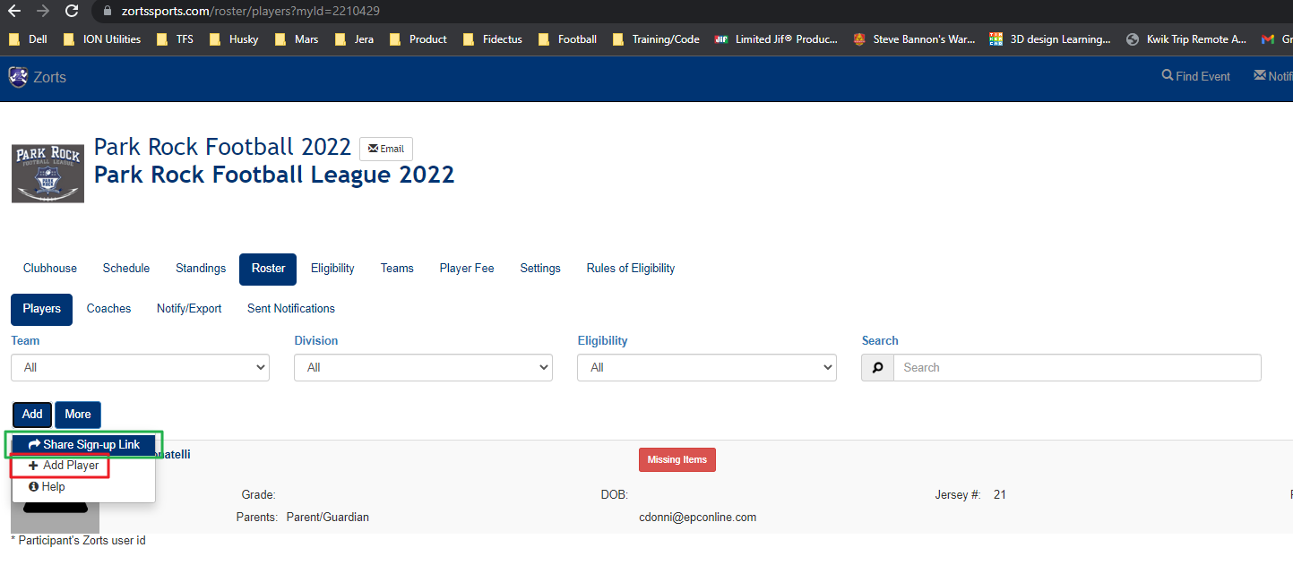
Then this screen appears. Add First/Last Name, Parent/Guardian Email Address and Player Number.
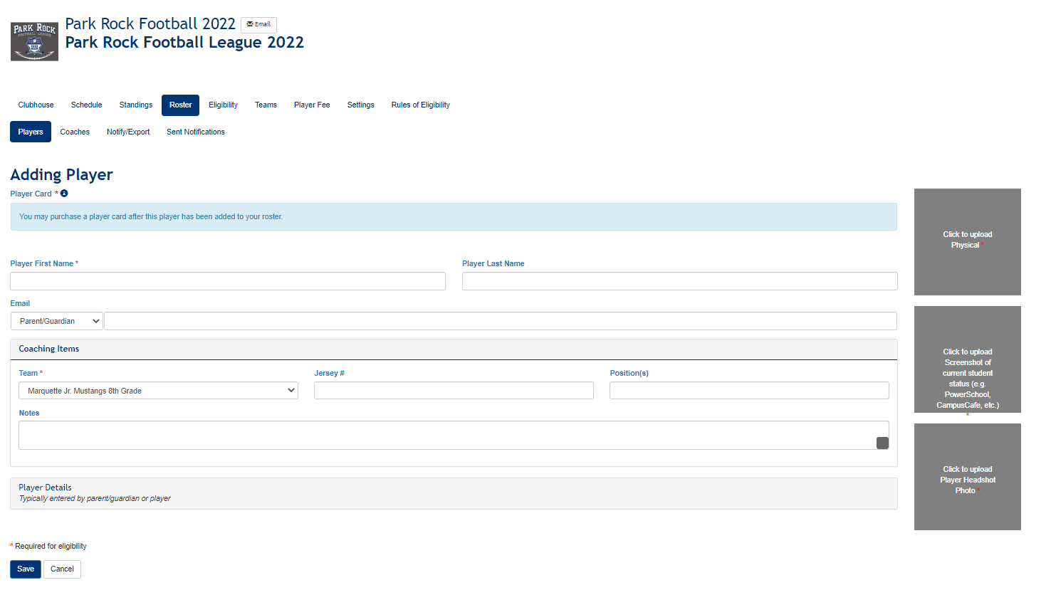
Then, back on the previous page, the Green Box (Share Sign-Up Link) gives you the ability to copy the invitation link which will be sent to everyone in that grade.
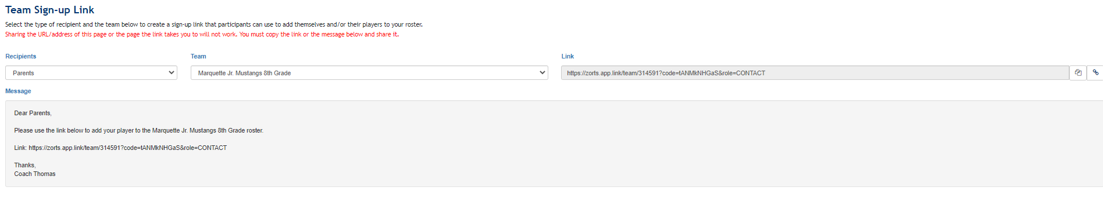
Use this Message when you send the email via the website:

Hello Mustang Families:
The Park-Rock Football League has strict eligibility standards. As a feeder program, all players must demonstrate eligibility to ultimately attend their respective high school…in our case Marquette High School. The information to be provided shows geographic information (address) and eligibility (Infinite Campus). You will also upload your physical here along with the information listed below and a Head Shot (Photo). Only our Admin will have access to this physical.
If you are not attending a Rockwood school, you will need to provide alternate information, such as state ID, passport, CYC card, School Report Card. This demonstrates your Age and Grade for eligibly. Finally, a photo with neutral background must be uploaded.
Our website contains a reference for the information necessary.
https://cdn1.sportngin.com/attachments/document/bbab-2482681/verification.pdf#_ga=2.161830587.68736083.1661029855-2086994675.1654560544
As always, contact your grade level coach with any questions!

