Porter Ridge Athletic Booster Swim Team
Coach
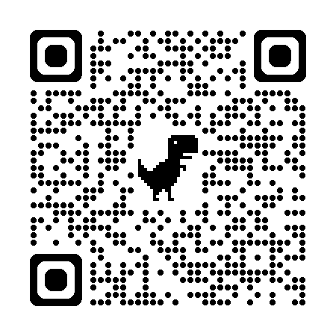
Ron Harycki

Team Commissioner/Assistant Coach
Shameeka Mcallister/Lindsey Dolan

PRABC Athletic Director
Lindsey Dolan | prabcathleticdirector@gmail.com

Tryouts
Date: October 27th @ 8:00 - 9:00 pm
Location: Wingate University Aquatic Center | 121 East Wilson St, Wingate, NC 28174
What to Expect: Athletes must be able to swim two lengths of the pool (50 meters) without stopping or touching the bottom. Preferably have knowledge of all four strokes. Athletes will demonstrate their stroke ability at tryouts. If you have a conflict with one of these days for tryouts, please email Lindsey Dolan at the above email.
Required before tryouts: MUST be registered in FamilyID with an uploaded NC approved Sports Physical to tryout. If you are not in FamilyID with an uploaded sports physical, you will not be able to try out. This is a UCPS Requirement.

Please visit www.prathleticboosterclub.org for a link to FamilyID under Resources, Documents and Forms….PRMS FamilyID Registration as well as Physical Form

Practice
Location: Wingate University Aquatic Center |121 East Wilson St., Wingate, NC 28174
Time: First Practice will be Monday, November 3rd from 8:00pm - 9:00pm
- Regular Practices will be held on Monday and Wednesday from 8:00pm - 9:00pm

Swim Meets
- There will be approximately six Swim Meets
  - Swim Meets are held on Saturday. There may be a couple during the week
- Locations (subject to change)
  - MSA Indian Trail Location : 13959 Tom Short Rd, Marvin
  - SwimMAC Location: 9850 Providence Rd, Charlotte
  - Wingate University: 121 East Wilson St, Wingate

Cost
Registration fee is $260. A link for payment will be provided via email after the team is formed. Registration must be paid by November 8th

