University of Pittsburgh Men’s Hockey
Prospect Camp – 2019
Questionnaire
First / Last Name:
DOB:
Height / Weight:
E-mail Address:
Phone Number:
Hometown (City, State):
High School:
Position (highlight those that apply)
Goalie / Left Defense / Right Defense / Center / Left Wing / Right Wing
Shot:
Team(s) for the 2019-2020 season:
At any time during the camp, will transportation need to be provided? (highlight answer)
Yes / No
Which payment option will you select for the camp? (highlight answer)
Check / Online
------------------------------------------------------------------------------------------------------------------------------------------
Please send prospect camp form to head coach Luc Brozovich at the following..
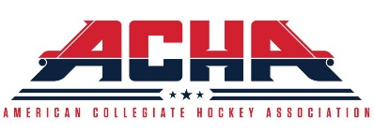
lbrozovich@pitthockey.com

