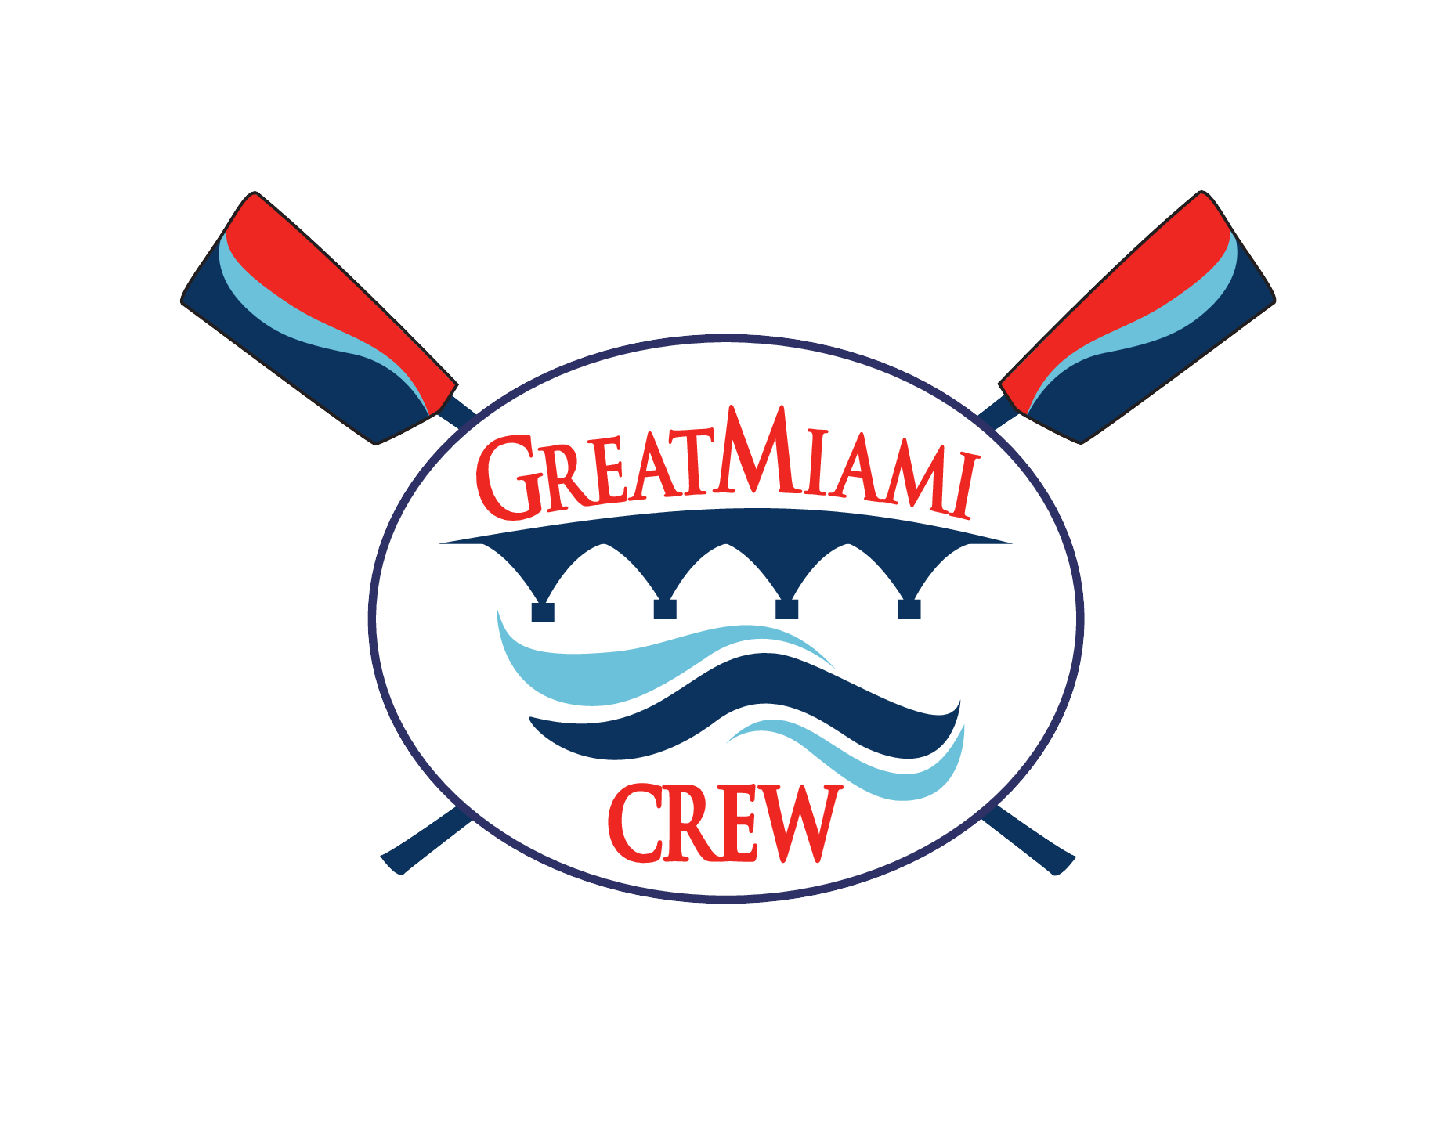
Great Miami Rowing Center & USRowing SafeSport Reporting Form
GMRC & USRowing strongly encourages the reporting of misconduct. GMRC & USRowing appreciates your willingness to report inappropriate behavior.
DATE OF SUBMISSION: ________________
SECTION I: This section is about the individual you are reporting. Please provide as much information as possible.
1. Name of Individual you are reporting (First & Last): Comments:
2. Age or Approximate Age:
3. Gender: Male/Female
4. Address (City, State required):
5. Position(s) this individual holds or held (please circle all that apply):
Head Coach / Assistant Coach / Club Employee/ Volunteer / Official / Other / Not sure
6. Club where individual works and/or volunteers or worked/volunteered previously: Comments:

SECTION II: This section asks questions about the incident or incidents you are reporting. Please provide as much specific information as you are able.
7. Type of Offense (i.e. what happened?):
8. Where did the incident or incidents take place? (City, State and any other available location information):
Comments:
9. Please Describe what happened (including who, what, when, where) Comments:

SECTION III: This section is for information about the victim or victims. If you are the victim and wish to remain anonymous, you may do so. In that case, please enter only your age, city, state, and club affiliation.
10. Name:
11. Age (or approximate age):
12. Club affiliation (if any):
13. Contact phone number (Note, if this person is under 18, please provide contact information for his/her parent or guardian):
14. Contact e-mail address (if this individual is under 18, please provide contact information for parent or guardian):
15. Gender: Male / Female

SECTION IV: Your Information
You may remain anonymous if you wish. However, providing your information is vastly helpful to a swift and effective investigation. A person reporting alleged misconduct should not fear any retribution and/or consequence when filing a report he or she believes to be true.
16. Name:
17. Phone number:
18. E-mail address:
19. Club affiliation (if any):
20. Relationship to victim (Please circle any that apply):
Self / Parent / Guardian / Other family member / Friend or acquaintance / Club member, coach or volunteer / Other or prefer not to say
SECTION V: Other Information
21. If you have any other information that you feel would be helpful to an investigation of the alleged offense you have reported, please enter it here:

