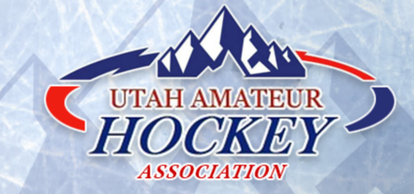
2026 BOYS PLAYER SELECTION/DEVELOPMENT CAMP
The Camp Schedule and information is posted on the UAHA website at https://www.utah-hockey.com/
Open to Birth Years*: 2009, 2010, 2011, 2012
“Goalie Only” session March 11 for ALL Goalies of Each birth year
March 13-15, 2026 for all players (including selected Goalies)
Schedules may vary for each age group

Locations for all weekend sessions: South Town Ice Sheet (Sandy, UT)
Online registration through the UAHA website is required for all participants.
The Utah Camp will be open to the first 48 Forwards, 24 Defensemen and 10 Goalies per birth years 2009, 2010, 2011, & 2012
All players must be USA Hockey registered.

Only US Citizens and permanent residents of the State of Utah are eligible to be selected
for advancement to Rocky Mountain District Player Selection/Development Camps.

This Camp is for players who have demonstrated the necessary skill level and skating ability to warrant consideration of advancement to the next level of USA Hockey’s National Player Development Camp process and is not intended for House Players or those with less than 2 years of experience.
All goalies must register and pay a $30 fee to attend the Goalies-Only Skills & Evaluation Session on Wednesday, March 11 at the Salt Lake Sports Complex.This session will be used to evaluate and determine which goalies advance to the full weekend camp. Selection is based on the number of teams per birth year (exceptions may apply).If selected, goalies must pay the remaining $125 balance to participate in the weekend sessions.
REGISTRATION OPENS JANUARY 18, 2026 @ 12:01am
REGISTRATION CLOSES FEBRUARY 15, 2026 @ 11:59pm
- Registration Fee Boys: $155 (Includes 4 ice sessions)
- All players will receive a jersey.
- Players must be present for ALL ice sessions.
- All players must register before the deadline.
- No walk-ups or late registrations are allowed.
- Please read the FAQs sheet on the UAHA website
- Parent Meeting 30 minutes prior to first ice session on Friday, March 13

The Next Level of Player Selection/Development Camps
Boys with birth years of 2009, 2010 and 2011, and are US Citizens and permanent residents of the State of Utah will be eligible to advance to the Rocky Mountain District Player Selection /Development Camp in Dallas, Texas in May 7-10, 2026.

For those born in 2012, the Rocky Mountain District,
the Pacific District and the Northern Plains District have joined forces to stage the “Western Regional Multi-District High Performance Select 14 Camp” held at Colorado College Colorado Springs, CO – June 8-13, 2026.

LINK TO REGISTER:
https://rockymountainregister.com/enroll/usah/login.asp?programid=163
For questions, please contact Steve Picano: uspdselections@gmail.com

