The 2025 Porter Parent Football Association (PPFA) Newsletter – Week7
The LTHS Porter Parent Football Association (PPFA) is a volunteer group dedicated to enhancing the football experience for players. Our goal is to foster a positive, memorable environment for each player, achieved through support for both the players and coaches. The PPFA funds its efforts through various fundraising initiatives, including spirit wear, player sponsorships, and volunteering.
- Twitter @LockportFootba1 - Facebook @ LTHSFootballBoosters  - Lockportfootball.com
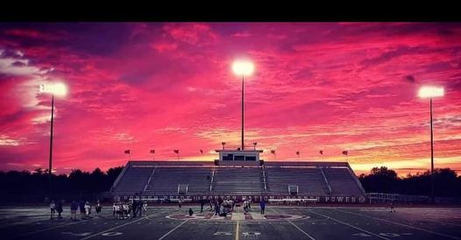Every Week
Varsity Players Pasta Dinner – Every Thursday @ Cooms Corner except this week, where we’ll serve breakfast (see below).
Week7 Varsity Breakfast (Cooms Corner): 10/10 @ 9:30am **Parent Volunteer and/or Beverage Donation**
** Ask-a-Porter ** - 10Q with Chris Miller
Game Schedule/Results
Varsity: Porters @ Carl Sandburg: Fri 10/10 @ 7:30pm Game Preview
Porters over Naperville Central on 10/3 (14-7) Game Recap
Sophomore: Porters @ Carl Sandburg: Fri 10/10 @ 5:00pm Porters lose to Naperville Central on 10/4 (21-28)
Freshman A: Porters @ Carl Sandburg: Sat 10/11 @ 9:00am Porters A over to Naperville Central on 10/4 (21-19)
Freshman B: Porters @ Carl Sandburg: Sat 10/11 @ 11:00am Porters B lose to Naperville Central on 10/4 (2-6)
News and Notes
PPFA Board Meeting: 10/21 (Tuesday) @ 7:00pm – LTHS (Porter Room)
Save-the-Date: 10/31 - State Playoffs (first round)
**Lost and Found** Missing a PPFA 2025 Newsletter? Click HERE

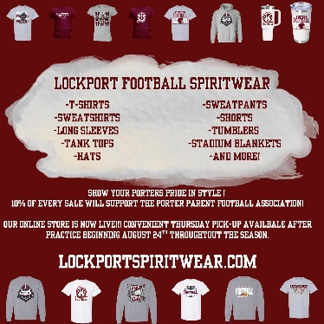
Order your 2025 Lockport Football Spirit wear HERE
Helpful Links
Spirit Wear Game Digital Tickets IHSA Football Info 8to18

