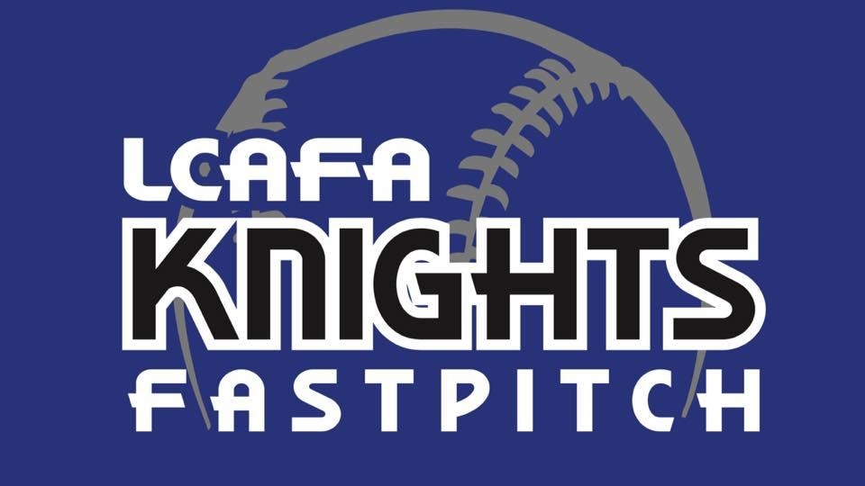

2021 LCAFA Registration

As the Lake Crystal Area Fastpitch Association board begins planning for the 2021 season, however that may look at that time, here is some information that is known at this time.

Registration for any girls who are 9 years old or older on January 1, 2021 will be January 1st through the 31st, 2021. No late registrations will be accepted, girls who are 8 & under will have registration at a later date to be announced.

To register, please go to www.lcafa.com and click the registration icon.

New Uniforms for 2021!!
We are excited to announce that the LCAFA association will be purchasing new uniforms for our 10U to 18U players. There will be future dates scheduled to try on jerseys & pants and sign up for sizes. These new uniforms are a direct product of your help with concessions, hosting tournaments and advertising for our association!

Volunteer Deposit Check
We will again be collecting a deposit check of $200 per family this year. We know that summer is a very busy time, but we need everyone to help in order to make our tournaments, field work, and concessions run smoothly. This check will be held until the end of the season, at that time if your family has fulfilled your shifts, your check will be returned or shredded. If you choose not to volunteer, your check will be deposited at the end of the season. Each family will be responsible for 2 volunteer shifts or families with multiple girls, 1 shift per player. This check is due when you pick up your daughter’s new uniform.
Note: adjustments will be made pending how the season does look this year.

How to contact us
Email: lcafainc@gmail.com
Website: LCAFA Website is up and running and a continued work in progress: http://www.lcafa.com
Address: PO Box 442 Lake Crystal, MN 56055

