Notify Me Instructions
- Click on the Notify me Link

- 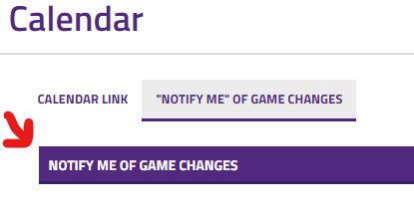
- Create an account
- Fill in the name, email, and phone information
  - Make sure to put in your phone carrier information so you can receive text messages if requested
- The next page is “Step 2” Choose Activities
  - You can choose to get notifications based on the school, the events, or school only events.
  - I would not choose “Categories”-schools. That portion is not completely set up
  - Choose the level, or levels, under “Conference/Non-Conference Events
  - Click “Continue to next step” at the bottom
- The next page is “Step 3” Notification preferences
  - You will see the activity/event you chose on the previous screen
  - Hit the down arrow and select notification you would like. (1 hour, or 1 day…)
- When you are finished, it will bring you to the calendar. There is nothing more you need to do

If a game is changed or cancelled, for the event you chose, you will receive the notification of that via email and text.

Calendar:
Now that you are on the calendar, you can also use this to pull up only the schedule you are interested in seeing.
- On the right side of the page, under the month view of the calendar, click the eye “view Schedules” option.
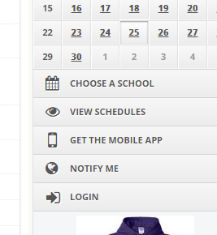
- You will see the list of available schedules to choose from.
- Select the one or more you are interested in, and click “view”.
- A new window will pop open with the schedule you chose.
- You can print this screen, email it, or download it. Look in the top right corner to see those options.
- You can also “subscribe” to this schedule. It the same upper right hand corner of the screen, click on “Subscribe” and you will get a detailed screen on how to have the schedule integrate in your own personal calendar
