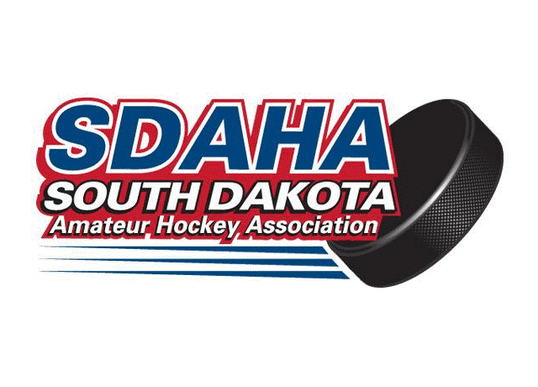
To: SDAHA Member Associations
From: SDAHA Executive Committee
Dated: December 7, 2021
Regarding: Zero Tolerance Policy Clarifications

SDAHA’s Administrative Rules under Section 9, Subsection d state the following:
- Parents/Spectators:
    - The game officials will stop a game when the parents/spectators displaying inappropriate and disruptive behavior interfere with other spectators or the game. The game officials will identify violators to the coaches for the purpose of removing parents/spectators from the spectator’s viewing and game area. Once removed, play will resume. Lost time will not be replaced, and violators may be subject to further disciplinary action by the local/state governing body. The Locals have the primary responsibility for crowd control behavior. This inappropriate and disruptive behavior shall include:
      - Use of obscene or vulgar language in a boisterous manner at anyone at any time.
      - Taunting of players, coaches, officials or other spectators by means of baiting, ridiculing, threat of physical violence or physical violence.
      - Throwing of any object in the spectators viewing area, player’s bench, penalty box or on or off ice surfaces, directed in any manner as to create a safety hazard. Spitting at players, officials, off ice officials, minor officials, or fans/spectators is also prohibited.
    - Basic rule of thumb: If you think it might be offensive to you or someone else, it probably is and should be dealt with.
      - 1st Offense: Removal from the Ice Arena for the remainder of the day and evening and a report with name, address, and reason of the person or persons is recorded and sent to the SDAHA Discipline Committee Chairperson. A written warning will be issued to the local association. The local will give a written warning to the person or persons in violation and a copy to the Discipline Chairperson.
      - 2nd Offense: Removal from the Ice Arena and All USA Hockey games, events, and practices for a Minimum of but not limited to a period of two weeks. If the offender violates the two weeks an additional two weeks will be added to the offender. A report with the offender’s name, address, and reason for getting removed is sent to the SDAHA Discipline Committee Chairperson. A written warning will be issued to the local association. The local will give a written warning to the person or persons involved in their local and a copy to the Discipline Chairperson.
      - 3rd Offense: Banned for the rest of the hockey season with a minimum of six weeks from all USA Hockey games, events, and practices. If there is not six weeks left in the hockey season, the remainder will be carried over to next season. A report with the offender’s name, address, and reason for getting removed is sent to the SDAHA Discipline Committee Chairperson.
__________________________________________________________
The SDAHA Executive Committee wants to provide Clarification, Guidance, and Direction to all member associations on items contained within this Zero Tolerance Policy Language and how they will be interpreted and applied:

          - Under Section d, Subsection i, the policy states “The Locals have the primary responsibility for crowd control behavior.” Please note this does not say only the Host Association but is says Local Associations. The Interpretations and Expectations regarding this statement are as follows:
- Each Local Association (both Home and Away Associations) have the primary responsibility for crowd control behavior of its Spectators and Parents at all locations in all rinks.
- This applies whether you are hosting in your home rink or are playing away in someone else’s rink.
- This expectation applies whether the Spectator or Parents are members of your local association or fans who are non-members.
- Essentially responsibility lies with the Association/Team for whom the Spectator or Parent is supporting to ensure their behavior is appropriate and respectful.

          - The Host Association has the Primary Responsibility in determining and enacting the Removal of a Spectator from an Arena. In addition,
- Leadership from the Visiting Association has the right and ability to recommend the Removal of a Problem Spectator to the Host Association. In the event there is negligence by the Host Association in addressing the Problem after it has been raised, the Visiting Association should report this to the SDAHA President for any review and subsequent action.
- Leadership from both Associations should work together to resolve the situation. Blatant disregard for authority of either association will not be tolerated and will be viewed as a violation of the Zero Tolerance Policy.
- If a Parent or Spectator is removed from an Ice Arena, the Host Association is charged with meeting all reporting requirements as set forth in the SDAHA Administrative Rules Section 9, Subsection d, Subsection ii regarding the reporting of the incident.
  - If the host association cannot determine the identity of the Parent or Spectator removed who is a part of the Visiting Fan Base, the leadership of the visiting Association shall complete the necessary investigation to determine their identity.
  - If the host association cannot determine the identity of the Parent or Spectator removed who is a part of the Hosting Fan Base or an anonymous Parent or Spector, the leadership of the Host Association shall complete the necessary investigation to determine their identity.
  - Even if the identity of the Parent or Spectator who has been removed cannot be identified by either Association, the available information shall be provided as required by the SDAHA Administrative Rules to ensure the activity is tracked.
  - Essentially if someone is removed, a report must be filed.

Also the Administrative Rule identifies the following: “This policy is designed to require all players, coaches, officials, team officials and administrators, and parents/spectators to maintain a sportsmanlike and educational atmosphere before, during and after all USA Hockey sanctioned games, events, and practices.” This means conduct in the lobbies, hallways, locker rooms, coaching rooms, ref rooms, and all other areas of the rink at all times will be measured in the same manner as the Spectator areas.

These Interpretations and Expectations related to the Zero Tolerance Policy shall be applied when determining any violations to the Policy not specifically defined elsewhere.

