July CAA Diamond Sports Digest



CAA Diamond Sports Board - Welcomes Katie Recker!
By CAA Diamond Sports 07/01/2021, 3:00pm CDT
CAA Diamond Sports would like to welcome Katie Recker to the Board as the Softball Player Agent. Katie will plan and coordinate player evaluations, manage evaluation scores, and maintain the integrity of the player evaluation process. Thank you Katie for stepping up and filling an open spot on the board!
October is the Annual meeting for the Diamond Sports Board where we have elections for open positions. More information will be sent out later this summer with the positions will be opening this October. In the meantime, start thinking about if you could make the time to volunteer on the board and what position might be a good fit. CAA is a volunteer organization and we need everyone's help to make it a successful!
Here is the link to the Baseball and Softball Leadership Positions:
https://www.chanathleticassociation.com/baseball-leadership
https://www.chanathleticassociation.com/softball-leadership
If you have any questions, feel free to reach out to any of the board members to find out more.


Tryouts - Save the Date!
By CAA Diamond Sports 07/01/2021, 2:45pm CDT
Save the Dates! Tryouts in August are for the 2022 baseball and softball tournament teams, and also for the fall 2021 softball season which starts in August. We will have information meetings later in July to cover our program offerings and answer questions about CAA Diamond Sports. Registration for softball will be ready in the next week or so and baseball will be later in July. We will send the links out when they are ready.
Softball dates: Aug 3rd & 4th (evening) for 10U & 12U travel teams.
Baseball dates: Aug 20th-22nd for ages 9-14 tournament teams.
If you have any questions contact:
Softball: Mark Stay mark_stay@hotmail.com or Kelli Strauss kelli.a.strauss@gmail.com
Baseball: Jake Isenburg (9-11 year olds) jisenburg@hotmail.com
Jerry Orcutt (12+) jmorcutt320@gmail.com


Softball State Qualifier Recap
By CAA Softball 07/01/2021, 2:30pm CDT
CAA Softball hosted a 10U State Qualifier bracket tournament at Lake Ann June 26th and 27th. There were 28 teams from around the Metro, an estimated 1,000 people experiencing fastpitch softball! Rain impacted Saturday afternoon games as the fields became muddy, but with the wonderful help of Jeff Olson from the Dugout Club and multiple volunteers the fields were dried and once again ready for play. Sunday started with rain, but again Jeff and the many volunteers stepped up and kept the fields in playing condition. Games were shortened on Sunday to make up the two rounds that were postponed from Saturday and the entire tournament was finished by 7:30 pm. Sunday! Concessions were also run by volunteers and were a huge success! Overall, the tournament was a great success and people enjoyed coming to Lake Ann and seeing what a great complex Chanhassen has to offer for softball. Congratulations to Orono Blue 10U for winning the championship game after coming through the loser’s bracket and playing 8 games on Sunday alone! Special thanks to the tournament Director, Meg Stone, for working tirelessly on setup, coordination and working through the rain re-scheduling issues with MN Softball and Kelli Strauss for countless hours spent in setting up and coordinating the tournament and also making multiple trips to get food to keep the concession stand stocked all weekend. Lastly, special thanks to the many volunteers that stepped up and did an absolutely amazing job running concessions, prepping fields and offering to help!
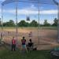

Taking Care of our Fields
By CAA Diamond Sports 07/01/2021, 2:15pm CDT
Last month's Newsletter highlighted the Dugout Club and all they do to care for and improve our fields, but they can't do it alone! We have asked all coaches for their help with this by taking a few minutes after games to rake the fields. In particular the holes dug in the batters box and pitching mound. This helps with drainage when it rains, it helps the city when they drag the fields, and it helps the crew chalking the fields. As players and families you can help with this by grabbing a rake and helping out or being patient while players stay an extra few minutes after the game to rake the fields. Let's take CARE & PRIDE in our fields!


CAA night with the Redbirds
By CAA Diamond Sports 07/01/2021, 2:00pm CDT
The Chanhassen Redbirds would like to invite all CAA players to attend the Redbirds vs Cold Spring game on Saturday July 17th at 5:00pm.
All kids in their Storm/CAA uniform will receive a ticket for a free popcorn and can run the bases and get autographs after the game!

Link to Redbirds Website:
https://www.chanredbirds.org/teams/?u=CHANHASSENREDBIRDSBA&s=baseball



Safety Update - Incident Form
By CAA Diamond Sports 07/01/2021, 1:45pm CDT
New this year we have added an Incident Report Form to our website.
Types of Incidents to report are: A) Concussions B) All other injuries that result in doctor visit C) Positive Covid-19 test results (of coaches and players) D) Any Behavior/Conduct incident (by any player, coach, umpire or fan). The Incident Report Form should be completed within 24 hours of the Incident.
Coaches or families can fill out this form and it will be submitted to our Safety Officer for review and follow-up if needed. The link to the Safety Resource Section of our website is below.
https://www.chanathleticassociation.com/baseball-safety


Coming Soon 8U/10U/12U Softball Skill Building Clinics!
By Katie Recker 07/01/2021, 1:30pm CDT
This summer, CAA Softball is excited to partner with local softball talent to provide small group, skills-based instruction in the following areas; fielding, batting and pitching/catching. The location will be Lake Ann Park, the weeks of July 12th, 19th and 26th. Additionally, there will be an optional session focusing on a 'mock tryout' to help prepare new players on what to expect for the upcoming August tryouts. Watch your email for important session details and registration information soon!

CAA Diamond Sports is proudly supported by:

At SCHEELS, we have a team of customer service experts passionate about the products within their department. We are dedicated to having the best retail experience in the eyes and minds of our customers where everyone can discover their passion for sports, hunting, fishing, camping and much more.
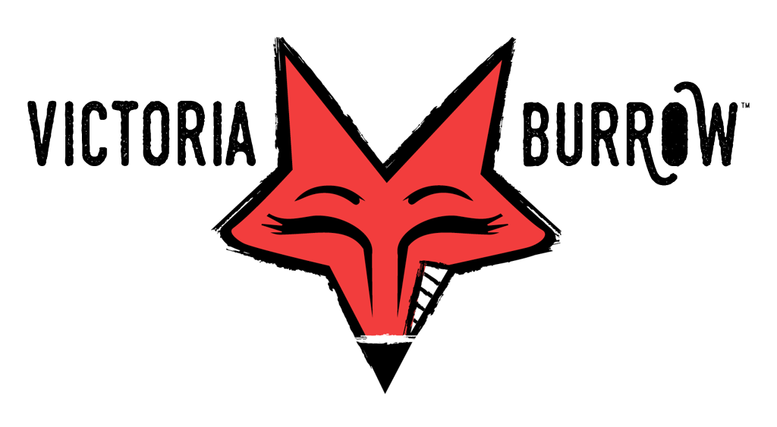
Food, Drinks, Shenanigans!
18-holes of championship level mini golf, Axe Chucking, bocce, classic arcade games, Pinball, darts, and so much more . It's all alongside food made from scratch, regional and local taps, and full bar - right in downtown Victoria, MN.

Our mission is to provide unmatched speed, power, deceleration, energy system development, movement and performance mastery training for serious athletes who are 100% committed to fully maximizing both their genetic physical and psychological potential. Our programs are designed for all athletes, at any ability level, from every sport, and customized to fit their needs.

