2023 Team Indiana Boys Heartland Duals Report

Team: IN Elementary/ IN MS

Team Leaders & ISWA Title: Ryan Parrish Folkstyle Developmental Director/ Jason Miller Kids Director
Coaches: Elem (gold) Ryan Parrish, Matt Kelley, Kyle Marsh; (Blue) Dave Wyatt, Randy Cochran, Nick Krause
MS: (gold) Sean Schmaltz, Pat Dowty, Scott Maddox; (blue) Gabe Dunham, Javier Salas

Volunteers & Others You'd Like to Thank: Melissa Strayer who helped with all gear hand out for teams

Team Results:
Elem Gold: (9th place overall in Diamond Bracket)
Vincent Obergon: 5-2
Layten Marsh:5-2
Oliver Guernsey: 4-3
D'Angelo Chavez: 7-0 --All American/ MVP
Max Kessinger: 4-3
Decon Gibbs: 5-2
Dron Scott: 2-5
Maximus Kleeberg 4-2
Ty Whitten: 5-2
J.J Doty: 4-3
Brody Weimer: 6-1 ---- MVP
Cameron Cooper: 4-3
Hayden Mullins: 3-4
Noah Fitzgerald: 6-1
Gavin Brown: 5-2
Bryce Harrell: 4-3
Mason Heidleberger: 5-2

Elem Blue: (10th place overall in Diamond Bracket)
Suncera Dickman: 6-2 -----MVP
Colton Herigis: 2-6
Karsten Casteter: 4-4
Colton Wiseman: 5-3
Henry Antrobus: 4-4
Haedyn Cochran: 5-3
Alex Ponce: 2-6
Derek Rogers: 4-4
Vaughn Wyatt: 5-3 ----MVP
Harper Lee: 4-4
Dalton Jones: 6-2 ----MVP
Noah Plahitko: 1-7
River Lilly: 4-4
Todd Gonzales: 4-4
Ellis Jones: 3-5
Skylar Mack: 5-3
Max Creager: 3-5

MS Gold: 1st place National Champions overall (Diamond Bracket)
75 Connor Maddox 8-0 ---AA
80 Cam Schofield 6-2
85 Traevon Ducking 7-1
90 Sebastian Garcia 4-4
95 Dallas Rosenbarger 8-0 ---AA
102 Patrick Dowty 3-5
110 Colin Strayer 7-1
117 Tony Kessinger 4-4
125 Gavin Lewis 8-0 ---AA
132 Lincoln Cooper 8-0 ---AA
140 Elijah Guyer 5-3
150 MJ Staples 8-0 ---AA MVP
160 Lucas Boe 8-0 ---AA MVP
175 Ben Clark 6-2
195 Ceasar Salas 7-1
220 Zach Clark 7-1
Hwt Tony Brooks 7-1

MS Blue: 17th place overall (1st place in their Gold bracket)
Javier Salas 6-2
Lukas Scott 2-6
Reed Wicker 6-2
Jacob Power 1-7
Nicholas Freeze 5-3
Lincolon Underwood 4-4
Bo Jackson 3-5
Cohen Long 3-5
Cameron Sommers 4-4
Jonah Strain 4-4
Aidan Kincaide 7-1
Aleksandar Tatum 5-3
Paul Woods 4-4
Kellen Fellure 3-3
Colin McMahon 8-0 ---AA & MVP
Carson Powell 6-2

Narrative: The behavior from all the kids on all teams was a great representation of Team IN teams with having no issues at tournament or hotel.

Special Awards: The Elementary Blue team received the sportsmanship award trophy for the tournament voted on by the other teams coaches and mat officials.

Photo(s):

Elem Gold Team
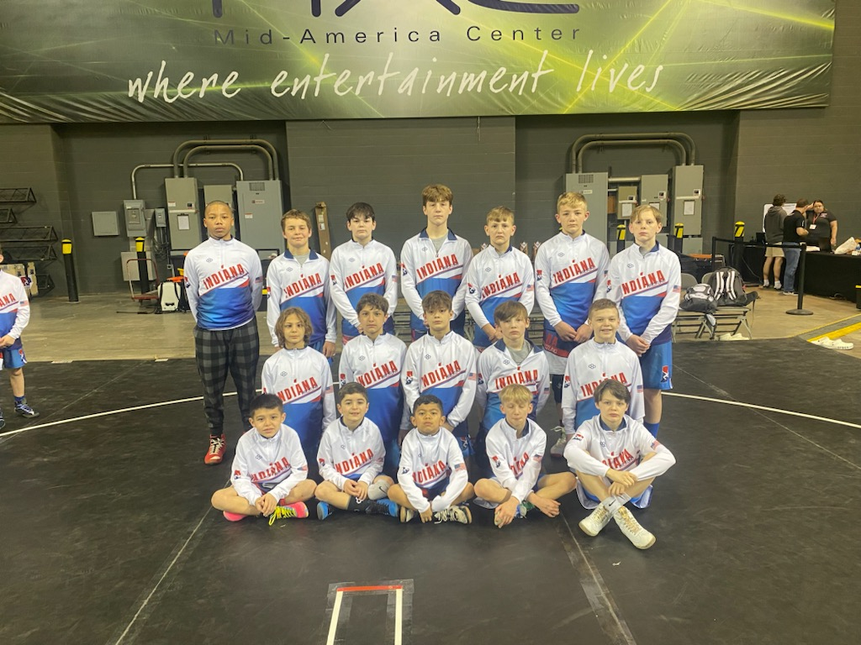

Elem Blue Team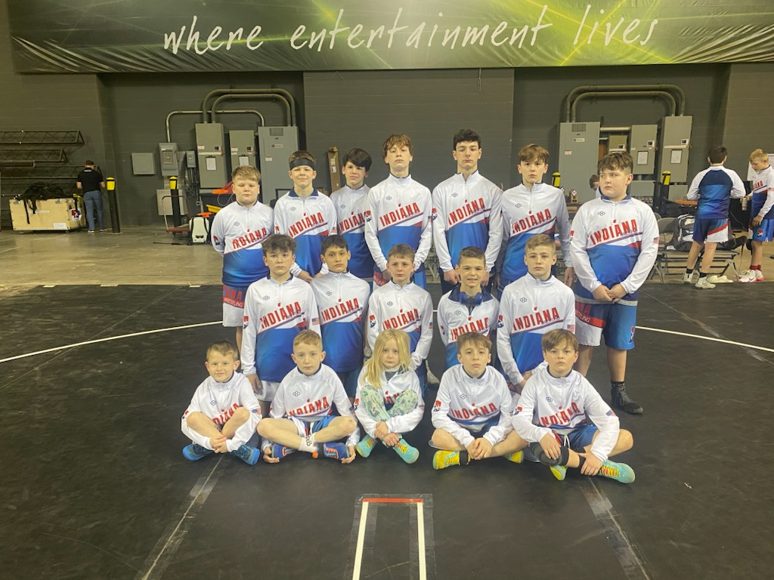

MS Gold Team Nat’l Champs
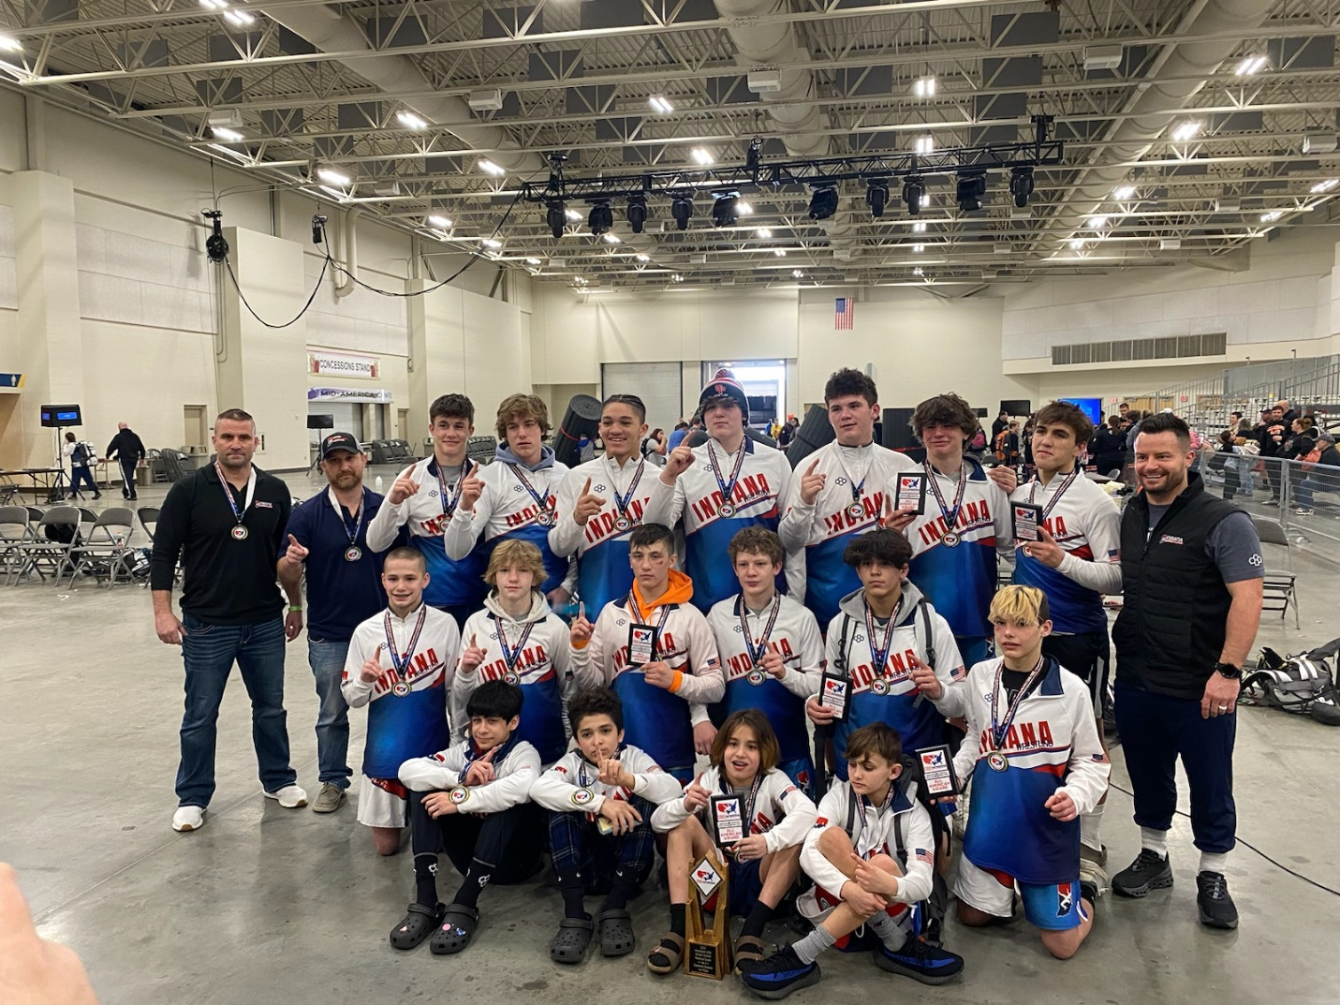

Blue Team MS
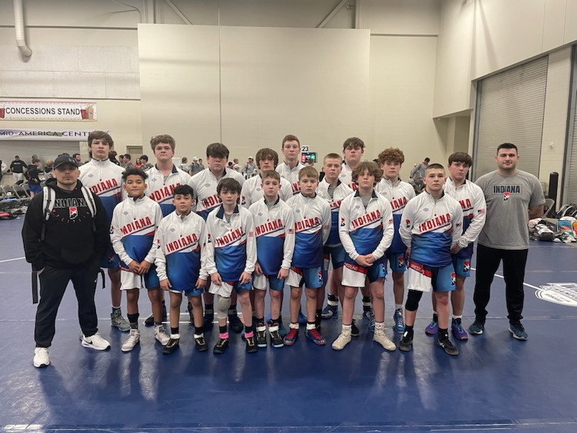

Thank you!

