PINNACLE SPORTSENGINE SET UP

When set up correctly on sportsengine parents and athletes gain access to information and the ability to RSVP.

Please follow this set up procedure to allow athletes to register themselves for events and practices. This will also allow athletes to reply if they are attending events on the calendar when prompted.

Step 1: Sign on to the www.pinnussa.com website. This will sign you into SportsEngine.

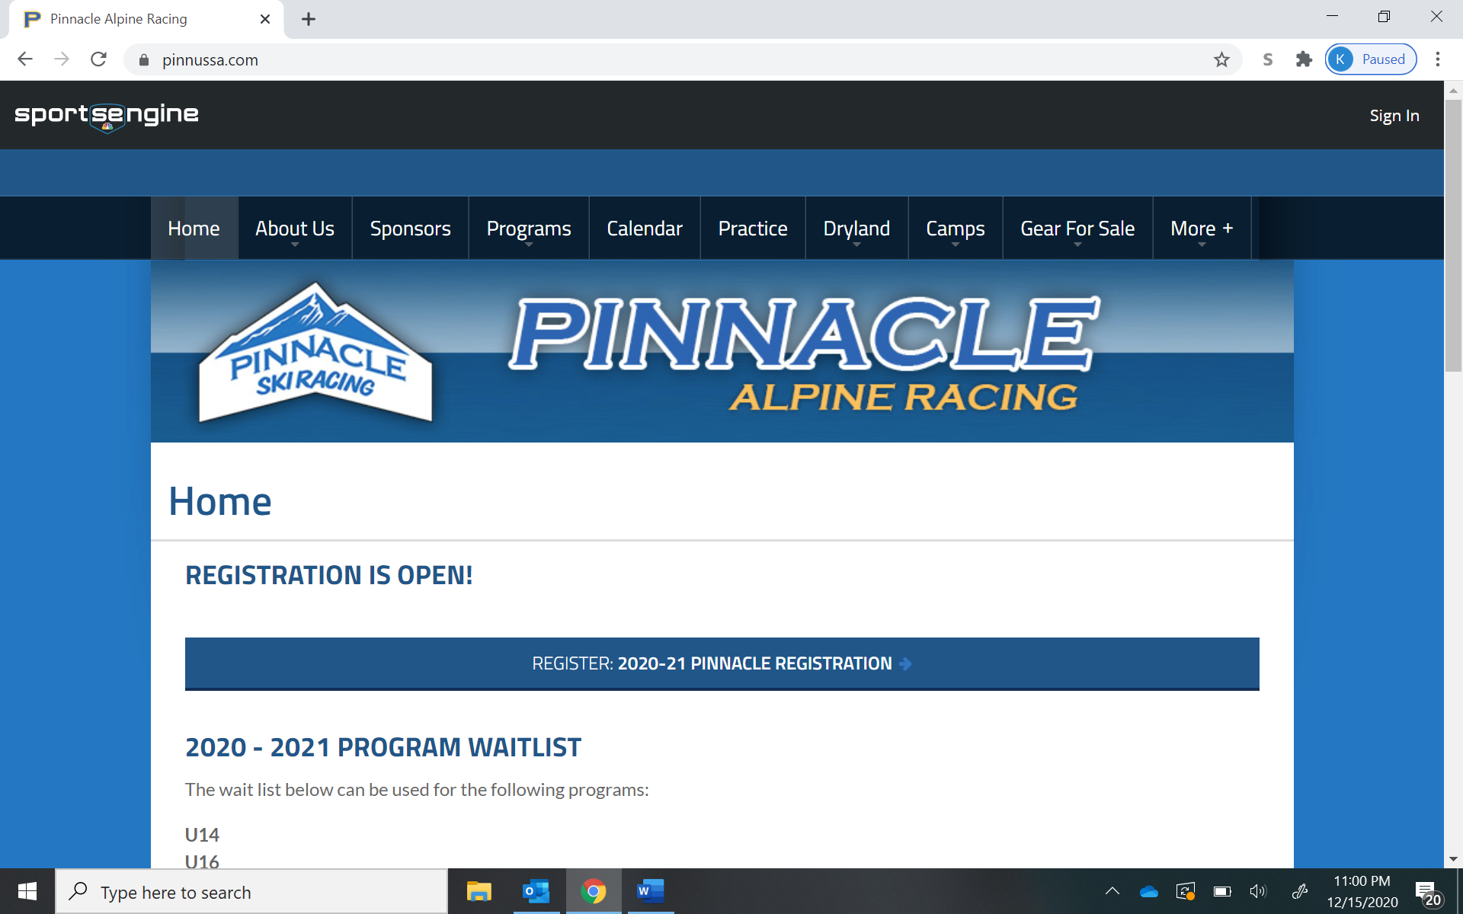

Step 2: Once signed in right click on your initials and then click the “My SportsEngine” link under your name:
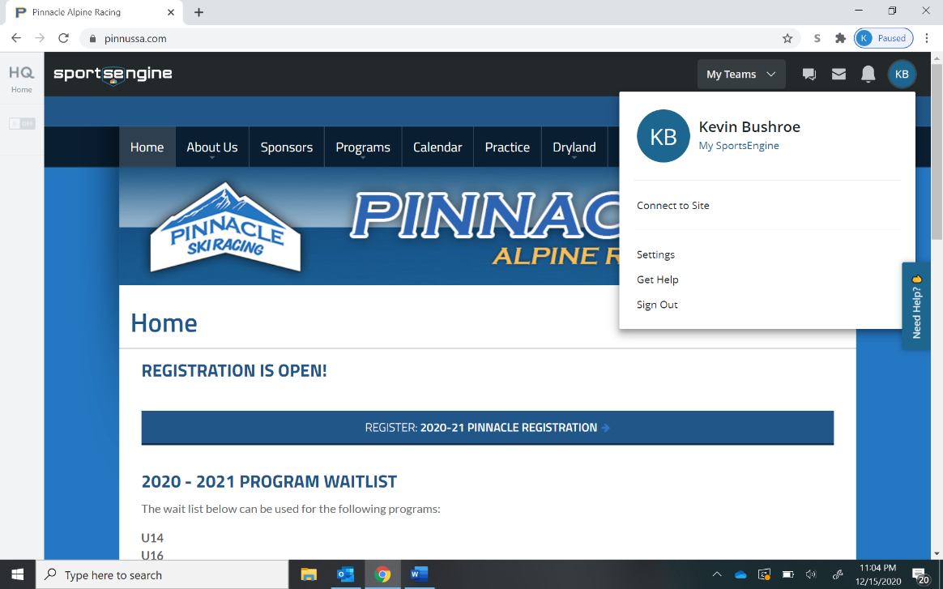

Step 3: On the left side of the screen go to the household tab and make sure all your athletes are listed:

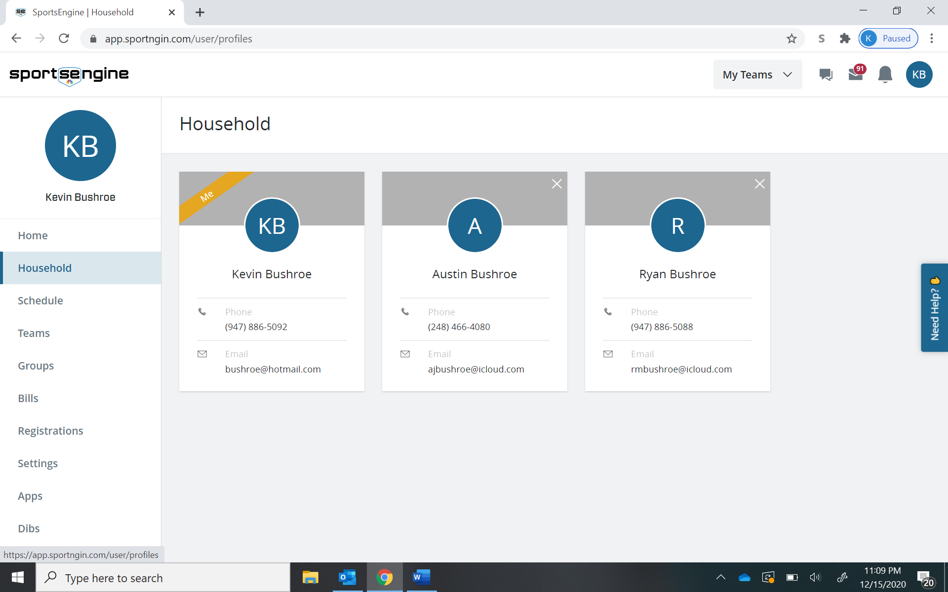

Step 4: Select your athlete’s name and make sure all their contact information is correct, including email and telephone if applicable. Then make sure he/she is listed as a guardian. If not, select the + in the upper corner.

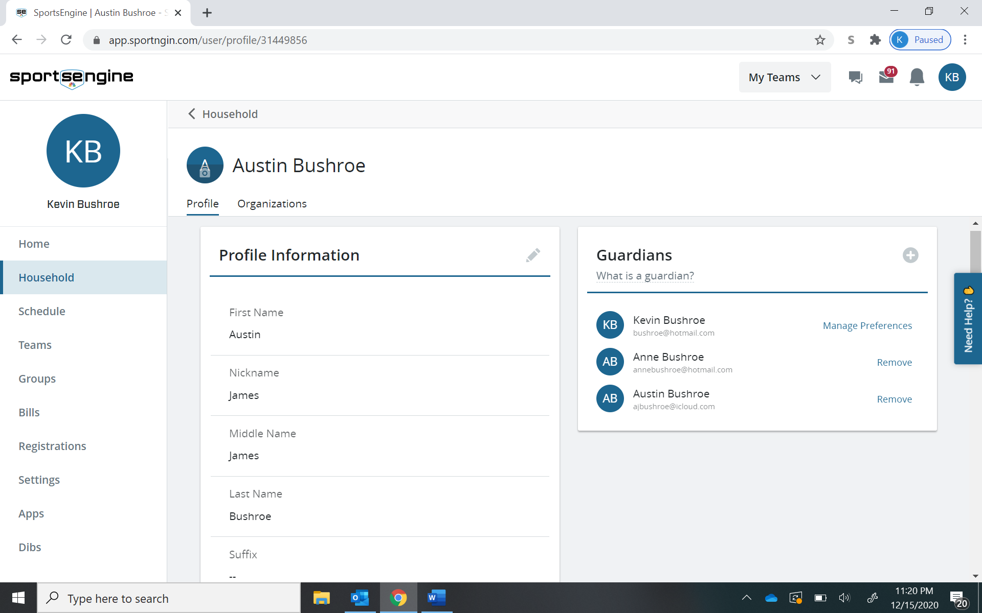

Step 5: Add their email in the section that says Invite and hit send invitation. The athlete will receive an invitation via email. Once they accept the invitation, they will have the ability to register for practices and select if they are attending on the calendar event. Repeat this for each athlete.

This can also be done on the app on your phone in a similar mannerr.

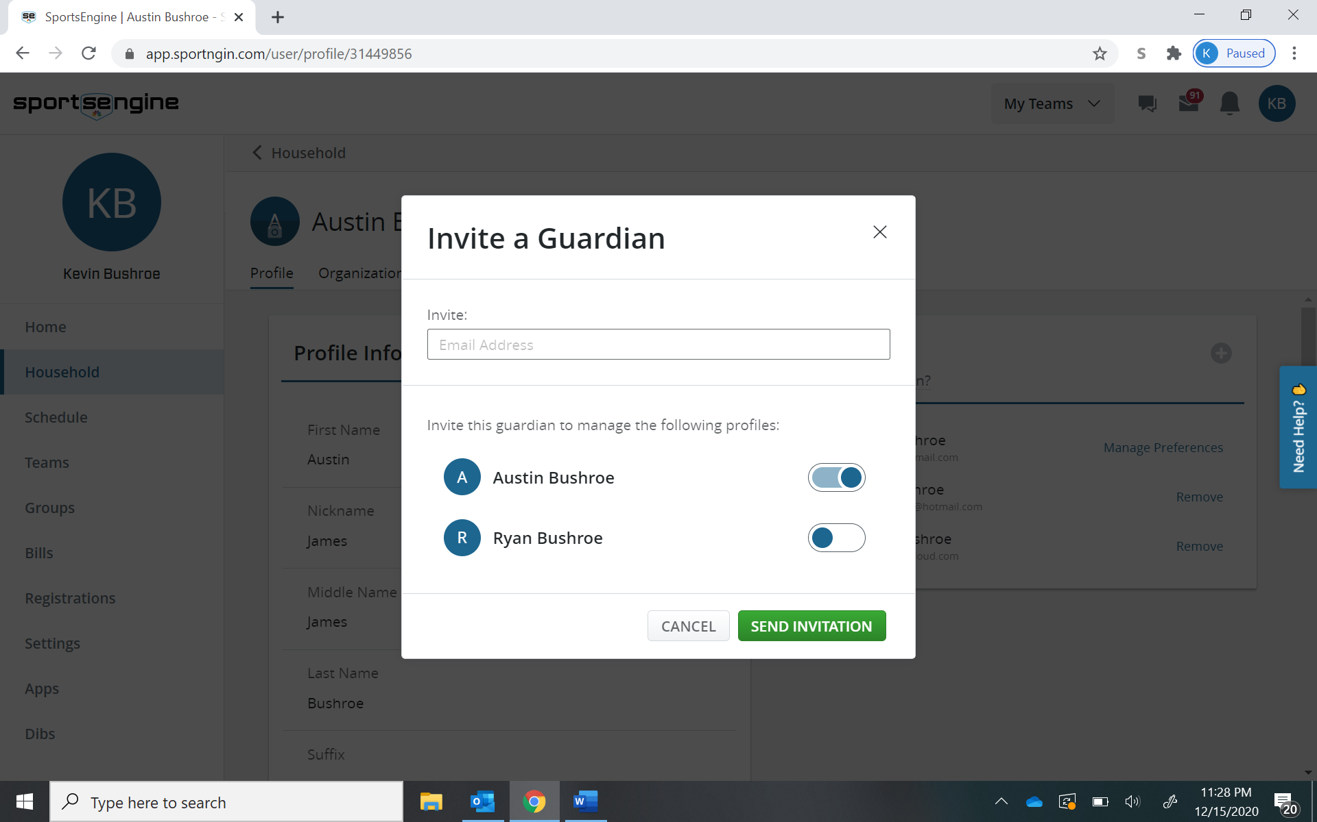

Or mobile options for setting up guardians.
- Go to the account section on the main screen (bottom right of the screen)
- See Household information
- Select the child you want to edit
- Hit the Edit button on the bottom right of the screen (blue pencil)
- Select Add Guardian
- In the "invite a guardian" box, add the child's email
- Hit "send invitation"
- Once the child accepts the invitation, they can RSVP for their own events.

Anyone with guardian access will have access to all registrations. This is helpful if and when wondering if you have registered for an event.

