Neenah Wrestling Business Sponsors
Accurate Fire Protection
A to Z Machine
the Barbershop
Bear Bones Brewery
Bee Hive
Center For Aesthetics & Plastic Surgery
Cowling Property Management
CR Fochs Electrical Contractors
Evolve Fitness Center
Firegold LLC
Fredericksen Electric
Galloway
Gerard Machine LLC
Gold Cross Ambulance
Great Lakes Mechanical
Ground Round Sports Grill
Inferno Subs
Legendary Gyro's
Lions Tail
Mark Mayer Century 21
Mathfab
Marsh Electronics
MCC INC
McMAHON Engineers/Architects
Midwest Restoration
Muntz Audio/Video of Oshkosh
Neenah Family Chiropractic LLC
NN 3d Prints and Design
Orthopedic and Sports Institute of the Fox Valley
RLJ Dental
Scheels
Styles by Design
Sunset Hill Stoneware
TNT Drywall and Plaster
2021-2022
Banquet Program

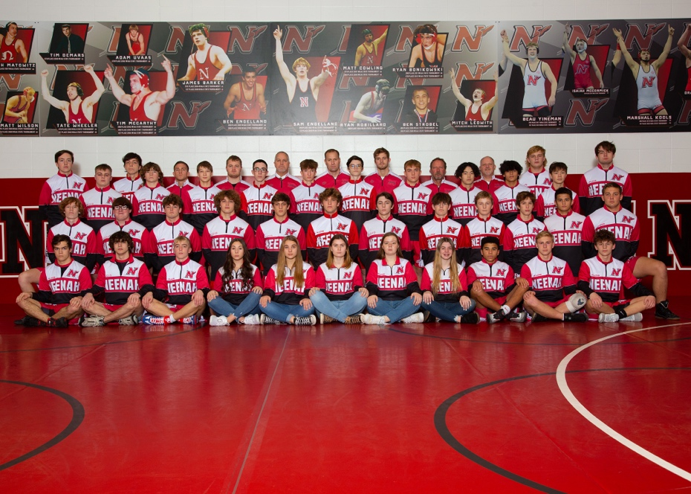

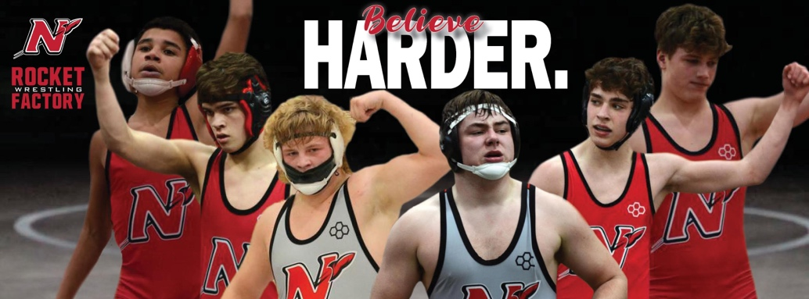

March 16th 2022 6:30 pm
Bridgewood Resort
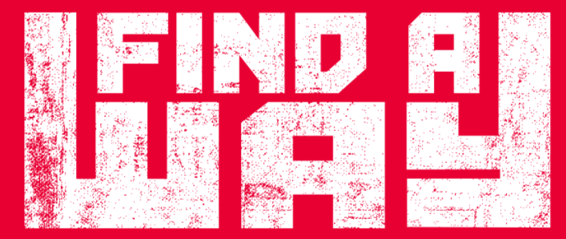
2021-2022 Neenah Wrestling Team

Freshmen (5): Maxim De Montigny, Jacob Herm, Jaden Reay, Zane Sano-Giles, Bly Wheeler

Sophomores (10): Eli Armatti, Owen Blenker, Aidan Carey, Nate Cleveland, Tyler Gillig, Christopher McLaughlin, Jesse Skelton, Logan Tessier, Jeremy Wiggs-Schmalz, Owen Young

Juniors (9): Joey Dringoli, Eli Gast, Ben Hansen, Preston Hella, Nathan Heller, Dalton Liebhauser, Nick Novak, Eric Schaufelberger, Jayden Sheppard

Seniors (8): Charlie Alft, Bryce Fochs, Caleb Letson, Austin Lewis, Denis McLaughlin, Davin Munoz, William Rambert, Caden Turnquist

Team Managers (7): Nora Pfister (9), Natalie Smith (9), Madelyn Lewis (10), Cali Tiedt (10), Alyssa Ross (10), McKenna Herm (11), Sophie Rundquist (11)

Head Coach: Kyle Kleuskens
Junior Varsity Coach: Chris Rundquist
Varsity Assistant Coach: Mark Cowling
Volunteer Assistants: Mason Bohm
Corey Knudsen
Jason Kurszewski
Brian Piechocki
Cory Zuberbier

Strength and Conditioning Steve Camber
Principal: Brian Wunderlich
Athletic Director: Michael Elkin
Assistant AD: Paula Hella

2021-2022 Varsity Dual Meet Scores
Team | Score |  |  | Result
Hortonville | 45 | 27 |  | Win
Oshkosh West | 42 | 25 |  | Win
Kimberly | 39 | 34 |  | Win
Appleton East | 78 | 6 |  | Win
Appleton North | 43 | 24 |  | Win
Appleton West | 54 | 18 |  | Win
Oshkosh North | 70 | 6 |  | Win
Fond du Lac | 59 | 9 |  | Win
Kaukauna | 31 | 38 |  | Loss
 | W | L
Conference | 8 | 1
Total Record | 8 | 1

2021-2022 Notable Varsity Team Accomplishments
- 4th Place Gunslinger Invitational 12/3/21
- 2nd Place Neenah Invitational 12/9/21
- 7th Place Oshkosh on the Water 12/29-12/30/21
- 2nd Place Valders Scramble 1/15/22
- 4th Place Highlander Invite 12/21/22
- 3rd Place FVA Conference 2/5/22
- 2nd Place WIAA Regionals 2/12/22
- 2nd Place WIAA Sectionals 2/19/22

Junior Varsity Season Records: (Min .250 Winning %)
Name Record Winning%
Zane Sano-Giles 4-7 .364
Chris McLaughlin 6-7 .462
Owen Blenker 6-1 .857
Eli Armatti 8-6 .571
Logan Tessier 8-4 .667
Jaden Reay 8-6 .571
Ben Hansen 10-9 .526
Jesse Skelton 7-5 .583
Tyler Gillig 10-5 .667
Joey Dringoli 5-2 .714
Nathan Heller 6-8 .429
Bly Wheeler 6-10 .375
Jeremy Wiggs-Schmalz 12-8 .600
Dalton Liebhauser 11-8 .579
Nate Cleveland 18-6 .750

JV Season Pins (Min: 6 Pins)
Name Pins
Nate Cleveland 9
Ben Hansen 6
Jeremy Wigg-Schmalz 6
Dalton Liebhauser 6
Owen Blenker 5

2021-2021 Varsity Individual Accomplishments

Varsity Season Records: (Min of 8 Matches or .25 Winning %
Name Record Winning %
Zane Sano-Giles 7-2 .778
Jacob Herm 47-3 .940
Preston Hella 14-21 .333
Owen Blenker 1-10 .091
William Rambert 27-17 .614
Eli Armatti 7-11 .389
Jayden Sheppard 18-9 .667
Jaden Reay 4-6 .400
Charlie Alft 12-8 .600
Austin Lewis 32-10 .762
Nick Novak 36-17 .679
Aidan Carey 12-21 .364
Joey Dringoli 9-12 .429
Eli Gast 29-11 .725
Davin Munoz 32-14 .696
Caleb Letson 36-14 .720
Bryce Fochs 44-7 .863

Varsity Season Records Pins: Min of 8 Pins
Name Pins
Jacob Herm 31 (Single Season School Record)
Bryce Fochs 29
Nick Novak 20
Davin Munoz 18
Eli Gast 17
Caleb Letson 17
William Rambert 11
Austin Lewis 13
Jayden Sheppard 10

2021-2022 Notable Tournament Accomplishments

Kimberly Friday Night JV Invite 12/3/21
Name Place WT
Owen Blenker 1st 126A
Christopher McLaughlin 1st 126C
Tyler Gillig 1st 152C
Dalton Liebhauser 1st 195A
Jeremy Wiggs-Schmalz 1st 195B

Gunslinger Invite 12/4/21: Top 3 Medal
Name Place WT
Jacob Herm 1st 113
Davin Munoz 1st 195
Bryce Fochs 1st 285
Nick Novak 4th 160
Caleb Letson 5th 220
Charlie Alft 7th 145
Austin Lewis 7th 152

Neenah Varsity Invite 12/10/21: Top 3 Medal
Name Place WT
Jacob Herm 1st 113
Austin Lewis 1st 152
Bryce Fochs 1st 285
Eli Armatti 2nd 126
Nick Novak 2nd 160
William Rambert 3rd 132
Eli Gast 4th 182
Caleb Letson 4th 220
Nate Cleveland 4th 285
Oshkosh on the Water 12/29-30/21 Top 12 Place
Name Place WT
Jacob Herm 1st 113
Bryce Fochs 5th 285
Austin Lewis 7th 145
Davin Munoz 7th 195
Caleb Letson 7th 220
Nick Novak 11th 152

Duffy Invite @ Port Washington 1/7/22 Top 8 Place
Name Place WT
Jacob Herm 2nd 113
Caleb Letson 2nd 285
Jayden Sheppard 3rd 132
Austin Lewis 4th 145
Bryce Fochs 4th 220
Nick Novak 5th 152
Davin Munoz 6th 195
Eli Gast 8th 182

WWCA Regional @ Neenah 1/8/2022
Top 3 JV State Qualifier
Name Place WT
Eli Armatti 2nd 126
Nate Cleveland 2nd 285
Jeremy Wiggs-Schmalz 3rd 182
Cayden Turnquist 4th 126
Jaden Reay 4th 138
Ben Hansen 5th 138
Dalton Liebhauser 5th 195

Valders Scramble 1/15/22
Name Place WT
Jacob Herm 1st 113
Jayden Sheppard 2nd 132
Nick Novak 2nd 152
Eli Gast 2nd 182
Davin Munoz 2nd 195
Caleb Letson 2nd 220
William Rambert 3rd 126
Joey Dringoli 3rd 160
Bryce Fochs 3rd 285

Highlander Invitational @ Homestead 1/21/22
Name Place WT
Bryce Fochs 285 1st
Jacob Herm 113 2nd
Austin Lewis 145 3rd
Jayden Sheppard 132 4th
Davin Munoz 195 5th
Nick Novak 152 8th
William Rambert 126 9th
Eli Gast 170 9th

WWCA JV State @ Wausau West 1/22/22
Name Place WT
Eli Armatti 6th 126
Nate Cleveland Consolation Champ 285

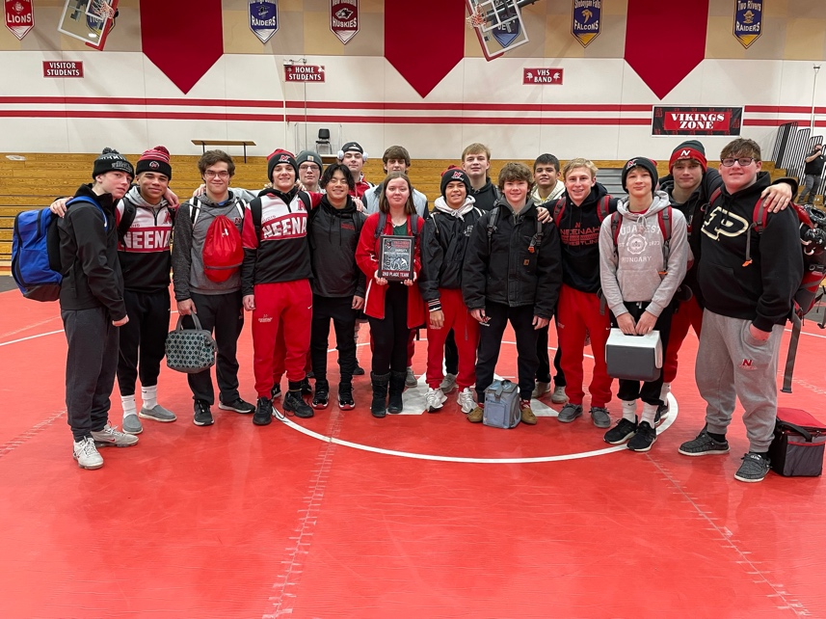

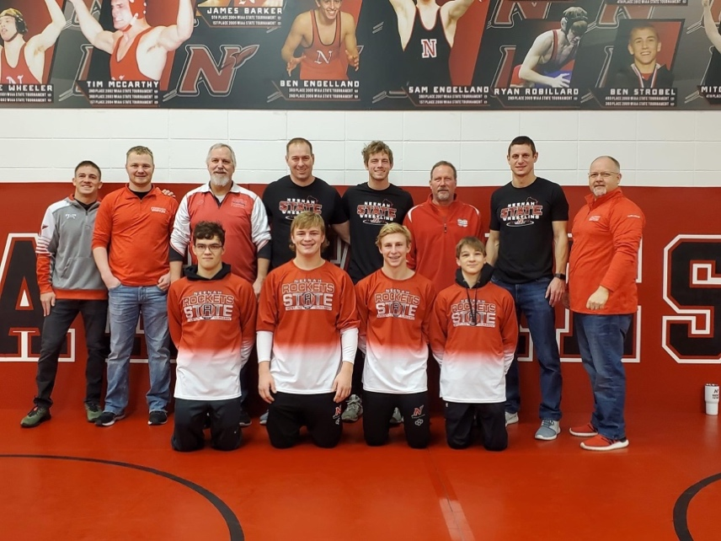

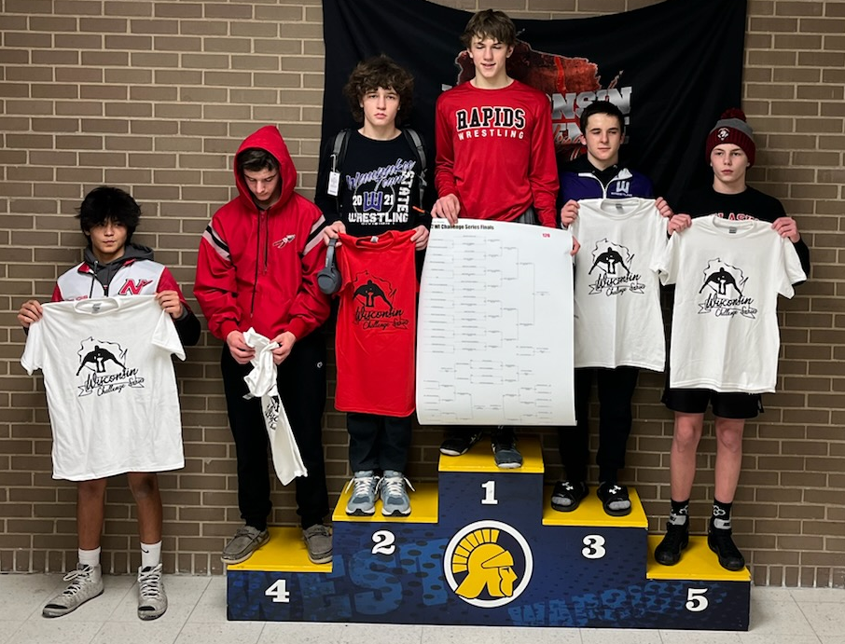

FVA Conference Tournament @ Kimberly 2/5/22
Top 3 All FVA Conference
Name Place WT
Jacob Herm 1st 106
Eli Gast 1st 170
Bryce Fochs 1st 285
Charlie Alft 2nd 138
Austin Lewis 2nd 145
Nick Novak 2nd 152
William Rambert 3rd 126
Davin Munoz 3rd 182
Caleb Letson 4th 220
Preston Hella 5th 113

FVA J.V. Conference @ Kaukauna 2/8/22
Name Place WT
Eli Armatti 1st 126
Jaden Reay 1st 138
Tyler Gillig 1st 152B
Logan Tessier 2nd 132
Nate Cleveland 2nd 285
Ben Hansen 3rd 138
Joey Dringoli 3rd 160

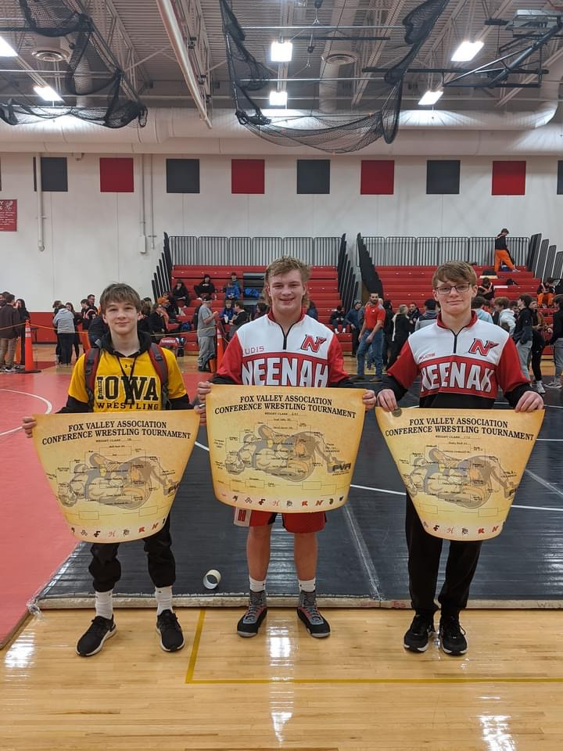

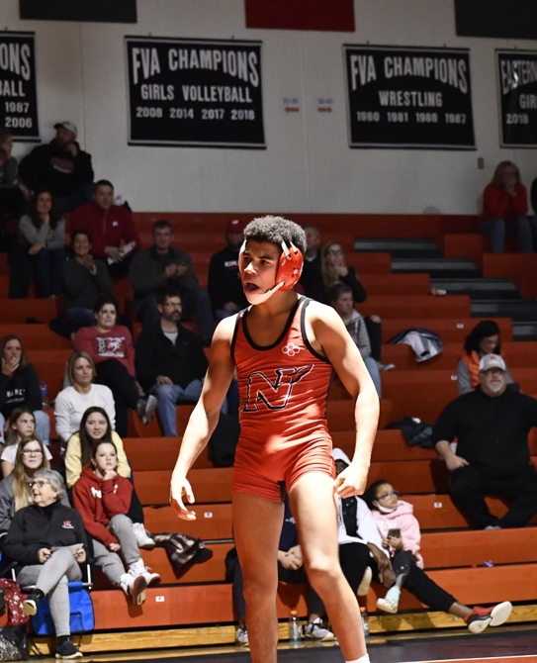
Fox Valley Association Conference (FVA)

Neenah Overall FVA Place: 2nd Place

FVA Team Dual Record: 8-1 2nd Place
FVA Tournament Finish: 3rd Place

FVA Varsity Team Dual Standings
Team Record
Kaukauna 9-0
Neenah 8-1
Kimberly 7-2
Oshkosh West 6-3
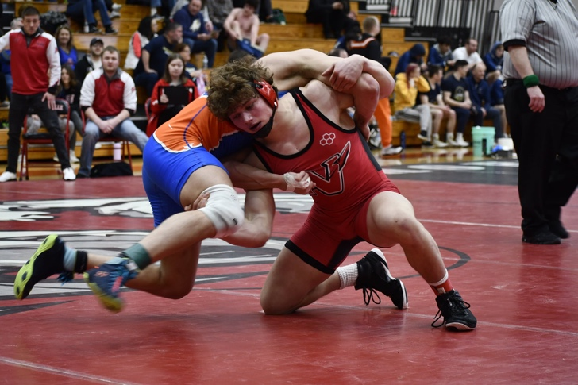
Appleton North 4-5
Appleton West 4-5
Hortonville 4-5
Fond du Lac 2-7
Oshkosh North 1-8
Appleton East 0-9

FVA Varsity Tournament Standings
Team Points
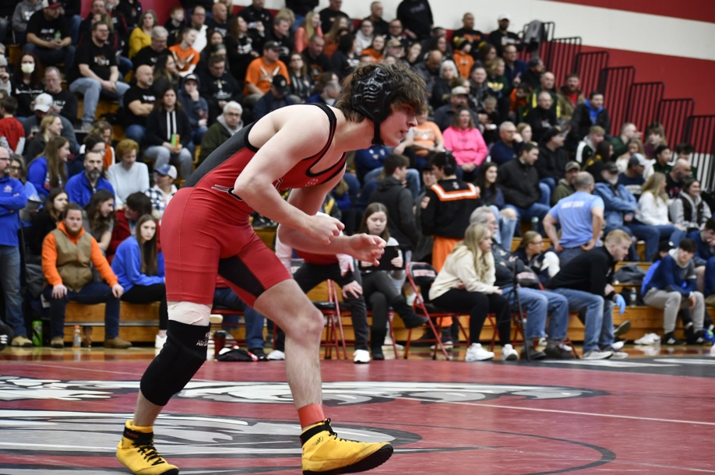
Kaukauna 278.0
Kimberly 190.0
Neenah 179.0
Oshkosh West 144.5
Appleton North 141.5
Hortonville 138.5
Appleton West 62.0
Oshkosh North 59.0
Fond du Lac 21.0
Appleton East 6.0
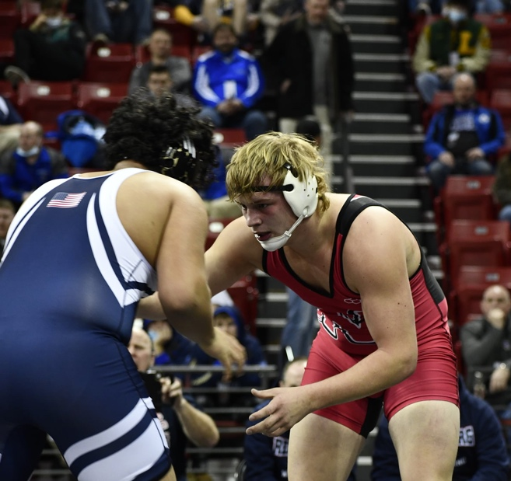

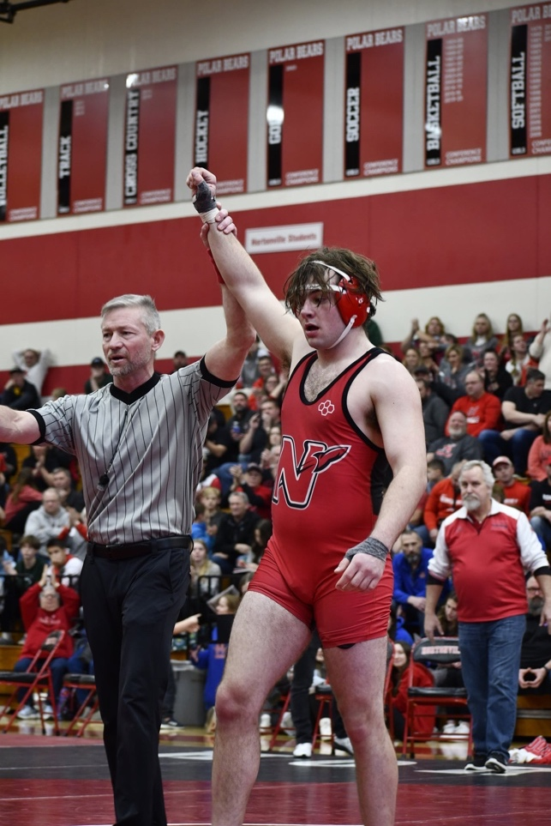

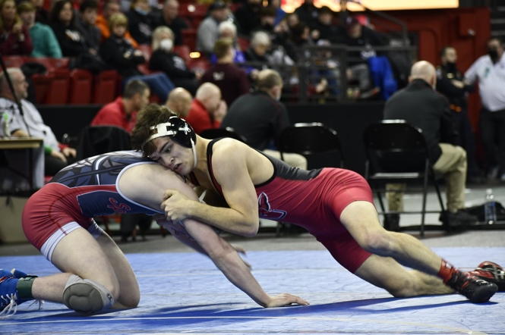

WIAA Regionals @ Hortonville 2/12/22
Top 4 Place-winners Qualify for WIAA Individual Sectionals
Name Place WT
Jacob Herm 1st 106
Austin Lewis 1st 145
Eli Gast 1st 170
Caleb Letson 1st 220
Bryce Fochs 1st 285
Nick Novak 2nd 152
Davin Munoz 2nd 195
Jayden Sheppard 3rd 126
Charlie Alft 3rd 138
Preston Hella 4th 113
William Rambert 4th 132

WIAA Sectionals @ Hortonville 2/19/22
Top 2 Place-winners Qualify for WIAA Individual State
Name Place WT
Jacob Herm 1st 106
Bryce Fochs 1st 285
Austin Lewis 2nd 145
Nick Novak 2nd 152
Eli Gast 3rd 170
Davin Munoz 3rd 195
Caleb Letson 3rd 220
Jayden Sheppard 4th 126
William Rambert 4th 132

WIAA Individual State Tournament 2/24-2/26
Top 6 Place-winners Podium
Name Place WT
Jacob Herm 2nd 106
Austin Lewis DNP 145
Nick Novak DNP 152
Bryce Fochs DNP 285
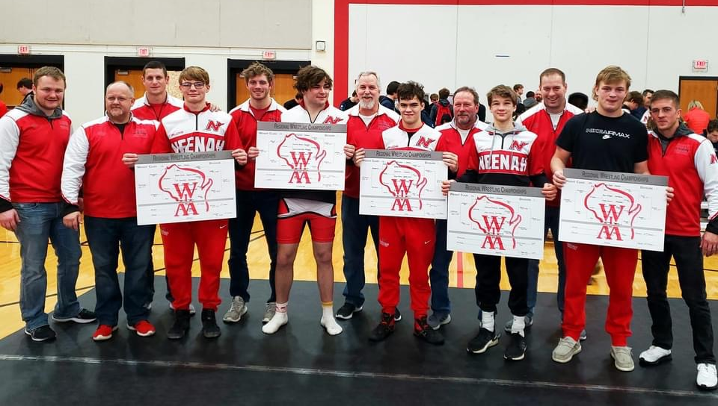

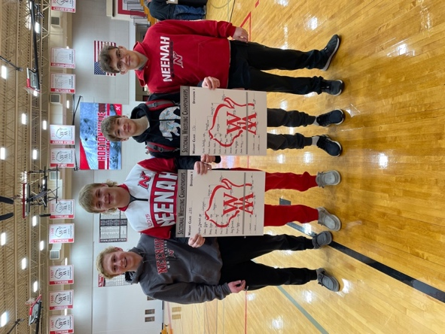
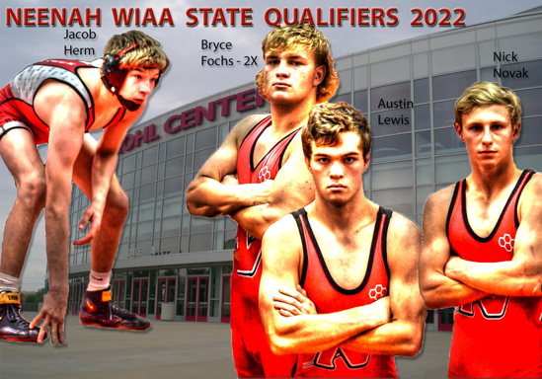

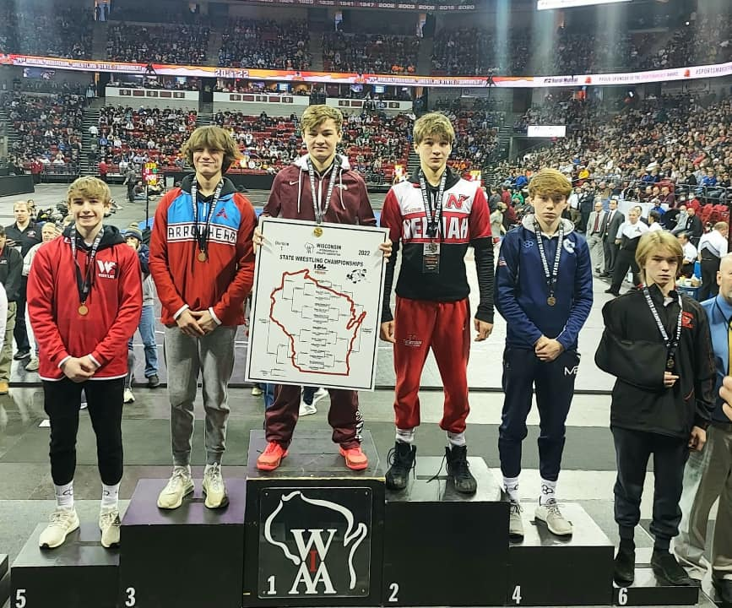

Neenah Wrestling Academic Team
Above 3.0 GPA Fall Semester or 3.25 Cumulative
Name Gr.
Jacob Herm 9
Maxim DeMontigny 9
Nora Pfister * 9
Jaden Reay * 9
Zane Sano-Giles * 9
Natalie Smith 9
Owen Blenker * 10
Aidan Carey * 10
Nate Cleveland * 10
Tyler Gillig ** 10
Christopher McLaughlin * 10
Madelyn Lewis * 10
Alyssa Ross * 10
Jesse Skelton * 10
Owen Young 10
Joey Dringoli ** 11
Eli Gast * 11
Ben Hansen ** 11
Preston Hella * 11
McKenna Herm** 11
Nick Novak* 11
Sophie Rundquist * 11
Eric Schaufelberger * 11
Jayden Sheppard ** 11
Charles Alft * 12
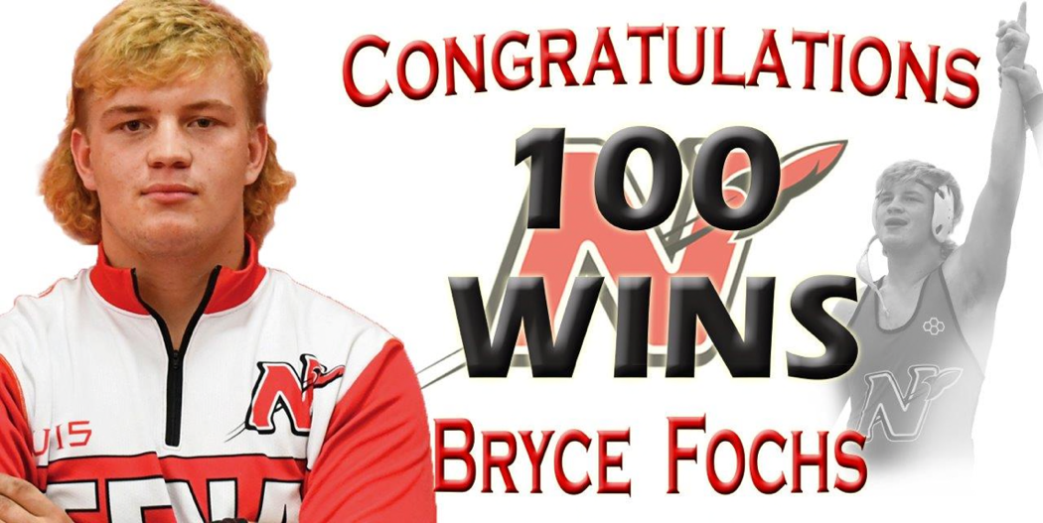
Bryce Fochs 12
Caleb Letson * 12
Austin Lewis 12
Davin Munoz * 12
Denis McLaughlin 12
Cayden Turnquist * 12
Team Members with 2.5 or Higher = 37/39 = 95%
Team Members with 3.0 or Higher = 31/39 = 79%
Team Members with 3.5 or Higher = 23/39 = 59%
Team Members with 3.75 or Higher = 14/39 = 36%
* Above 3.5 GPA ** 4.0 Student
Neenah HS Wrestling Career All-Time Wins
# | Name | # | Years
1 | Tim McCarthy | 158 | 2000-2004
2 | Marshall Kools | 148 | 2016-2020
3 | Beau Yineman | 146 | 2014-2018
4 | Sam Engelland | 146 | 2004-2008
5 | Ben Engelland | 144 | 2002-2006
6 | Alex Kueck | 139 | 2008-2012
7 | Ryan Robillard | 132 | 2006-2010
8 | Ben Strobel | 130 | 2005-2009
9 | Ryan Bonikowske | 129 | 2008-2012
10 | Adam Manteufel | 127 | 2003-2007
11 | Matt Wilson | 122 | 1996-2000
12 | Drake Hayward | 119 | 2017-2021
13 | James Barker | 117 | 2001-2005
14 | Tate Wheeler | 116 | 1998-2002
15 | Matt Cowling | 110 | 2004-2008
16 | Doug Surgenor | 108 | 1994-1998
17 | Keith Matowitz | 107 | 1993-1997
18 | Bryce Fochs | 104 | 2018-2022
19 | Blaine Hornes | 103 | 2001-2005
20 | Josh Cowling | 102 | 2010-2014

