Guidelines for Ice Trades:
(To have edit functions to the Ice Swap page, you must have edit access to a team site)

TO POST NEW ICE:
- Navigate to the Ice Trade page on https://www.aaaha.org/page/show/29739-ice-trade
- Log on to the website using the link in the upper left (just like you would for your team site)
- Select “Edit” mode in the upper right and you now have access to post ice swaps to the calendar
- Create a new calendar item (“ADD EVENT”) on the Ice For Trade/Sale Calendar and complete the following information
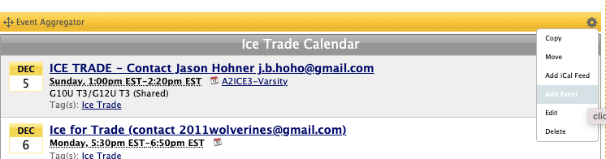

  - Event Name: Include the Team Information and Desired Actions (e.g., “Ice Trade – Contact janedoe@gmail.com”)
  - Description: Team Name and Contact Information (include any additional comments).
  - Location: Rink Name (please leave the rink name in location field)
  - Date and Time:
  - Tags: Please be sure to check the “Ice For Trade/Sale” tag
  - Select “Create This Event”
- Your ice has just been posted to the Ice Trade/Sale calendar

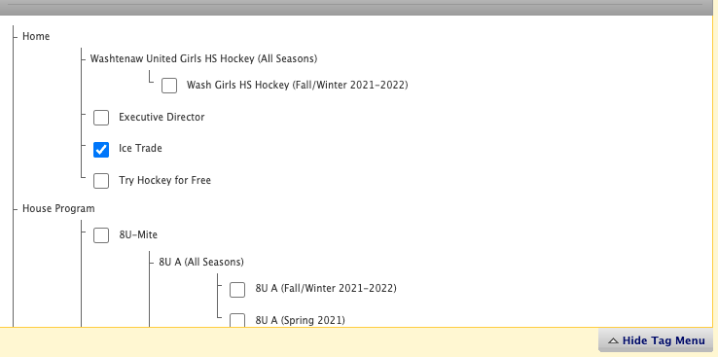

TO EDIT ICE:
- Following the same logon process as above
- Locate YOUR ice posting on the calendar (DO NOT change or modify any postings other than your own)
- Select the event by clicking on the “Event Name”
- Click on the "Edit" button to change the posting
- Update the complete the following information:

- Event Name: Include the Team Information and Desired Actions (e.g., “Ice Trade – Contact janedoe@gmail.com”)
- Description: Team Name and Contact Information (include any additional comments).
- Location: Rink Name (please leave the rink name in location field)
- Date and Time:
- Tags: Please be sure to check the “Ice For Trade/Sale” tag
- Select “Save Changes”
    - Optional Tip: You may want to include the tag for your team to remind you that it has been posted to the Ice Trade/Sale site -- do not select any other tags
Please note:
- Each team is responsible for ALL hours assigned to them
- It is the responsibility of the team to sell or trade ice that cannot be used
- If a team needs to sell or trade ice, you may contact the rink scheduler to request a trade directly or post the ice trade directly on the AAAHA ice trade website.
- Teams may NOT sell or trade ice with a non-association party.
- If the ice time is shared by two teams, both teams need to be in agreement with posting the ice up for trade and be in agreement with the ice that is being traded for, unless another arrangement has been made between the two teams.
- Please remember that if you do swap or sell ice, you must notify the Ann Arbor Ice Cube Manager and Yost Managers.

