4-2-3-1

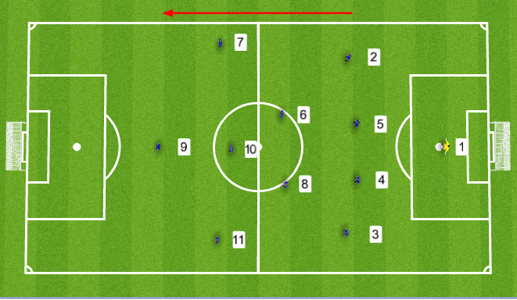

The 4-2-3-1 is perhaps the most balanced and universally used formation in the modern game. It provides teams with adequate structure to defend effectively and quickly transition moving forward.

The 4-2-3-1 is most often used in the English Premier League. The formation relies on the Nos. 6 & 8 (defensive minded midfielders) providing cover for their defenders and Nos. 7, 10 & 11 (attacking midfielders) who can produce chances for each other and the No. 9 (forward), who is typically the primary goal scorer in this formation.

Defenders in the 4-2-3-1 occupy similar roles to defenders in the 4-3-3 formation. Nos. 4 & 5 (central Defenders) typically remain in defensive positions while the Nos. 2 & 3 (fullbacks) are responsible for contributing to the attack and defense as mentioned before.

The 4-2-3-1 features both a No. 6 & 8 in the central defensive midfield role as opposed to the 4-3-3 that only has one. These players are share the same responsibility as the single central defensive midfielder in the 4-3-3 formation and are required to have the same skillset. The benefit of having two of these players rather than one is more protection for the back line. Having two players in this position allows one player to pressure the ball and the second player to drop in behind, cutting off passing lanes and serving as second line of defense if the first player is beaten. This makes it more difficult for the opposition to create breakaways and bypass the midfield.

The Nos. 7,10 & 11 (left, center and right midfielders, are responsible for creating chances in the 4-2-3-1. These three players are typically creative, comfortable on the ball, and skilled dribblers and passers. Although these players are often times interchangeable throughout the course of the game, the No. 10 is the catalyst for the offense in this formation.

The No. 10 is the focal point. In the 4-2-3-1 the most complete and creative attacking player occupies this position. The No. 10 attempts to get on the ball as much as possible, looking to make passes in behind the oppositions defense to create chances for the Nos. 7, 9 & 11 to cross or finish. When the No.10 is not picking out passes, they are beating players with the ball, keeping possession, and even looking to shoot from distance.

PLAYERS/SKILLS REQUIRED

- Creative offensive players
- Ability to dribble and pass comfortably
- Hard working central midfielders who will not deviate from their duties

PROS

- Ability to attack while still having coverage
- Concede fewer goals

CONS

- Score fewer goals
- If players are not organized gaps in the formation will appear

