**Minnesota Girls Gymnastics Officials Association**

*A Minnesota State High School League Association of Excellence*

**FLIP IT FORWARD**

Become a High School Gymnastics Official!

For more information, contact us on our website or Instagram:

**MGGOA.ORG**

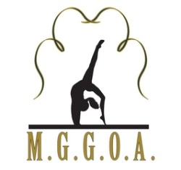

**Every Routine, Every Time**